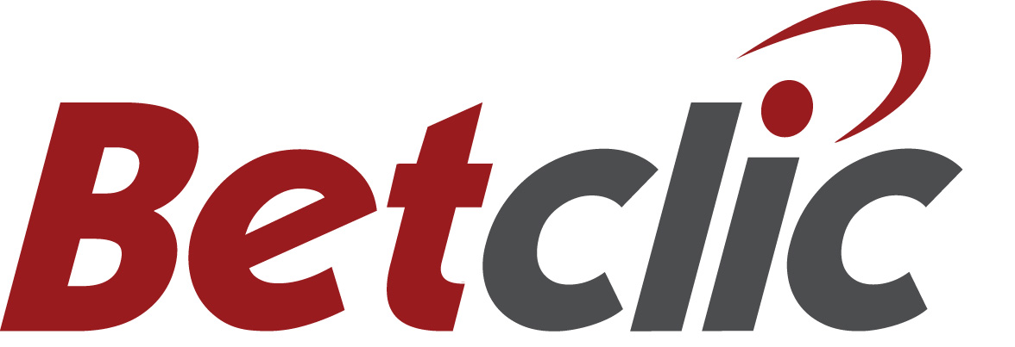

**Betclic presents new logo**

**– and an improved site**

***Press release 5 July 2011***

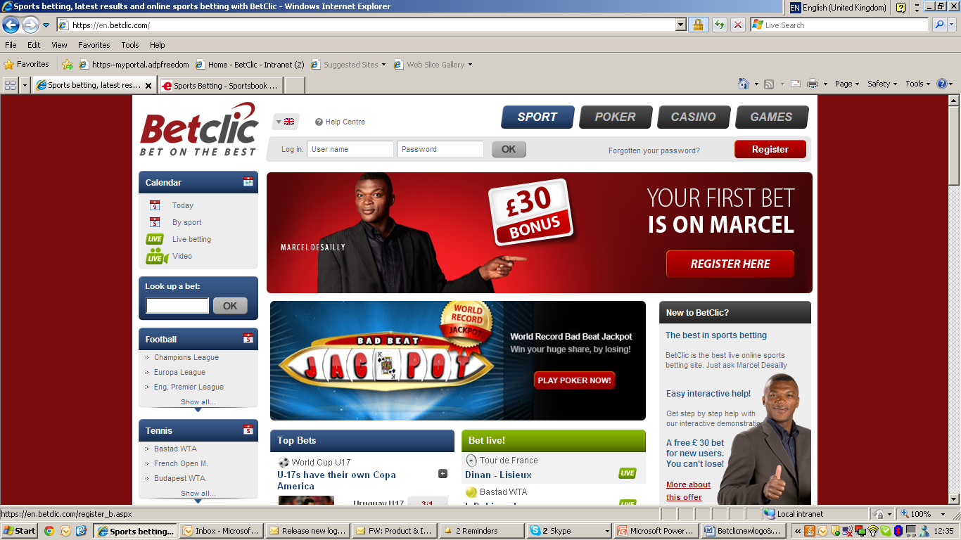

**Away with capital C and an optimized look and feel. That was the idea behind the new logo for Betclic which was launched this week. At the same time the site has gotten an improved look and feel.**

Betclic as one word is the key change for the new logo of the online bookmakers with millions of customers around Europe.

* The overall objectives were to evolve the logo a little and to covert the brand from a 2 word brand to a 1 word brand. We optimized the whole curvature of the font, aligned the vectors and made the geometry have more consistent movement. Another secondary objective was to make the grey in the word 'clic' the same tonality as the red, for it to have a uniform grey-scale colour and also to improve visibility of the word 'clic', states the creative director Ian Schranz.

Betclic.com has at the same time gotten a modern facelift with an improved look and feel for the customers.

Betclic is the official sponsor of Juventus, Lyon and Olympique Marseille and are the leading sports brand in Betclic Everest Group.

***The new logo:***  


***The old logo:***

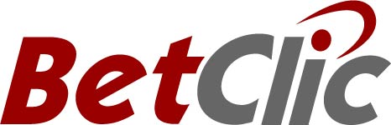

*For more information, please contact PR Manager Dan Vikman:*

*Mobile nr: +4479177 35995*

*Mail:* [*dan.vikman@betclic.com*](mailto:dan.vikman@betclic.com)