25th of May 2016

ConceptoMed named in Disrupt 100 - Index of Disruptive Businesses Worldwide

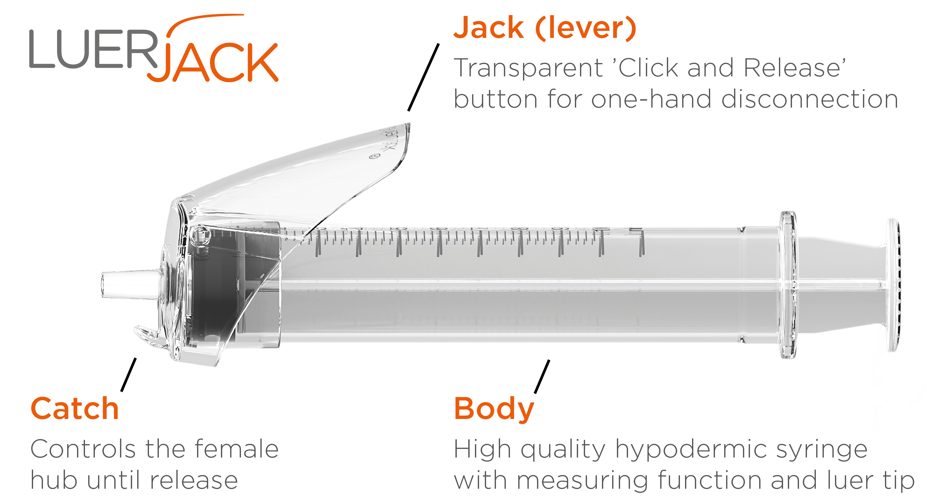
We are proud to announce that ConceptoMed has been named in the Disrupt 100 - a bi-annual Tällt Ventures publication celebrating the businesses with the most potential to influence, change or create new global markets.

The report tracks the world’s most disruptive businesses, compiled and curated by the world’s leading entrepreneurs, investors and business people.

We were selected from over 1 million global startups and corporate ventures, and judged by global brands including Astra Zeneca, KPMG, IBM and Silicon Valley Bank, tech accelerators Microsoft Ventures, Mass Challenge and WAYRA and entrepreneurs Emma Sinclair, Tom Goodwin and Bill Liao.

Matt Connolly, Managing Director, Disrupt 100, said: ‘Entire industries are being disrupted by new, often well-funded startups that are able to quickly scale and displace long-established companies. The Disrupt 100 champions those businesses who are rethinking todays products, services, technologies and business models to open new markets and create new demand.’

ConceptoMed’s key product, the innovative Luer-Jack syringe, is unique through the very simple one-hand operated disconnection function. Based on the leverage effect, the ‘Click and Release’ feature performs faster, safer and more efficient one-hand disconnections from needles and any other medical luer connections, and thereby reduces the risk of needlestick injuries. Using only one hand safeguards aseptic technique and could become a vital part of the on-going struggle to reduce the occurrence of hospital-acquired-infections.

‘We are proud and humbled to be selected as the only Nordic company recognized by this index. The great potential of the innovative Luer-Jack syringe is not new to us, as healthcare professionals throughout Europe are now starting to use it, however, this is the first time we have been independently celebrated by a global index’, said Christian Mide, M.D., CEO and founder of ConceptoMed.

‘The simplicity of Luer-Jack will make a large footprint in the medical workplace and increase quality of care. From a business standpoint, strong IPR and very low co-innovation risks come from full compatibility of the Luer-Jack technology across existing medical connection standards’, said Mide.

Details on the Disrupt 100, judges, themes and more can be found at www.disrupt100.com

ConceptoMed AS is a rising medtech star serving the global market with innovative product categories and unique proprietary technology. We create smart medtech systems that empower healthcare professionals and improve patient care. Excellence through simplicity is our code. We are brave, curious and dedicated. We simply care.
Based in Norway, the team is continuously meeting milestones and expanding its activities for international growth. For more information on the company and career opportunities, see www.conceptomed.com and www.luerjack.com. Follow us on MyNewsdesk and LinkedIn.

Tällt Ventures is a research and innovation company that tracks and analyse over 1M startups around the world providing clients unique insights into disruptive threats and opportunities.
Working with organisations across the private, public and third sectors, it combines 3rd party and owned research, consultancy and studio production to maximise clients’ business growth across markets. www.tallt.ventures

Luer-Jack® is a registered trademark owned by ConceptoMed AS. The Luer-Jack® technology is widely patent protected throughout the world, currently with almost 50 patents and pending patents from 8 patent families.

