SMART CONTROLS AND INTUITIVE DISPLAY CHOSEN FOR THE WORLDS FIRST 300HP DIESEL OUTBOARD ENGINE
Progressive Miami International Boat Show, Miami Marine Stadium,
February 15 to 19, 2018 – Booth # F602 - F Tent

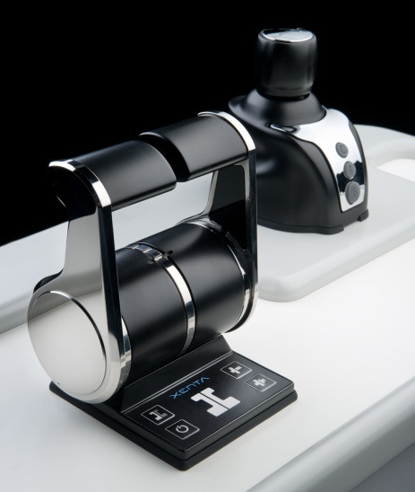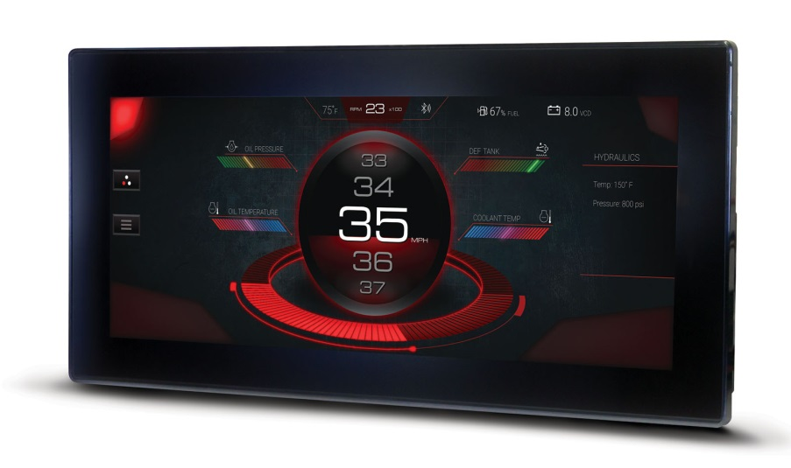

Xenta controls and joystick (left) and the Murphy by Enovation’s PowerView® 1200 display system chosen for the CXO300 diesel outboard engine

Miami, February 15, 2018 – Exhibiting at its first Progressive Miami International Boat Show, British diesel outboard engine innovator, Cox Powertrain, will today reveal the engine joystick control and display system that have been exclusively chosen for its ground-breaking new diesel outboard engine, the CXO300.
Partnering with Italian controls specialist, Xenta Systems and Tulsa, US based controls and display pioneer, Murphy by Enovation, Cox Powertrain has paired the most sophisticated joystick control and display technology with the company’s new and revolutionary 300hp diesel outboard, to deliver a highly intuitive and superior performance.
Italian controls specialist, Xenta Systems is the first company to develop and patent the intuitive joystick control system. Working closely with retrofit and OEM production markets to offer a fully integrated engine control package, Xenta has developed in a highly intuitive control system, the Xenta Smart Stick, that can intuitively control a boat using the engines, transmissions and bow thruster to provide seamless manoeuvrability in close quarters.
Murphy by Enovation Controls’ latest display technology, the new PowerView®1200 display screen has been chosen for its superior design and great looks to provide outstanding clarity on its easy-to-read operator interfaces. The PowerView®1200, launched in the USA last year, offers full-featured engine diagnostics on a configurable display screen. As Murphy’s largest engine display system, the PowerView®1200 was chosen for its power, large memory and excellent connectivity. The 12.3-inch, glare-free LED screen, can be viewed in full sunlight and the display is fully bonded helping it withstand all environments.
The CXO300, the world’s highest power density diesel outboard engine, is set for launch later this year. For further information visit www.coxmarine.com, www.xentajoystick.com and www.murphybyenovationcontrols.com
ENDS

About Cox Powertrain

Cox Powertrain is a world-leading British designer and builder of marine diesel outboard engines developed for worldwide and multi-market applications.

Based on the South Coast of England, Cox Powertrain is backed by the Ministry of Defence and a solid shareholder base of private and institutional investors. As a result, the company has been able to implement a long-term development programme of ground-breaking new products.

Led by ex-Cosworth CEO, Tim Routsis, whose background lies in engine development in global automotive, aerospace and marine markets, the company’s mission is to deliver a completely new concept in diesel engines that has the potential to revolutionise the marine market.

With a strong pedigree in Formula 1 racing and premium automotive design, Cox’s highly skilled team of engineers has decades of experience in combustion engines and understand the many difficulties customers are challenged with.

Cox’s first ground-breaking diesel outboard engine, the CXO300, is the highest power density diesel outboard engine ever developed. As a low weight, high power, single fuel engine, the CXO300 delivers the same performance and efficiency of an inboard but with the convenience and flexibility of an outboard.

For further information, visit www.coxmarine.com

Media contacts:

Reena Bayley, Marketing Manager
Cox Powertrain Limited
Tel: +44 (0) 1273 454 424
E: reena.bayley@coxpwertrain.com

Media information & images:
Karen Bartlett
Saltwater Stone
Tel: +44 (0) 1202 669 244
E: k.bartlett@saltwater-stone.com

