NEWS from:
Springworks AB
For immediate release

Sveavägen 52
111 34 Stockholm, Sweden
Contact: Sophia Skinbjerg
Email: sophia.skinbjerg@springworks.se
Direct phone: +46 70 405 47 56

autoSense, a connected car platform using Springworks’ technology, launches in Switzerland, opening a wide world of connected car services for Swiss drivers.

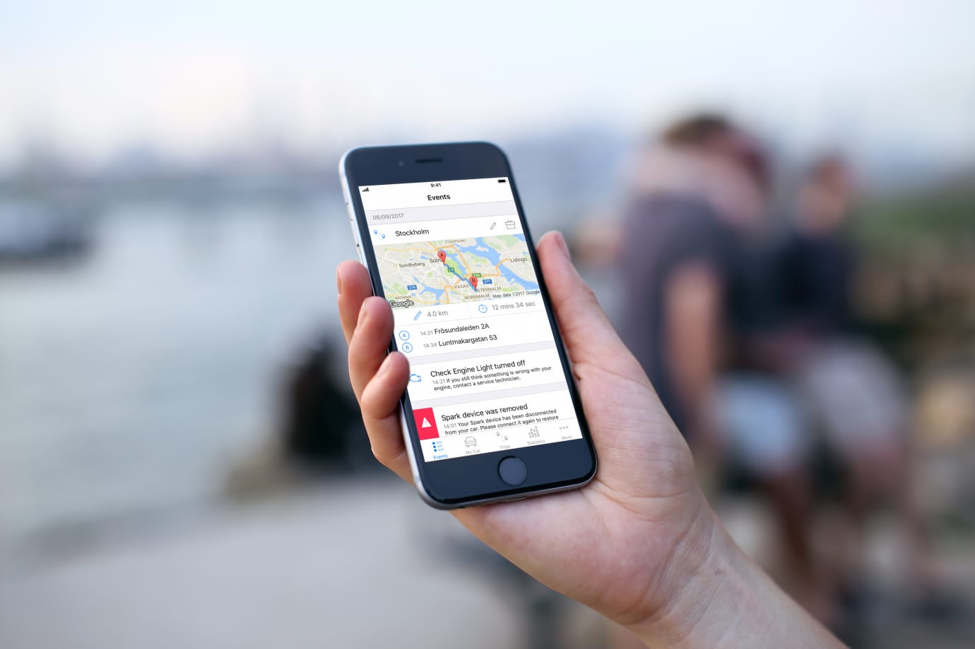
Stockholm, Sweden – autoSense is now available for both Swiss consumers and fleet managers. The app-based digital car assistant is compatible with cars from model year 2004. Swisscom, AMAG and Totalmobil! are already partners of the venture. Following last year’s announcement, Springworks and the autoSense team have worked together to launch the service in less than 12 months.
Image: Spark, the connected car platform developed by Springworks.

CCO at Springworks, Fredrik Åkerlind, explains that “autoSense is all about delivering a truly valuable connected car experience to Swiss drivers that saves time, money, and brings drivers a level of safety and security not yet seen in an app-based service.”

From security warnings to trip journal

With the autoSense app (free to download and demo) and a small plug-in device that is connected to the car, users receive valuable information about their car, letting them take timely or proactive action.

For example, drivers can see real-time car location and get immediate push notifications if their car is tampered with or moved outside a designated area. If battery levels are low, drivers can find the closest garage to drop in or book an appointment. Driving time and distance are also captured in the trip journal for those using their car for work.

autoSense CEO Jaap Vossen says “I am convinced that we can offer our customers an attractive and unique offer in Switzerland. The open approach invites you to participate. Together with our partners, we want to create a promising Swiss ecosystem.”

###

For more information please visit www.springworks.se or contact Sophia Skinbjerg sophia.skinbjerg@springworks.se. Additional media assets (including screenshots) provided on request.

About Springworks - www.springworks.se

Springworks develops a connected car platform called SPARK that connects telecom providers with a host of service providers in the automotive industry including car manufacturers, insurance, roadside assistance, parking companies, repair shops and more. Based in Stockholm, Sweden.

About autoSense - https://www.autosense.ch
autoSense is a subsidiary of Swisscom (Schweiz) AG. The company develops, builds, operates and distributes a Connected Car Platform and Connected Car ecosystem
and offers services for private individuals and fleet managers in the field of intelligent networking of cars. Using an app and an adapter, the vehicle owner receives a digital assistant for his car - whether new or used. The platform is open to interested partners and is constantly being expanded with exciting offers. Swisscom, AMAG and Totalmobil! are already on board!

