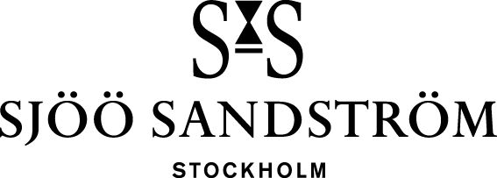

Press release, Stockholm, 2024

Update your icon.

We take pride in being pioneers in the industry and a feature we've proudly offered since our start in 1986 is that you can change the dial. By allowing you to effortlessly change dials, our watches promote sustainability, as you can update your look over time.

It all started with a vision. The best of both worlds would be united in a wristwatch in a completely new way. Classic watchmaking would be included with new age electronics. After years of development, in 1997 we presented a unique wristwatch, Sjöö Sandström CHRONOLINK Worldtimer UTC. Elegance in one classic, mechanical watch is united with the electronic brilliance. A concept that is still unique in the watch world today.

The Chronolink Worldtimer UTC was a game-changer, revolutionizing the global watch market of its time. We are pleased to introduce a long-awaited and exclusive update to one of our most iconic timepieces launched 1997. Our devoted Chronolink enthusiasts can now enjoy an exclusive set featuring two new dials in an elegant handcrafted leather case. “Vibrant” contains a green and an orange dial with steel index and the “Elegance” contains an ivory and a blue dial, both with rose gold index. Two dial changes are included upon presentation of the note included in the leather case.

Links:

Chronolink package Vibrant
Chronolink package Elegance

For more information, please contact:
Kristofer Johansson
Press contact, Sjöö Sandström Sweden AB
kristofer.johansson@sjoosandstrom.se
Telephone: +46 760 06 82 90

