HAVENGORE’S STUNNING NEW DECK IS UNVEILED FOLLOWING EXTENSIVE RESTORATION

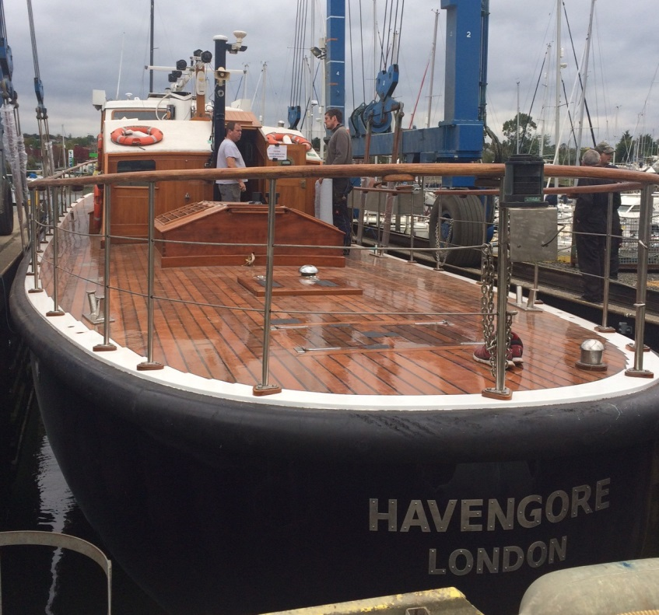

Caption: MV Havengore’s deck after restoration

MV Havengore, the classic launch famous for carrying the coffin of Sir Winston Churchill along the River Thames during his State Funeral, has been relaunched and has arrived back on her home berth at St. Katherine Docks having undergone an extensive restoration by Ipswich based Fox’s Marina & Boatyard.

A key element of Havengore’s refit was replacing her solid teak deck. To help overcome some of the challenges in re-laying the deck on such an historic vessel, Sika’s professional marine deck caulking system, Sikaflex® 290 DC PRO was chosen to to ensure the deck remains watertight and durable over many years.

Following the restoration completion Managing Director, Fox’s Marina & Boatyard, Will Taylor-Jones said, “Fox’s Marina & Boatyard’s growing reputation for delivering high quality, large refit projects requires a solid base of reliable partners and suppliers. With their range of excellent products and first class technical support, Sika has always been our first choice for deck caulking and bonding solutions.

Havengore’s deck presented its own challenges. With over 500 metres of 25mm thick, solid teak deck planking, fastened directly to oak deck beams with no underlying sub-deck, the performance of the caulking seams is fundamental to the deck’s integrity. Working with Sika, we are confident we have the best solution in place for this wonderful project.”

Gareth Ross, Sika Limited’s Marine Market Field Specialist added, “We were privileged to have been involved in such a high-profile classic boat restoration as Havengore. It gave us the perfect opportunity to demonstrate the benefits of Sikaflex® 290 DC PRO and we are confident that the long-term results will speak for themselves.”

The introduction of Sikaflex® 290 DC PRO for professional users has set a new benchmark for premium deck caulking systems and is rapidly becoming the product of choice of reputable yards and boat builders around the world.

On returning to her home berth at St Katherine Docks, MV Havengore resumes her role as a corporate hospitality vessel and taking part in ceremonial duties on the River Thames.

For further information visit www.sika.co.uk or http://www.foxsmarina.com

Ends

Further press information & images from:

Karen Bartlett
Saltwater Stone
Tel: +44 (0) 1202 669 244
E: k.bartlett@saltwater-stone.com

Notes to Editors:
Sika Limited is a wholly owned subsidiary of Sika AG, a global company based in Switzerland specialising in the manufacture and supply of chemical based products for construction and industry. A world-leader in its field Sika has subsidiaries in more than 70 countries, generates annual sales of CHF 4.6 billion and is committed to providing quality, service, safety and environmental care.

In the UK, Sika provides market-leading solutions for flooring, sealing and bonding applications, waterproofing, roofing, structural sealing and strengthening and many other construction applications.

Sika’s head office is based in Welwyn Garden City at Watchmead, Welwyn Garden City, Hertfordshire, AL7 1BQ. Call 01707 363866, or visit www.sika.co.uk.

