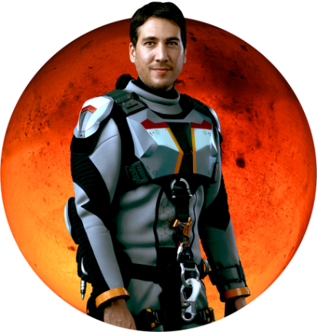

CREW MEMBER: Javier Delgado

ASSIGNMENT: Hydrologist and geochemist

NATIONALITY: Spanish

NOTES: Delgado is responsible for developing and managing the settlement’s most basic and precious resource: water. An avid golfer at home, he is a naturally social man who despite his toughness will in some way find the strains of Martian isolation more difficult than the other crew members.

ACTOR BIO: Alberto Ammann

Alberto Ammann plays Spanish hydrologist and geochemist Javier Delgado. In 2008, Ammann won a Goya (Spanish Academy Award) for his riveting performance in “Cell 211,” which became the year’s most successful Spanish film. He was born in Cordoba, Argentina, and trained professionally at the Juan Carlos Corazza Acting Studio in Spain. Ammann starred in the 2012 thriller “Invasor,” playing a Spanish military doctor stationed in Iraq during the war, and he guest starred in the sci-fi thriller “Mindscape” directed by Jorge Dorado. He is currently finishing shooting the second season of the Neftlix series “Narcos,” in which he plays Pacho Herrera.

