Kongsberg Digital wins contract to deliver cutting-edge engine room simulator to German training institute
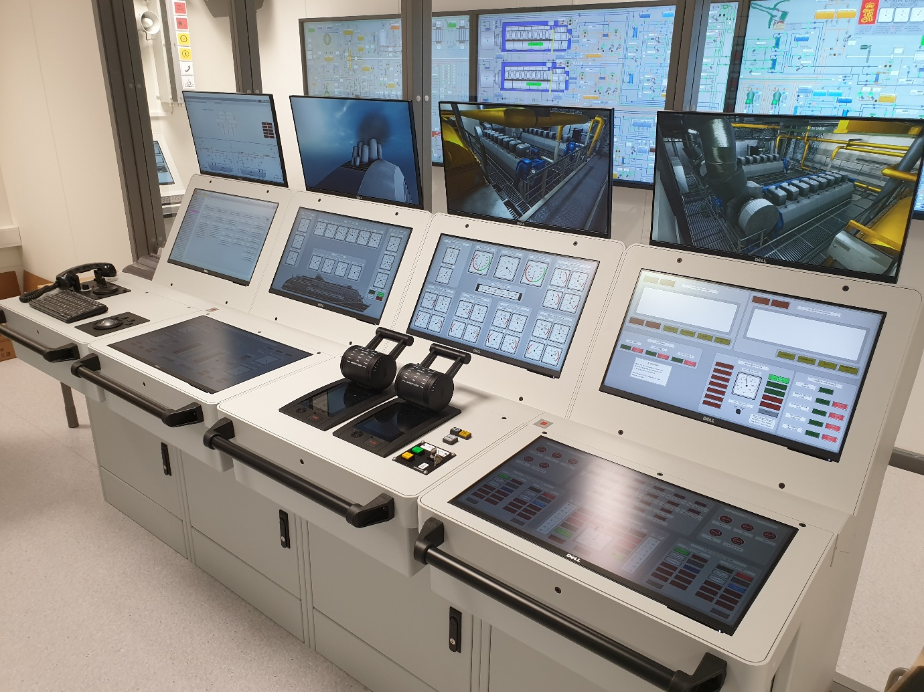
The Hochschule Flensburg University of Applied Sciences has ordered an ultramodern K-Sim simulator solution
Kongsberg, Norway, September 28th, 2020 – Kongsberg Digital (KDI) is pleased to reveal that it has won an international public tender to supply the Maritime Center in Flensburg University of Applied Sciences in Germany with a complete K-Sim engine room simulator package.
Scheduled for August 2021, the extensive delivery includes a K-Sim Engine Full Mission engine room simulator and a K-Sim Engine desktop classroom configuration. In addition, the university has ordered six different K-Sim Engine models to achieve the desired training outcomes for a variety of propulsion and engine types.
To meet modern shipping training needs KDI will also develop an entirely new model based on the machinery configuration from a next-generation LNG Carrier propelled by two MAN ME-GI low-speed engines that can operate on LNG, MGO and HFO: the K-Sim Engine LNG Carrier MAN ME GI L22. The model will be specifically designed to meet new safety and sustainability requirements in shipping. It will enable students to attain expertise in operating two-stroke LNG-fueled engines, with an emphasis on safety-related LNG handling which aims to minimize risk to personnel and the marine environment.
Additionally, to enable IGF code training in LNG bunkering procedures, the DEDF42 Cruise Ferry model – based on a pioneering Dual Fuel passenger ship – is also included in the delivery. To comply with the Ballast Water Management Convention, several of the included models have a combined electrolysis and filter system in order to meet IMO and USCG requirements for such a system.
Kongsberg Digital’s new K-Sim Engine eLearning modules are also included with the delivery. These are accessible via K-Sim Connect, a pioneering cloud-based ecosystem providing members with a range of simulation services and tangible benefits. Simple and straightforward to use, it provides instructors with the possibility to upload, share and manage exercises for eLearning purposes. Students can obtain access to the simulation exercises at any time or location, simply by logging in.
“Kongsberg Digital is the first to deliver advanced cloud-based simulation, supporting maritime training institutes in modernizing and improving the quality of their training. We are pleased to provide Hochschule Flensburg with the flexibility of our subscription-based simulation services, delivered via K-Sim Connect,” says Tone-Merete Hansen, Senior VP in Kongsberg Digital, Maritime Simulation. “By collaborating with the industry and integrating advanced functionality from KONGSBERG’s well-reputed real equipment, such as K-Power, K-Chief and AutoChief, into our simulators, we’re constantly developing new realistic models meeting the trends of fuel and propulsion systems.”
“The upgrade to Kongsberg Digital’s new-generation simulator technology will make a world of difference in improving our training environment,” comments Pawel Ziegler, Professor, Flensburg University of Applied Sciences.
Prof. Dr. Michael Thiemke adds: “The new K-Sim Engine models will prepare our students for controlling and managing the engine systems onboard different vessels, including the top modern ones. With the cloud-based eLearning solution our students will also gain access to high-quality simulation exercises outside the school, to practice more and build the necessary competence.”
Ends
For further information, please contact:

Anne Voith
Marketing and Communications Manager, Simulation
Kongsberg Digital
Tel: +47 4808 4640
anne.voith@kdi.kongsberg.com
David Pugh
Saltwater Stone
Tel: +44 (0)1202 669244
d.pugh@saltwater-stone.com

About Kongsberg Digital
Kongsberg Digital is a provider of next-generation software and digital solutions to customers within maritime, oil and gas, and renewables and utilities. The company consists of more than 500 software experts with leading competence within the internet of things, smart data, artificial intelligence, maritime simulation, automation and autonomous operations.
Kongsberg Digital is subsidiary of KONGSBERG (OSE-ticker: KOG), an international, knowledge-based group delivering high-technology systems and solutions to clients within the oil and gas industry, subsea, merchant marine, defence and aerospace. KONGSBERG has 11.000 employees located in more than 40 countries.
Web: Kongsberg Gruppen | Kongsberg Digital
Social media: LinkedIn | Twitter | Facebook

