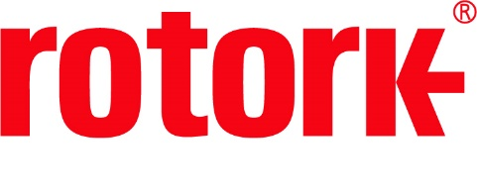
APPROVED PRESS RELEASE (3.1146) 3rd December 2020
Rotork IQ modulating actuators supporting wastewater management in Milan
Rotork IQ electric modulating actuators were selected for the Milano San Rocco Wastewater Treatment Plant (WWTP), which serves the city of Milan, Italy.
This treatment plant represents one of the biggest examples of wastewater reuse for irrigation in the world where practically all the treated water can be reused for farm irrigation. It processes the wastewater of a population of over one million people, which equates to an average flow of 3 m3/s.

Over 30 Rotork actuators have been installed on jet valves in order to provide critical air regulation control at the treatment plant. The actuators have been installed to control the air-inlet in the oxidation tanks. The oxygen within the tanks allows the various microorganisms that process the harmful elements within the wastewater to survive, so precise control is essential. The actuators are operated by a signal from the control room to regulate the valves and keep the set air flow rate within the tanks.
The actuators have been installed with a Folomatic analogue input card and a Current Position Transmitter (CPT). The Folomatic card enables the actuator to respond to an analogue signal from the control room, while the CPT provides an analogue current output relative to its position. This data allows the operator to measure the valve’s movements.
The IQM with Folomatic & CPT, watertight enclosure and 400-3phase 50 Hz power supply was specified to meet the exact needs of this application. The IQM has a solid state reversing starter in place and is capable of up to 1,200 starts per hour, with a direct seating torque output range of 10 to 544 Nm (7 to 400 lbt.ft).
These are not the first Rotork products to be used at this site. Since its construction in 2002, Rotork has provided intelligent electric actuators ensuring that wastewater treatment services have been able to continue to operate reliably. The reliable and efficient nature of Rotork products and services means that they have been selected as the sole provider.
Rotork Site Services has a maintenance contract to carry out any necessary site repairs, fault finding and maintenance on an annual basis. This will ensure that all the actuators can continue to function efficiently.
END
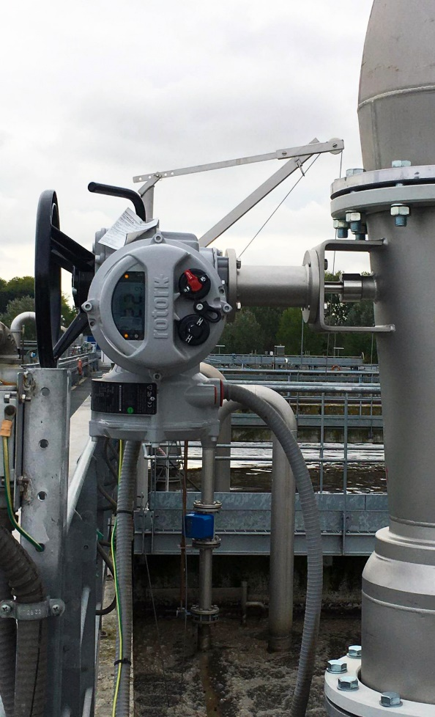

Photo caption
Rotork IQ actuators in place at the Milano San Rocco Wastewater Treatment Plant.

For further information please contact Rotork PLC
Sarah Kellett Brassmill Lane
Group Marketing Communications Manager Bath
Telephone: +44 (0) 1225 733492 BA1 3JQ
Email: Sarah.Kellett@rotork.com UK

About Rotork
Rotork is a market-leading global provider of mission-critical flow control and instrumentation solutions for oil and gas, water and wastewater, power, chemical process and industrial applications. We help customers around the world to improve efficiency, reduce emissions, minimise their environmental impact and assure safety.

