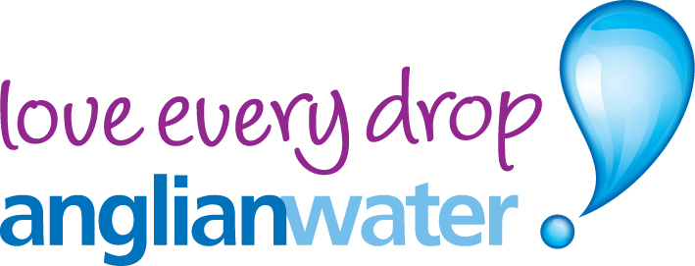 | 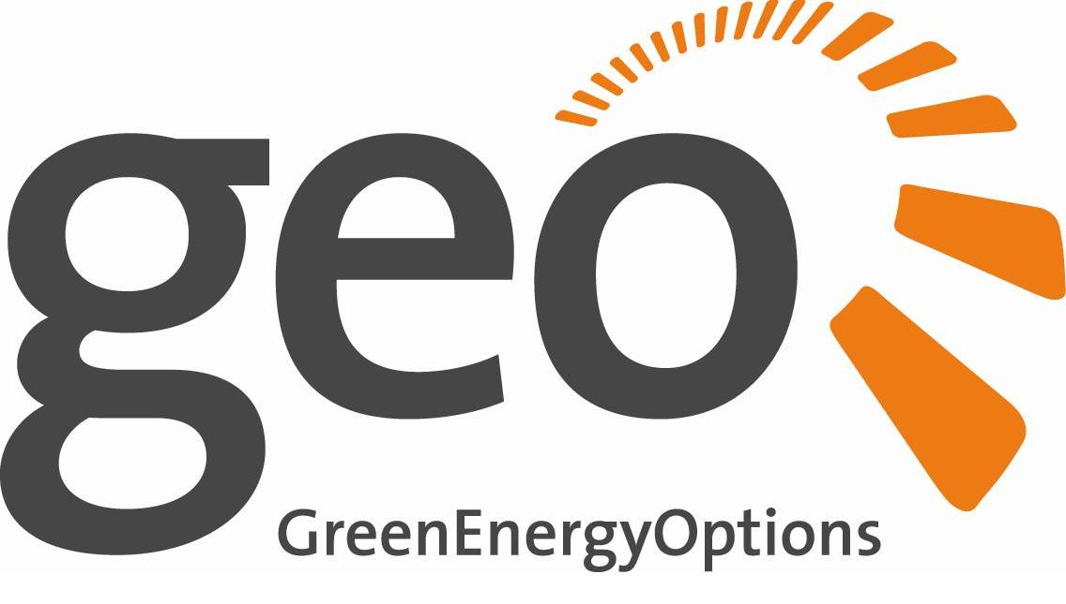

Media release

12th November 2012

Read all about it!

New technology lets customers track water use

Thousands of Anglian Water customers are being offered the chance to try out the latest in water saving technology.

Selected households have been sent letters asking if they want to apply for state-of-the-art display units, which let them see at a glance how much water they are using.

The units are connected to people’s water meters by a radio link and turn the information they receive into easily understood displays.

By keeping a close eye on their water use, customers should be able to reduce it – driving down their bills at the same time.

Paul Glass from Anglian Water’s metering team, said: “At present these displays will only work in properties with internal radio meters – those actually fitted inside the home rather than the garden or driveway.

“That’s why we are offering them to eligible customers rather than rolling them out to everyone. A thousand letters have been sent to suitable homes and we are waiting to see what kind of take-up we get.”

He added: “We’d really encourage people who are offered a display unit to give it a go.

“Our data already shows that simply switching to a meter means people use between five per cent and 15 per cent less water.

“Having a meter means you only pay for what you use, so on average metered customers save about £100 a year on their water bills.

“With these displays, people can keep a much closer eye on their water use, which means they should be able to bring their bills down even further.”

The displays have been designed by Cambridgeshire firm Green Energy Options.

Green Energy Options’ Chief Executive Officer, Patrick Caiger-Smith, said: “We’re really pleased to be working with Anglian Water on this project. We’re providing a unique colour display – the first of its kind – to their customers.”

He added: “The display, like all our products and services, is designed to help households manage, analyse and quantify their water consumption. Our aim is to take the customer relationship away from the traditional supply and demand and into a conversation that is informative and fun. A conversation that people want to join.”

“We engage customers by bringing water consumption to life, in the same way we do with electricity, gas and micro-generation. All of which mirrors exactly Anglian Water’s ‘Love Every Drop’ campaign. Working together in this way is a perfect fit for us both.”

The brightly-coloured displays allow people to set a daily water budget, which it displays as a beaker that slowly fills as the day goes on. If the tank overflows then you’ve gone over your budget.

At the same time, red and green fish let you to see at a glance if you are under or over budget and by how much.

A stop watch button allows users to see how much water different activities and appliances use and lets them compare the water used by a shower and a bath.

It can even alert you to leaks on your pipe.

“We knew early on we were on to something”, said Patrick Caiger-Smith. “During testing we received an alert about a leak in our system which, if it had gone unnoticed, would have caused an awful amount of damage. We would never have known without this display.”

Paul Glass said: “This is an exciting project for us and one we really hope will lead to a drop in the amount of water people use every day. The plan is to compare the amount people have used in the six months before and after having a display installed.

“After that we want to install up to 11,500 displays around the region during 2013, which should lead to significant savings.”

-Ends-

For more information contact:

John Clare, Anglian Water press office 0871 6770123
Christine Rush, Marketing Communications Manager, Green Energy Options 01223 851390

Join our campaign for the future. It’s called Love Every Drop.
You can take part at a tap near you.
www.anglianwater.co.uk/loveeverydrop

About GEO
GEO designs and produces in-home energy displays, online energy services and mobile applications that make energy engaging. They enable energy suppliers, meter manufacturers and installers to strengthen the relationship with their customers by putting end-users in control of their energy consumption, home appliances and energy budget in a visual, informative and engaging way. GEO’s products and services work together with pre-smart and smart meters and micro-generation to enable the energy-efficient home.

