**Gelleråsen Arena next up for Andreas Bäckman**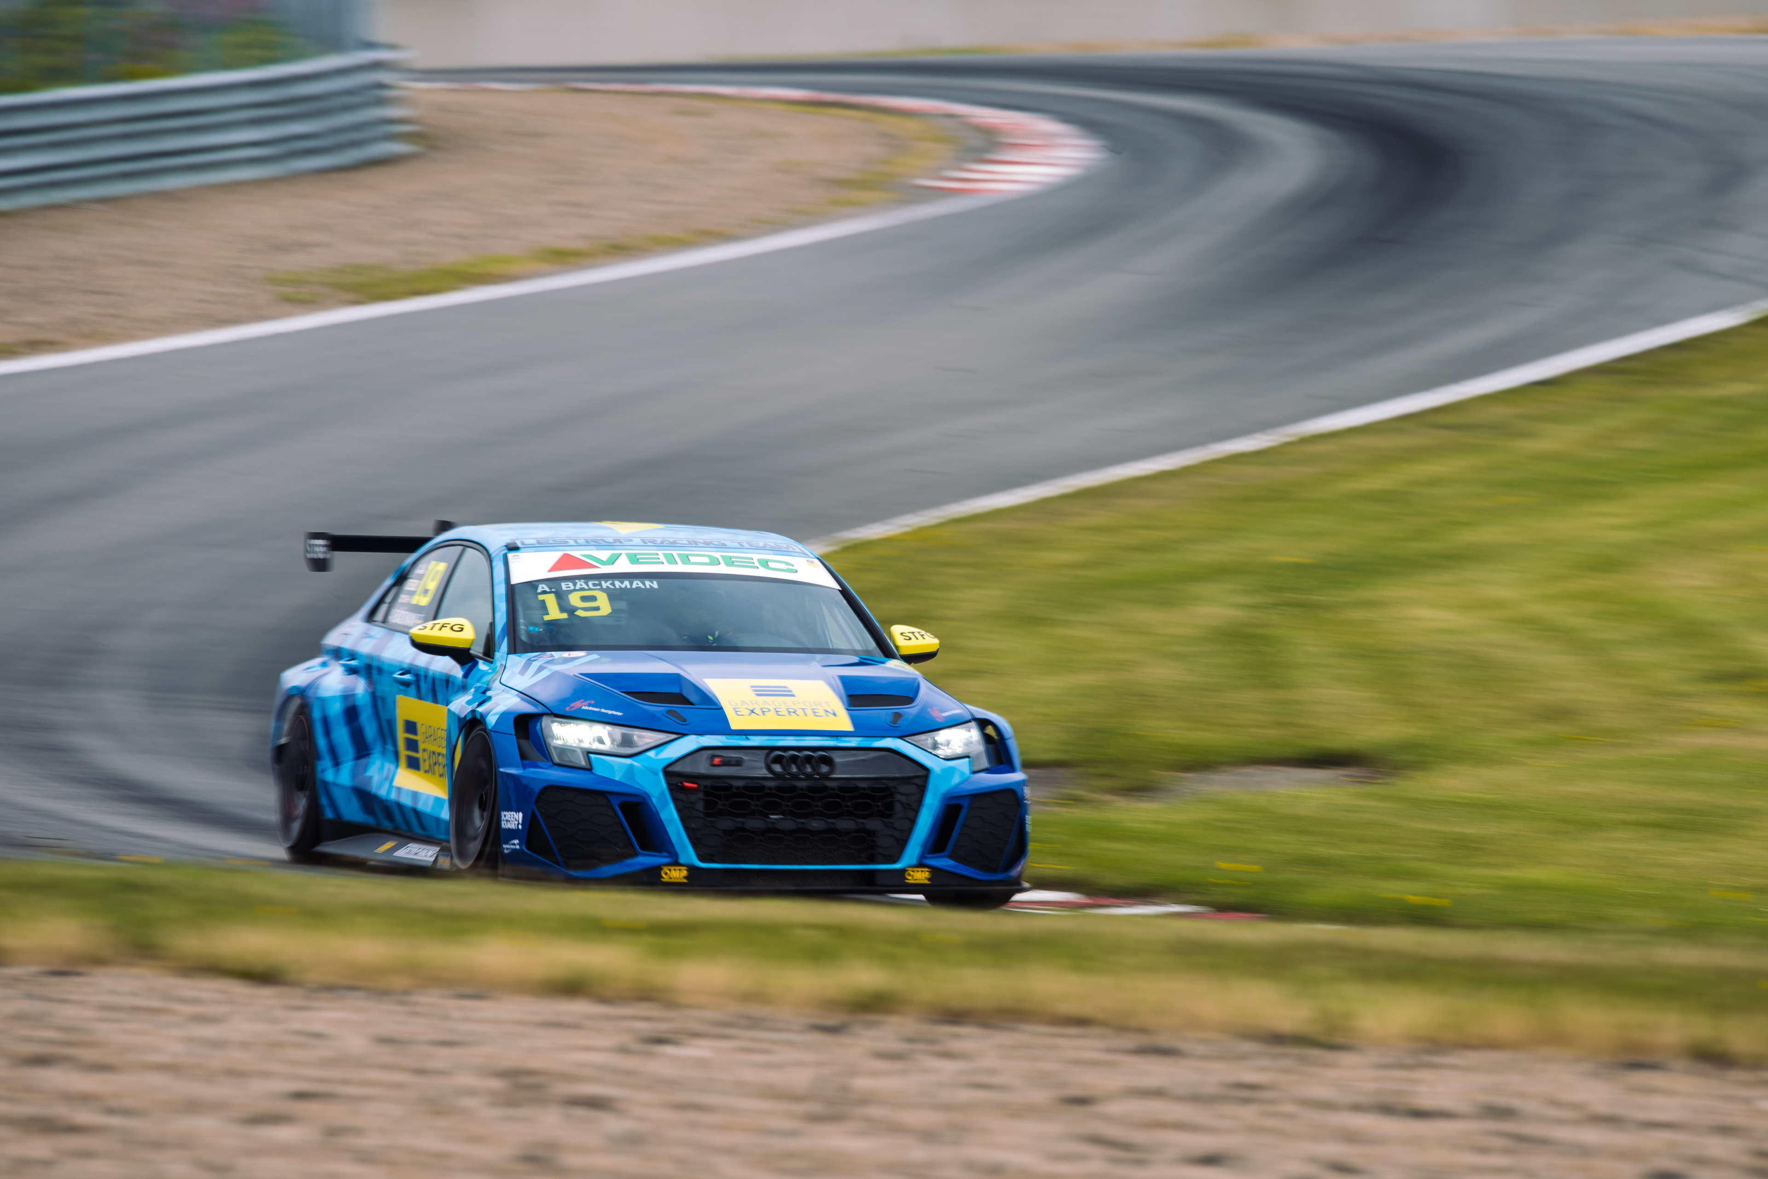Andreas Bäckman is competing this weekend with his Audi RS 3 LMS TCR car for Lestrup Racing Team in the classic race Kanonloppet at Gelleråsen Arena, located near Karlskoga, Sweden.  
Photo: Martin Öberg (Free rights to use the image)

**This weekend, August 18th-20th, Andreas Bäckman competes at Gelleråsen Arena when the second half of the STCC season begins after the summer break with the classic annual race Kanonloppet.  
– The feeling in car has been good the last two races, so I’m looking forward to see where we stand against our competitors this weekend, Andreas Bäckman says.**

STCC (Scandinavian Touring Car Championship) is Sweden's most prestigious motorsport championship and is today the leading class for Touring Car Racing in Sweden. The cars are built according to the global TCR regulations, which means that the cars used in STCC are the same as those in the other TCR series around the world. The series consists of six races that are run on different Swedish tracks and this weekend, August 18th-20th, the fourth round of the championship, Kanonloppet, are being held at Gelleråsen Arena. Gelleråsen Arena is a challenging track that was built in 1949, is located outside Karlskoga, Sweden and is Sweden’s oldest permanent racing track. The first time Kanonloppet was held was already in 1950. The track has a lot of elevation changes, mixes fast and slow corners, has tricky braking zones and puts great demands on the drivers.

Andreas competes together with Lestrup Racing Team in an Audi RS 3 LMS TCR car in this year's STCC season and is in fourth place in the driver's championship after the first three races of the season.

- Nice to be back after the STCC summer break and nice to be back at Gelleråsen Arena where I last competed four years ago. A very technically challenging track with many different types of corners which will hopefully suit the Audi well. Have had a good feeling in the car for the last two race weekends and looking forward to seeing where we stand against the other teams this weekend, **Andreas Bäckman says**.

**The structure of the race weekend**  
Already on Thursday afternoon, the practice begins with one official test session, which is one hour long. Then on Friday morning, the race weekend continues with two more practice sessions, which are followed by two timed qualifying sessions in the afternoon. The timed qualifying consists of two qualifying segments, Q1 (20 minutes) and Q2 (10 minutes), where it is important to drive as fast as possible and the lap times are counted. The eight fastest drivers in Q1 will continue to drive in Q2. The result from Q1 determines the starting position for Race 1 and the Q2 starting position for Race 2 for the top eight drivers.

Saturday is the race-day and consists of three races; Race 1, Race 2 and Race 3. The starting position for Race 3 is based on the result from Race 2 but with the reverse starting order for the eight top drivers from that race.

Points are awarded to the top five in the Qualifying and the top 15 in each race.

**The event are broadcasted LIVE at STCC+**The STCC weekend at Gelleråsen Arena are broadcasted LIVE at: [plus.stcc.se](https://plus.stcc.se/)  
Live-timing:   
<raceresults.se>  
[livetiming.getraceresults.com](https://livetiming.getraceresults.com/stcc#screen-results)  
More information about STCC can be found here: [stcc.se](https://www.stcc.se/)  
Information about Kanonloppet 2022:   
[stcc.se/race/gellerasen/](https://www.stcc.se/race/gellerasen/)  
[gellerasen.se/event/kanonloppet/](https://www.gellerasen.se/event/kanonloppet/)

**Timetable for this weekend (STCC round 4 - Gelleråsen):**(all times are in CEST/Swedish time)

**Thursday August 18th:**17:00 Official test

**Friday August 19th:**10:05 Free Practice 1  
14:00 Free Practice 2  
16:35 Qualifying (Q1 and Q2)

**Saturday August 20th:**  
10:40 Race 1 (Broadcasted LIVE on [plus.stcc.se](https://plus.stcc.se/))  
14:10 Race 2 (Broadcasted LIVE on [plus.stcc.se](https://plus.stcc.se/))  
16:40 Race 3 (Broadcasted LIVE on [plus.stcc.se](https://plus.stcc.se/))

**About the track (Gelleråsen Arena):**

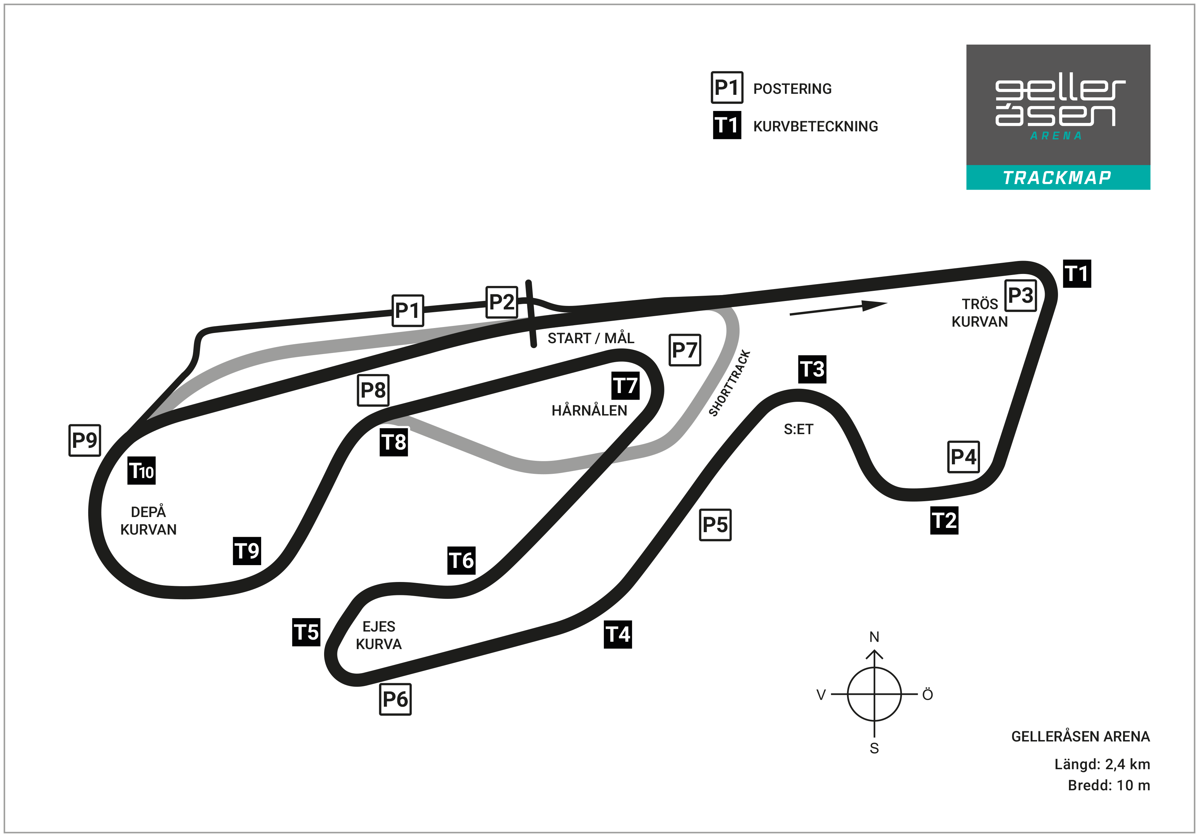

**Located in:** Karlskoga, Sweden

**Length:** 2,350 km

**Corners:** 10

**Race duration:** 14 laps (18 minutes + 1 lap)

**Lap record (TCR):** 1min 05.295s

**STCC Championship Standings before round 4 of 6:**

**STCC – TCR Scandinavia – Drivers’ Championship Standings – Overall (Top 3)**STCC 2022 (After 3 of 6 race weekends)

1: Robert Dahlgren (SWE), 136 p.

2: Oliver Söderström (SWE), 104 p.

3: Tobias Brink (SWE), 95 p.

–

**4: Andreas Bäckman (SWE), 92 p.**

[See the full standings here](https://www.stcc.se/poang/stcc-2022/)

**STCC – TCR Scandinavia – Teams’ Championship Standings – Overall (Top 3)**STCC 2022 (After 3 of 6 race weekends)

1: CUPRA Dealer Team - PWR Racing, 217 p.

**2: Lestrup Racing Team, 196 p.**3: Brink Motorsport, 176 p.

[See the full standings here](https://www.stcc.se/poang/stcc-make-2022/)

**Did you miss the previous STCC race at Ring Knutstorp?**

[Click here](https://plus.stcc.se/video/s-kvallsposten-grand-prix-knutstorp-5229lsp) to see the replay at STCC+

**Follow the STCC season:**Live-stream: [plus.stcc.se](https://plus.stcc.se/)   
Other information: [stcc.se](https://www.stcc.se/)Facebook: [facebook.com/STCCOfficial/](https://www.facebook.com/STCCOfficial/)  
Twitter: [twitter.com/stcc_official](https://twitter.com/stcc_official)Instagram: [instagram.com/stcc_official/](https://www.instagram.com/stcc_official/)YouTube: [youtube.com/c/STCCTV](https://www.youtube.com/c/STCCTV)

***Free rights to use the images.***

***Download press-photos here:***[***http://bit.ly/jabaeckman-photos***](http://bit.ly/jabaeckman-photos)[***https://www.mynewsdesk.com/se/ja-backman/images***](https://www.mynewsdesk.com/se/ja-backman/images)

