**MANFROTTO PRESENTS:**

**X PRO GEARED HEAD**

**Portability. Framing precision. Convenience.**

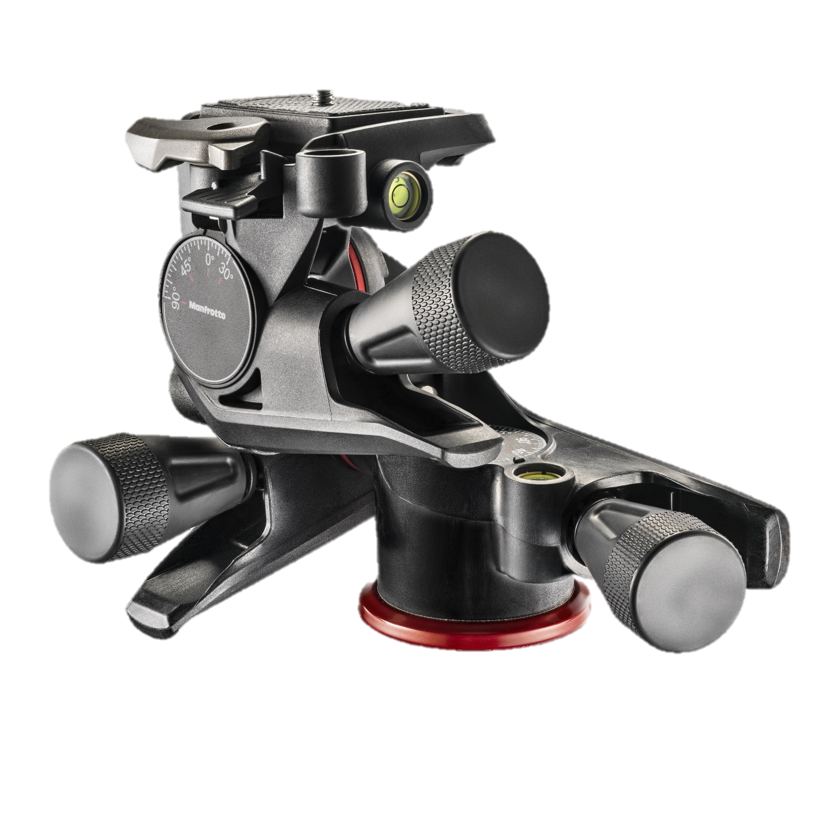

*Photokina, Sept 15th 2014* - Manfrotto, world leader in the photography and imaging equipment and accessories industry, announces the launch of the new XPRO GEARED HEAD.

The new Manfrotto head is designed for **experienced keen photographers**, who have reached high technical level thanks to their constant commitment to photography, and need to be supported when taking macro pictures or architecture shoots.

The new Manfrotto head, part of the XPRO range, ensures three essential features to photographers: **portability,** thanks to its Adapto body; **framing precision,** withthe micrometric knobs; **convenience,** thanks to its 200 PL Light camera plate.

**PORTABILITY**

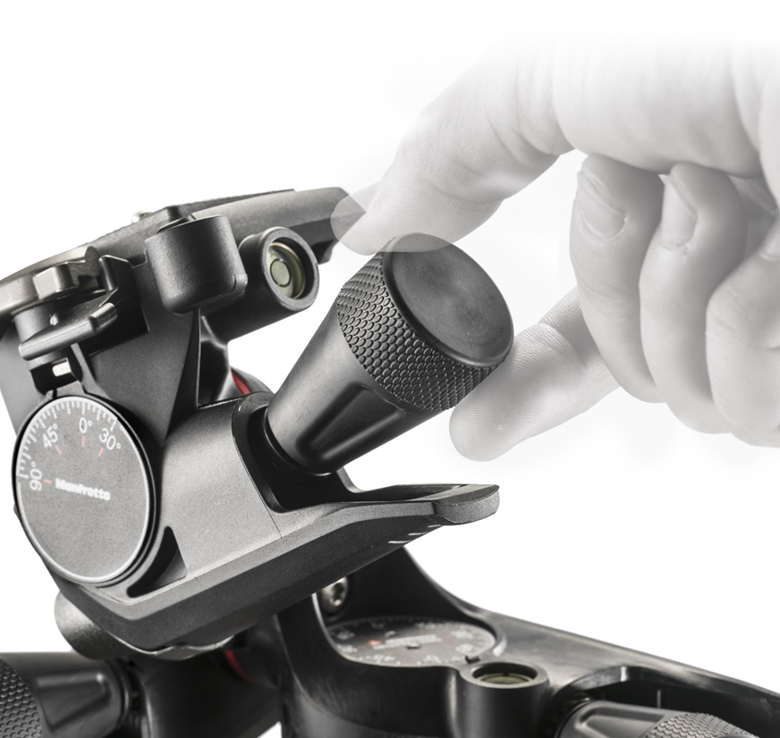For passionate photographers asking for portable supports, extremely precise in controlling framing and ideal to be used particularly in outdoor locations, this head designed by Manfrotto weighs **only 750 g** (1.65 lbs), but can support up to 4kg (8.8 lbs) of payload. Its **Adapto body, a strong and rigid technopolymer,**  makes this head the most precise lightweight head that Manfrotto has ever created. This allows photographers to shoot outdoor and control the composition in the most convenient way.

**FRAMING PRECISION**

Thanks to the head’s patent pending **micrometric knobs**, photographers can set their cameras into the desired position. The geared movement allows to frame precisely the picture, going through small micro steps in **all three axis**. The knob ensures ergonomic comfort even during extensive usage. Moreover, if the photographer doesn’t need to make fine adjustments, he can loosen the locking system pushing the knob against the levers, and move the axis in a quicker way .

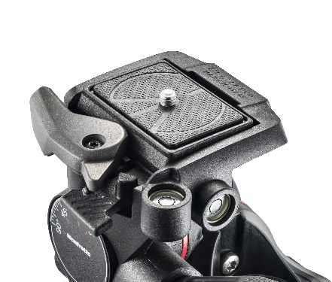

**CONVENIENCE**

By using the most common photographic **plate** in the world, the 200PL, there will be **no need of using different plates** when switching among various Manfrotto heads. This strikes the perfect balance between **quick setup** and savings: one plate is always attached to the camera, ready to be used in any situation with whatever photo or video support the photographer has in mind.

The new XPRO Geared Head features the 200PL Light, which ensures great rigidity, improved grip into a lightweight photographic plate.

**MADE IN ITALY**

XPRO Geared Head is designed and made in Italy: the 10 years warranty, the premium materials and advanced engineering processes and tests guarantee its quality. Moreover, the Geared technology is patent pending.

For more information, please visit[www.manfrotto.com](http://www.manfrotto.com)

**--------------------------------------------------------------------------**

**Manfrotto (Vitec Group)**

Manfrotto is the world leader in the design, production and distribution of professional products for photography, video and entertainment. The company was founded in 1972 based on Lino Manfrotto’s experience, and its mission has always been to support and simplify the work of reporters, photographers and producers. The Imagine More project adds to this historical mission the idea of fuelling the enthusiasm of weekend photographers and supporting the surge of new amateurs. Part of the UK-based Vitec Group since 1989, Manfrotto has now become a worldwide presence. In its eight key markets – Italy, France, Germany, the United Kingdom, China, Japan, Hong Kong and the United States – it is represented by its own direct distribution system, Manfrotto Distribution, whereas in 80 other countries sales are handled by independent distributors

**Contacts**

**MANFROTTO PRESS OFFICE**

Address:

Principal contact:

Phone:

Email: