Improving patient results and growing
the business with solutions from
Dentsply Sirona Implants
Press Contact
Kerstin Wettby
Senior Manager
Global Communication & PR

Dentsply Sirona Implants
Aminogatan 1
SE-43121 Mölndal, Sweden
Phone: +46 705 16 32 02
kerstin.wettby@dentsplysirona.com

About Dentsply Sirona Implants
Dentsply Sirona Implants offers comprehensive solutions for all phases of implant therapy, including
Ankylos®, Astra Tech Implant System™ and Xive® implant lines, digital technologies, such as Atlantis™ patient-specific CAD/CAM solutions and Simplant® guided surgery, Symbios®
regenerative solutions, and professional and business development programs, such as STEPPS™. Dentsply Sirona Implants creates value for dental professionals and allows for predictable and lasting implant treatment outcomes, resulting in enhanced quality of life
for patients.

About Dentsply Sirona
Dentsply Sirona is the world’s largest manufacturer of professional dental products and technologies, with a 130-year history of innovation and service to the dental industry and patients worldwide. Dentsply Sirona develops, manufactures, and markets a comprehensive solutions offering including dental and oral health products as well as other consumable medical devices under a strong portfolio of world class brands.
As The Dental Solutions CompanyTM, Dentsply Sirona’s products provide innovative, high-quality and effective solutions to advance patient care and deliver better, safer and faster dentistry. Dentsply Sirona’s global headquarters is located in York, Pennsylvania, and the international headquarters is based in Salzburg, Austria. The company’s shares are listed in the United States on NASDAQ under the symbol XRAY.
Visit www.dentsplysirona.com for more information about Dentsply Sirona and its products.
Press Release

September 2016—Whether you want to improve patient quality
of life through function and esthetics or grow your dental
implant business, the solutions are available in the
Dentsply Sirona Implants portfolio.

Present at the EAO, Dentsply Sirona Implants presents several new solutions to their already extensive portfolio.

Digital solutions
Atlantis® CustomBase
The Atlantis CustomBase solution combines an Atlantis Abutment and an Atlantis Crown with a screw access hole. The crown is cemented to the abutment extraorally and screw-retained into the implant, avoiding potential complications caused by excess cement. The crown can be fabricated in the customer’s own software by ordering a unique digital file, with a screw hole indicated.

Atlantis CustomBase is a premium single-tooth solution providing
- patient-specific design, as the VAD (Virtual Abutment Design) software takes the edentulous space, surrounding teeth and soft tissue anatomy into consideration, replicate natural tooth function and esthetics;
- excellent fit between the crown and the abutment, due to design and manufacturing in the same process; and
- flexibility of abutment materials and interface options.

The Atlantis CustomBase solution is available for single-tooth,
screw-retained restorations on all major implant systems.

Additive manufacturing for fixed Atlantis® suprastructures
Additive manufacturing, the latest in world-class manufacturing,
is a metal 3D printing technique which provides new possibilities
for advanced geometries. This technique is available
for Atlantis Hybrids and Bridges in cobalt-chrome and titanium.

The main advantage with additive manufacturing is individualized products with high precision and accuracy with limited need for further treatment before veneering with composite or ceramic material. In addition, additive manufacturing technology optimizes the retention for veneering. This unique increased retention promotes a better surface for ceramic or composite layering technique. Different retentive surfaces are available to fit the customer’s needs.

Additive manufacturing technology will continue to play a key role in the world class manufacturing at Dentsply Sirona.

mySimplant® Planning Service
With mySimplant Planning Service, the clinician has easy access to the benefits of computer guided implant treatment. Using computer guided implant treatment, the clinician will have more time to focus on and treat patients.

This new outsourcing service from Dentsply Sirona Implants gives clinicians the possibility to rely on an experienced partner to build and grow their business while staying in control of their implant planning cases, and most importantly, without compromising the clinical outcome of their case.

mySimplant Planning Service can ease the clinician into the world of implant treatment, as well as facilitate their more complex cases.

Implant solutions
OsseoSpeed® Profile implants – new data
Newly published results on OsseoSpeed Profile implants show optimized bone preservation, increased soft tissue volume and regain of keratinized mucosa in patients with compromised soft tissue conditions (width of less than or equal to 2 mm at postoperative visit).
PD Dr. Robert Nölken, co-author of the study, explains “We have seen a great deal of improvement on the peri-implant soft tissue in our research follow-up. This allows us to achieve a good esthetic outcome for patients with thin biotypes.”
The study—prospective, 2-year, multicenter—investigates OsseoSpeed Profile implant survival rate,
soft and hard tissue maintenance following placement in healed sites of the posterior mandible.
Twenty-four centers, 184 patients and 238 implants are included in the study.
Marginal bone preservation is an important factor to achieve excellent esthetic results. OsseoSpeed Profile EV is a uniquely shaped, patented implant specifically designed for sloped ridge situations. The OsseoSpeed Profile EV implant is placed level with both buccal and lingual marginal bone, where the design supports the soft tissue by preserving marginal bone 360 degrees around the implant.
Reference: Schiegnitz E, Noelken R, Moergel M, Berres M, Wagner W. Survival and tissue maintenance of an implant with a sloped configurated shoulder in the posterior mandible-a prospective multicenter study. Clin Oral Implants Res 2016;E-pub May 13, doi:10.1111/clr.12869.

IMAGES
are available in our News & Press Room at:
www.dentsplyimplants.com/en/Resources/News-and-Press
 | 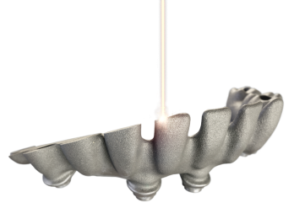 | 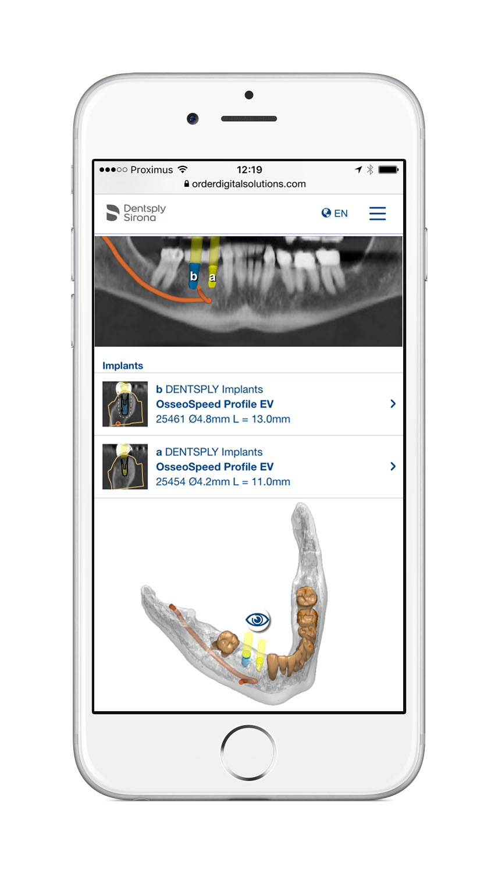 | 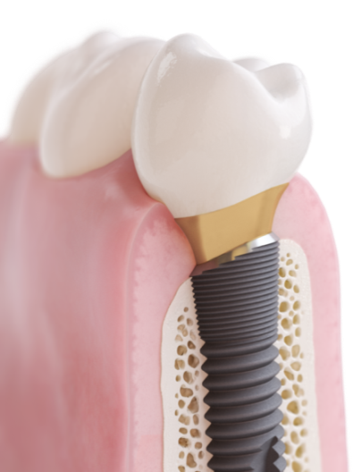
Fig.1: Atlantis CustomBase solution for extraoral cementation | Fig.2: Atlantis suprastructures in additive manufacturing | Fig.3 mySimplant Planning Service | Fig.4: OsseoSpeed Profile EV implant

