Warning: Do not get victimized by the cancer treatment!
Most cancer related deaths are due to the treatment, chosen by your doctor!
50 % of chemo treatment 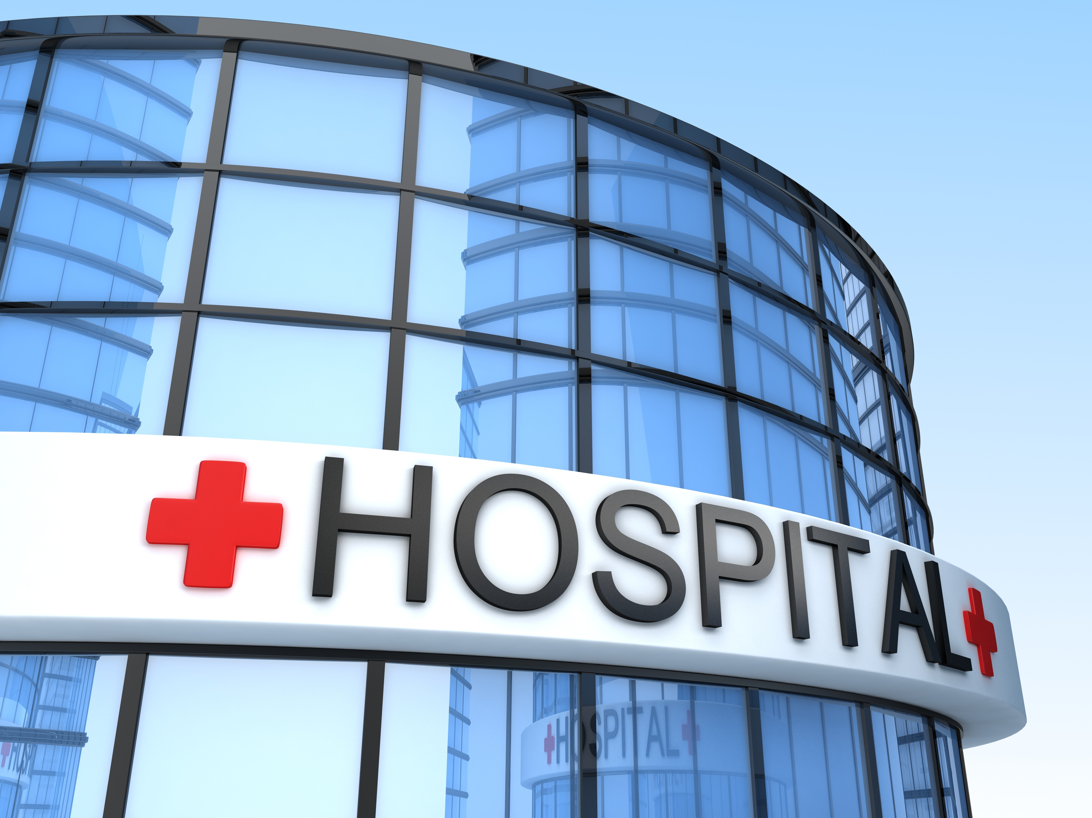 = 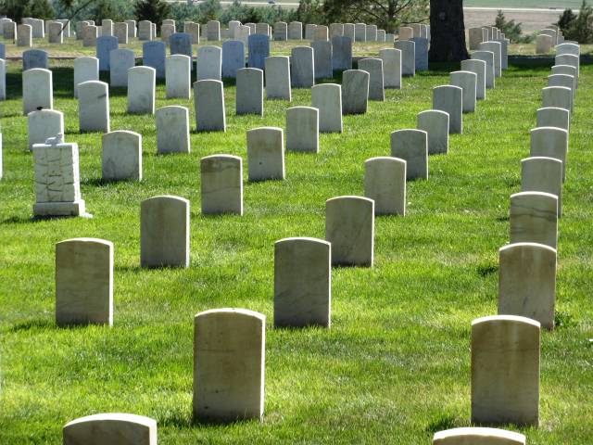
Risk 1 - Patients being killed by the chemo "cure" - not cancer
Recently there was an article in The Lancet Oncology - The Telegraph - The Guardian bringing attention to the fact that hospitals in UK killed up to 50% of their cancer patients with chemo in 30 days. Even if you were to survive this toxins they put into your body, and call a cure, painful side effects can haunt you for the rest of your life.

Risk 2 - Patients dies from dehydration/malnourishment - not cancer
Our experience shows that many cancer patients dies of dehydration and being malnourished, from lack of monitoring and follow up in hospitals.

Why is so many cancer patients choosing toxin instead of non-toxin cancer treatment, and pay with their life ?
Lack of knowledge and not having "the right" information, together with some doctors that are not willing to tell their patients about non-toxic treatments, are the main reasons.

Leaders of Cancer Management are tired of the doctors who accepting the killing of their own cancer patients. This is totally unacceptable, and we demand that doctors are being more responsible and start informing patients about side effects from chemo, and give information about the non-toxic treatments in Caribbean. CM will continue their work to enlighten people through their webpage Cancerphone.com. Cancer patients can find statistics, read about side effects, and learn about non-toxic cancer treatments.

How can patients know which hospital taking life or saving the most lives?
Patients need to understand that doctors in public hospitals give you the treatments "the system" guide them to use, no matter the results and outcome.

Your choice may determine whether you survive or die!
Once you understand the different cancer treatments, you are on the right path to avoid being another victim and on the death statistic. Many cancer patients easily become victims to their disease. This is why chosen the right cancer treatment can be vital for your survival!

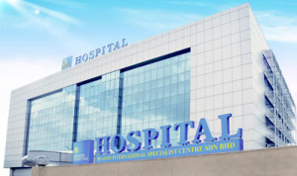
Hospitals can lose as many as 98 % of their cancer patients after years with harsh chemo treatment - nearly zero survivals

Hope4Cancer in Cancun can save 90 % of their patients in 21 days using non-toxic treatments

Examples of your survival options
Choose wisely - It is your life!
Some results compared with the prices
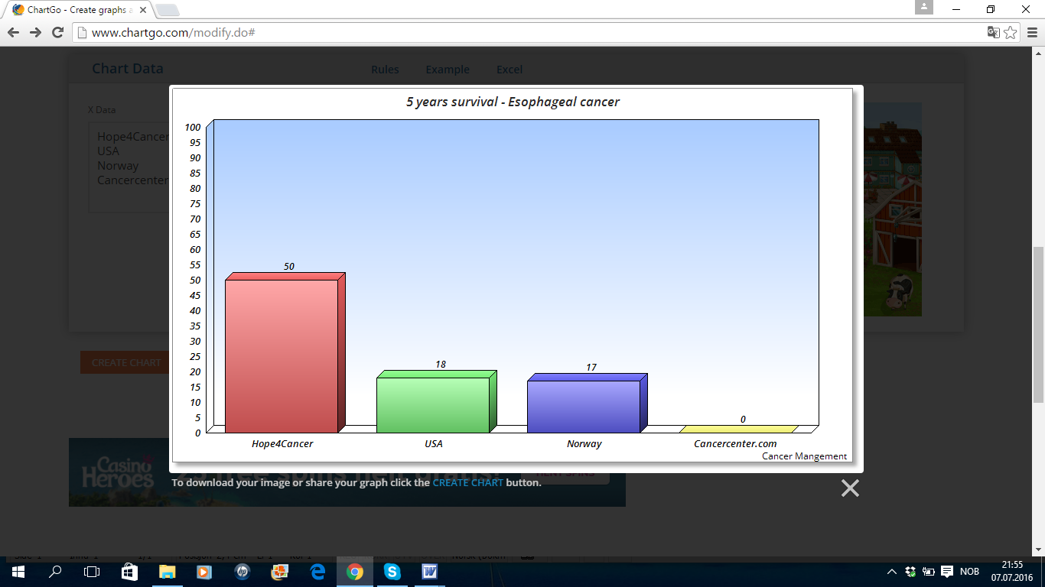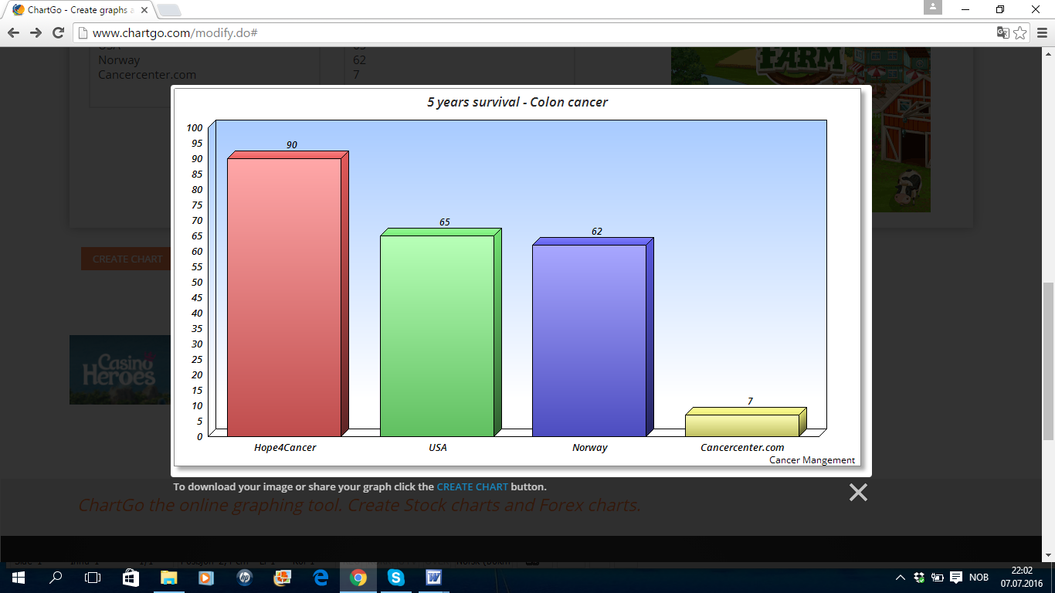

Highest survival with lowest prices
Prices of different cancer treatment clinics

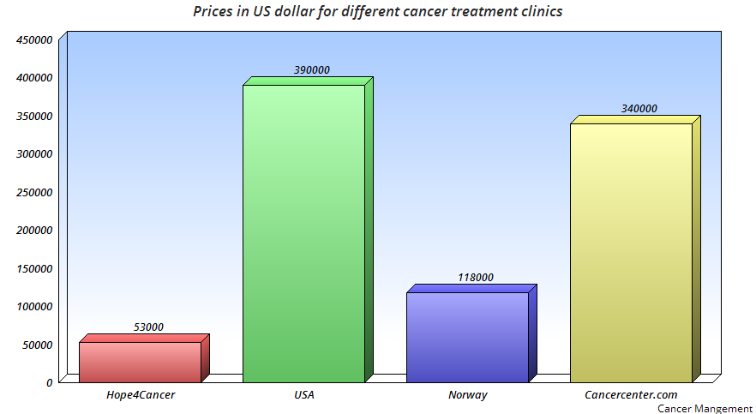
Hope4CancerCancun - 1/5 of the price of hospitals in USA

Cancer Management warning all doctors to use inhuman treatments on their patients. This is not acceptable.

Help your patients find non-toxic treatments that are effective when you do not manage to make them healthier and your treatment fails.
More information - Cancerphone.com

