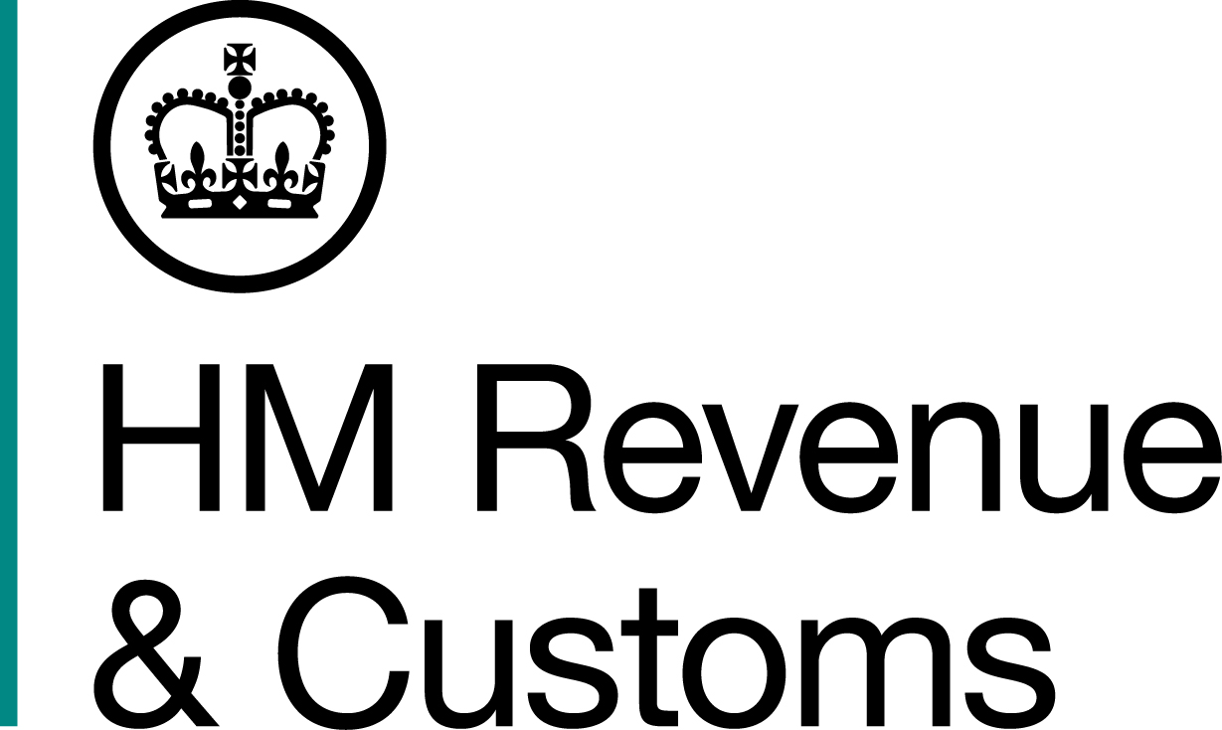
News Release

 | For the attention of News Desks |  | No of pages: 3
 | Date: | 5 Sept 17 | Ref: | NTH 09 17

The ‘Shisha Man’ fraudster jailed

A tobacco smuggler known as the ‘Shisha Man’, who smuggled more than 4,000kg of illegal tobacco products into the UK and then tried to flee the country, has been jailed for 42 months.

Sam Khazaei, of Rooley Lane, Bradford, illegally imported large quantities of shisha tobacco to evade more than £440,000 in taxes, a HM Revenue and Customs (HMRC) investigation revealed.

Five days before he was due to appear in court, Khazaei was arrested by Immigration Enforcement officers at Belfast Ferry Port after he was found carrying fake travel and identification documents. He admitted intending to use the documents to travel to Mexico in an attempt to escape punishment for his crimes.

Angela McCalmon, Assistant Director, Fraud Investigation Service, HMRC, said:

“This was a shameless attack on the UK taxpayer, which undoubtedly harmed legitimate, hardworking businesses. Khazaei was foolish to think he could run from his crimes. He stole money which should have been used to fund our public services and now he is paying the price.

“HMRC will continue to pursue criminals like Khazaei who think stealing from the public is a legitimate way to do business. We urge anyone with information about illegal tobacco to contact us on 0800 788 887.”

Mike Golden, from Immigration Enforcement in Northern Ireland, said:

“My officers quickly identified that the passenger’s documents were fake and thanks to their expertise, Khazaei’s attempts to flee the country and escape justice were stopped.

“The case was passed to officers from Criminal and Financial Investigations who ensured Khazaei was prosecuted for the offence of being in possession of false identity documents. The team also worked closely with HMRC officers.

“This case is testament to the varied work we do to keep the UK safe, and we will continue to work with law enforcement partners to ensure that offenders face the consequences of their crimes.”

The thirty-four-year-old’s scam was revealed after two batches of Al-Fakher branded shisha tobacco totalling 609kg, sent from Austria, were seized at London Heathrow Airport and Manchester Airport Cargo Centre.

Khazaei was arrested at Manchester Airport by HMRC officers when he arrived to collect one of the consignments, which was mislabelled as dry mixed fruits, in November 2014.

Mobile phone evidence revealed Khazaei sold the fruit flavoured tobacco to shisha cafes and other buyers across the UK, including in London, Cardiff, Birmingham, Leicester, Manchester, Leeds and Derby.

One of the customers addressed Khazaei as ‘Shisha Man’.

Enquires with Austrian Customs revealed the illicit goods were imported from Iraq and a raid on a warehouse in Linz, Austria, led to the seizure of 10,000kg of shisha tobacco.

Khazaei tried to flee the country 48-hours before his final court hearing. However his attempt was thwarted by Immigration Enforcement officers who arrested him for having false identity documents including a Greek passport, driving licence and ID card, at Stena Terminal, Belfast Docks, on 9 August 2017.

He was given a three month suspended prison sentence after he admitted possession of a false identity documents at Belfast Magistrates’ Court on 14 August.

Investigations by HMRC revealed Khazaei illegally imported 4,381kgs of shisha tobacco, worth £441,314 in duty taxes, between February and November 2014.

Khazaei admitted 13 counts of excise fraud at Manchester Crown Court on 31 May 2016 and was sentenced to 42 months in prison at the same court today (5 Sept 2017).

Notes to Editors

- Sam Khazaei, of Rooley Lane, Bradford, DOB 16/12/1982, was sentenced to 42 months in prison for 13 counts of excise fraud.
- He was given a three month prison sentence, suspended for two years, for the possession of false identity documents at Belfast Magistrates’ Court on 14 August.
- Shisha tobacco is also known by the following terms:
- Waterpipe tobacco
- Hookah pipe tobacco
- Sheesha tobacco
- Nargile/Narguile
- Flavoured tobacco

- Follow HMRC Press Office on Twitter @HMRCpressoffice.
- HMRC's Flickr channel: www.flickr.com/hmrcgovuk.

Issued by HM Revenue & Customs Press Office

Press enquiries only please contact:
Paul Conroy
Tel: 07469 022985
Email: paul.conroy1@hmrc.gsi.gov.uk

Or

Helen Danson
Tel: 03000 541066
Email: helen.danson@hmrc.gsi.gov.uk

Out of hours
Tel: 07860 359544
Website www.gov.uk/hmrc

