FOR IMMEDIATE RELEASE

Intellian’s v60Ka 2 and v100NX Ka antennas
gain type approval from Telenor Satellite

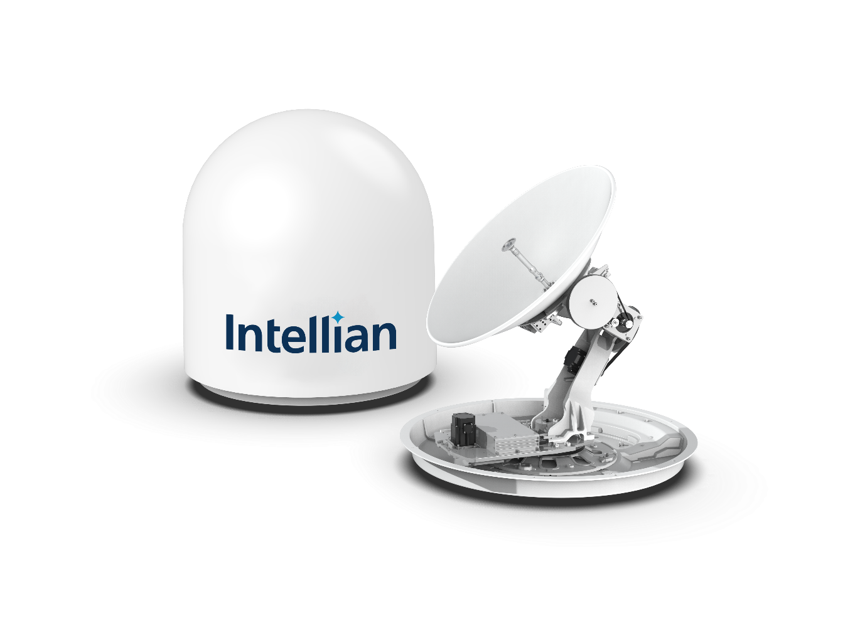
Intellian’s v60Ka 2 (above) and v100NX Ka antennas are now approved for the THOR 7
satellite network

18 November 2020 – Intellian is pleased to reveal that two of its industry-leading antenna systems, the v60Ka 2 and v100NX Ka, have gained type approval from Telenor Satellite for use on their THOR 7 Ka-band GEO satellite network. This means that the systems are now officially certified to take their place in service alongside Intellian’s v85NX, the first 85cm antenna to receive type approval on the network.
The Intellian v100NX Ka delivers market-leading RF performance and is future-proofed with a specially-tuned radome and reflector in anticipation of forthcoming 2.5GHz wideband Ka network services. Like all NX Series antennas, the v100NX Ka supports multi-orbit operation and can be simply converted between Ka and Ku bands, allowing owners of existing v100NX Ku-band antennas to easily switch to the THOR 7 network if desired. An optional 10W BUC upgrade provides a straightforward means of further boosting the antenna’s performance.
The compact, affordable, 65cm v60Ka 2 weighs only 39kg and is based upon the same platform as Intellian’s NX Series antennas. Available in both 5W and high-power 10W BUC configurations for high-bandwidth users, the v60Ka 2 offers best-in-class RF performance to provide incomparable data rates for this antenna size.
The Below Deck Units (BDUs) for both antenna systems have the THOR 7 modem built in and feature embedded mediators, enabling easy configuration of a dual-antenna setup to avoid potential interference from a vessel’s superstructure. Shipped pre-slung and with dome-on connection via a single coaxial cable which combines Tx, Rx and DC power, the antennas can be installed swiftly, with the process further simplified by a step-by-step commissioning wizard integrated within the AptusNX management and control platform. Easily accessible via a web interface, AptusNX also enables remote diagnosis to be carried out and issues timely predictive maintenance alerts.
The antennas use Intellian’s standardized modular components, which speeds up repairs and lowers spare part stock requirements for service providers by up to 40%. These attributes all contribute to considerable savings in both time and expenditure, thereby lowering the total cost of ownership.
Active since 2015, the THOR 7 HTS Ka-band mobility VSAT service provides full satellite coverage for key pan-European shipping routes throughout the Mediterranean Sea, North Sea, Red Sea, Norwegian Sea, Baltic Sea, Barents Sea and Persian Gulf, deploying up to 25 highly-focused, simultaneously active spot beams for seamless handover. “It’s a pleasure to be able to expand our service provision options with Intellian’s v60Ka 2 and v100NX Ka systems,” says Jan Hetland, Director, Data Services, Telenor Satellite. “The Intellian v85NX has proven itself to be a popular, powerful, reliable and cost-effective choice since it gained type approval in May this year, and it’s rewarding to consolidate our working relationship with a company whose reputation for high-quality technology and drive to innovate correlates so closely with our own.”
“We’re very proud to have another endorsement of our products with this certification from Telenor Satellite,” says Jon Harrison, Intellian VP & GM Strategic Accounts and EMEA BU. “The company’s type approval for the v60Ka 2 and v100NX Ka marks another positive step in our mutual quest to provide the best-performing, most flexible maritime mobility VSAT service in Europe at the most competitive price.”
-Ends-

For further enquiries, please contact:
Paul Comyns / VP of Marketing
Intellian Technologies USA
T + 1 949 727 4498 ext. 1301
Paul.Comyns@intelliantech.com

David Pugh
Saltwater Stone
T +44 1202 669 244
d.pugh@saltwater-stone.com
Sadie Brown / Marketing Manager
Intellian Ltd
T +44 2380 019 021 ext. 1612
Sadie.Brown@intelliantech.com

Natalia Grøvan / Head of Marketing and Communications
Telenor Satellite
Mob: +47 995 04 642
Natalia.groven@telenor.com

About Intellian Technologies
Intellian is a leading global technology and solutions provider for satellite communications, empowering connectivity for the maritime, government, military, energy, cruise and enterprise sectors. Founded in 2004, Intellian is renowned for its innovative design, future-proofed technologies and outstanding customer support, which combined with continued investment in its partners, logistics network, quality control and low environmental impact production facilities make it a trusted enabler within the satellite communications industry. Its bold, pioneering solutions include the award-winning v240MT – the world’s first tri-band, multi-orbit antenna system – and the future-proof NX series antennas, optimized for high performance and low cost of ownership.
Intellian has a global presence with over 400 employees, 10 global offices and five logistics centers on three continents. Intellian Technologies Inc. is listed on the Korean Stock Exchange, KOSDAQ (189300:KS)
About Telenor Satellite
Telenor Satellite is Europe's most versatile satellite operator, serving customers with premium, high-quality Broadcast and Data Services for maritime and land-based connectivity throughout Europe, the Middle East, North Africa and the Caribbean from its prime position at 1º West. Telenor Satellite serves over 18 million homes, nearly 1,600 vessels, 600 land terminals and delivers services to more than 400 broadcasters. telenorsat.com

