**PRESS RELEASE**

Contact Details:

For more information, contact Mike Williams, CEO on 07748620235 or newsdesk@ukbjja.org

**12 December 2018**

**\*For immediate release\***



**UKBJJA International Open Tournament of Brazilian Jiu Jitsu**

​​On 16 December 2018, the town of Motherwell will play host to some of the best Brazilian Jiu Jitsu (BJJ) competitors in the world at the 1st UKBJJA International Open Tournament.

Held at Ravenscraig Regional Sports Facility the event is the most prestigious BJJ event ever to be held in Scotland, with a total prize fund of £20,000.

Black belt competitors from Brazil, Poland, Norway, Sweden, Portugal and beyond will take on local Scottish athletes and competitors from across the UK in an attempt to walk away with the top prize of £2000.

In addition, there are cash prizes for the brown belt, purple belt and blue belt divisions, along with prizes for the white belt open weight final provided by official sponsor, Tatami Fightwear.

Alongside the adult competition, the junior tournament will see the rising young stars of the sport test themselves against youngsters from across the UK.

The tournament officially opens at 9:15 am on Sunday 16 December, with a short opening ceremony which will be attended by Jean Jones, Provost for North Lanarkshire Council and by Motherwell & Wishaw MSP, Clare Adamson

Spectator tickets cost £5 and all proceeds from ticket sales go to [Cash4Kids Mission Christmas.](http://www.cashforkids.uk.com/mission/)

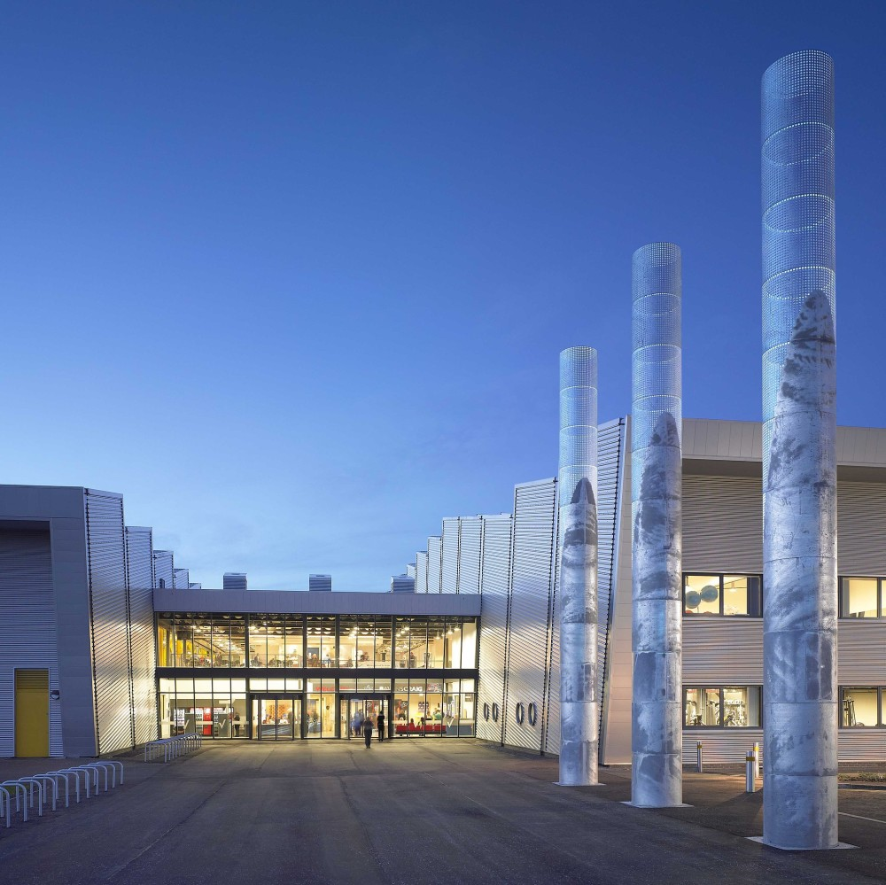Ravenscraig Regional Sports Facility (photo: Muchobenny, from Wikimedia Commons

For more information, please contact Mike Williams, CEO, on 07748620235 or [ceo@ukbjja.org](mailto:ceo@ukbjja.org)

* ENDS *

About the UKBJJA:

The UKBJJA ([www.ukbjja.org](http://www.ukbjja.org)) is a not-for profit organisation which aims to provide a governance structure for the martial art of Brazilian Jiu-Jitsu, that promotes and develops the sport while allowing individual clubs and practitioners the space and freedom to practice the martial art in the way they enjoy. The UKBJJA is currently under assessment to be recognised by Sport England as the governing body for Brazilian Jiu Jitsu in the UK.

The UKBJJA was formed in 2013, and the association’s goal is to foster the development of BJJ at elite, community and grassroots levels, raising the profile of the sport but also providing pathways for development and involvement across communities in the UK. Visit UKBJJA at www.ukbjja.org or follow us on Twitter @ukbjja.

Contact Details:

For more information, contact Mike Williams, CEO on 07748620235 or newsdesk@ukbjja.org