Jessica Bäckman Vice Champion in ADAC TCR Germany 2022
The season finale of the ADAC TCR Germany was held last weekend, October 21-23rd, at the Hockenheimring track in Germany. Jessica Bäckman had a tough start to the weekend with a serious crash in the second practice which followed up with broken wheel suspension in Race 1, but despite this managed to turn the page and secure the Vice Title in the ADAC TCR Germany Championship 2022.
- It was really tough weekend, but I'm incredibly proud of myself and the whole team that we managed to turn everything around in the last race of the season, nice to take home the Vice Championship from this season which has been my best ever but at the same time a season with a lot of setbacks. It bodes well for the future, Jessica Bäckman says.
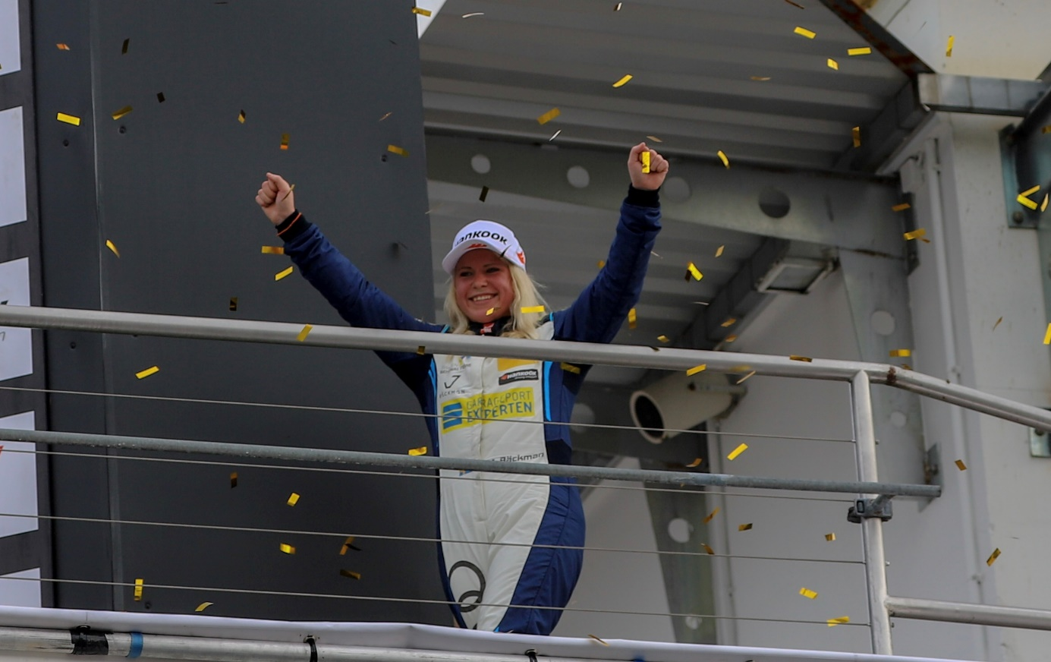
ADAC TCR Germany is one of the toughest TCR series in the world and has a high status for the drivers who come from several different countries around Europe. Each race weekend consists of two free practice sessions on Friday, one qualifying session on Saturday which determines the starting position in Race 1 on Saturday, and one qualifying session on Sunday which determines the starting position in Race 2 on Sunday. Points are awarded to the top 8 in the time qualifying and the top 15 in each race. The driver with the most points after the final race at the Hockenheimring at the end of October will take home the "ADAC TCR Germany Drivers Title" in the ADAC TCR Germany series. The season started at the Oschersleben track in Germany where Jessica took her first win of the season and ended the last weekend at the well-known Formula 1 track Hockenheimring in Germany where Jessica, who races for Comtoyou Racing in an Audi RS3 LMS car, managed to take the Vice Title in the drivers' championship after an exciting last race.
- It has been a tough weekend with a lot of setbacks, but in the end, I am very satisfied that I managed to take the Vice title in the drivers' championship after an exciting final race. I have developed a lot as a driver throughout the season and have been in situations that I have never experienced before in a racing car. Then that I manage to be 2nd in ADAC TCR Germany 2022 despite all the setbacks and technical problems is clearly approved, Jessica Bäckman says.
Jessica started the weekend in the wall after a big crash on Friday
The weekend started on a wet surface. In the second practice, Jessica pushed hard to get good times and was one of the fastest cars on the track. But after entering a corner a little too fast, Jessica got a big oversteer and then ended up into the wall where most of the car collapsed. The team tried everything they could to get the car together for qualifying three hours later and tried but didn't have enough parts. Where half the team had to go to the Nürburgring to get more parts for the car. Then for Race 1 on Saturday, Jessica's car was ready to go. The Sweden National Team driver started from last position because she did not run the qualifying and did an impressive race. When there were 5 minutes left in the race, Jessica was in fourth place and had her sights set on a podium. But then the unthinkable happened, the wheel came off the car and Jessica had to stop the race and lost even more points in the championship. The team then worked very hard to get the car back together for Qualifying 2 on Saturday afternoon where Jessica qualified in third place, which also became her starting position for Sunday's Race 2.
-I came to Hockenheim with a 38-point lead over the guy who was third in the championship. But he ate up those points quickly when I had setback after setback. Before Race 2 on Sunday, only one thing mattered. If Ladniak won the race, I had to finish at least 2nd otherwise he would win the Vice title in the championship, Jessica Bäckman says.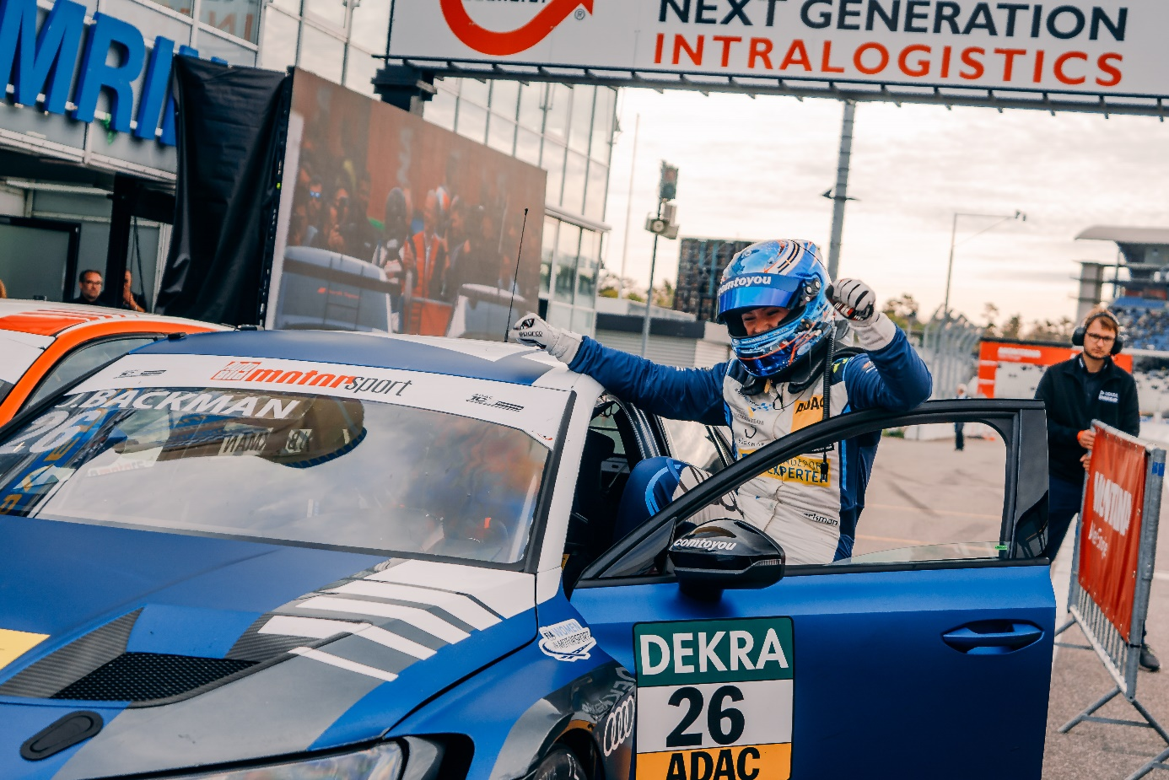
Jessica did not crack under pressure and secured the Vice Championship in TCR Germany
Jessica started in third position behind Ladniak who started from Pole Position and his teammate Martin Andersen started 2nd. Jessica got off to a good start and was up to second place already in the first corner and was then heavily pressured by Andersen from start to finish. In the end, Jessica managed to handle the pressure in the 18-lap race and finish second in the Drivers' Championship after an impressive season.
- In race 2 I had a task to take care of and I managed that task, so incredibly fun that we managed to turn around a tough weekend together, big thanks to the Comtoyou Racing team for very good teamwork all weekend and for a very fast car, Jessica Bäckman says.
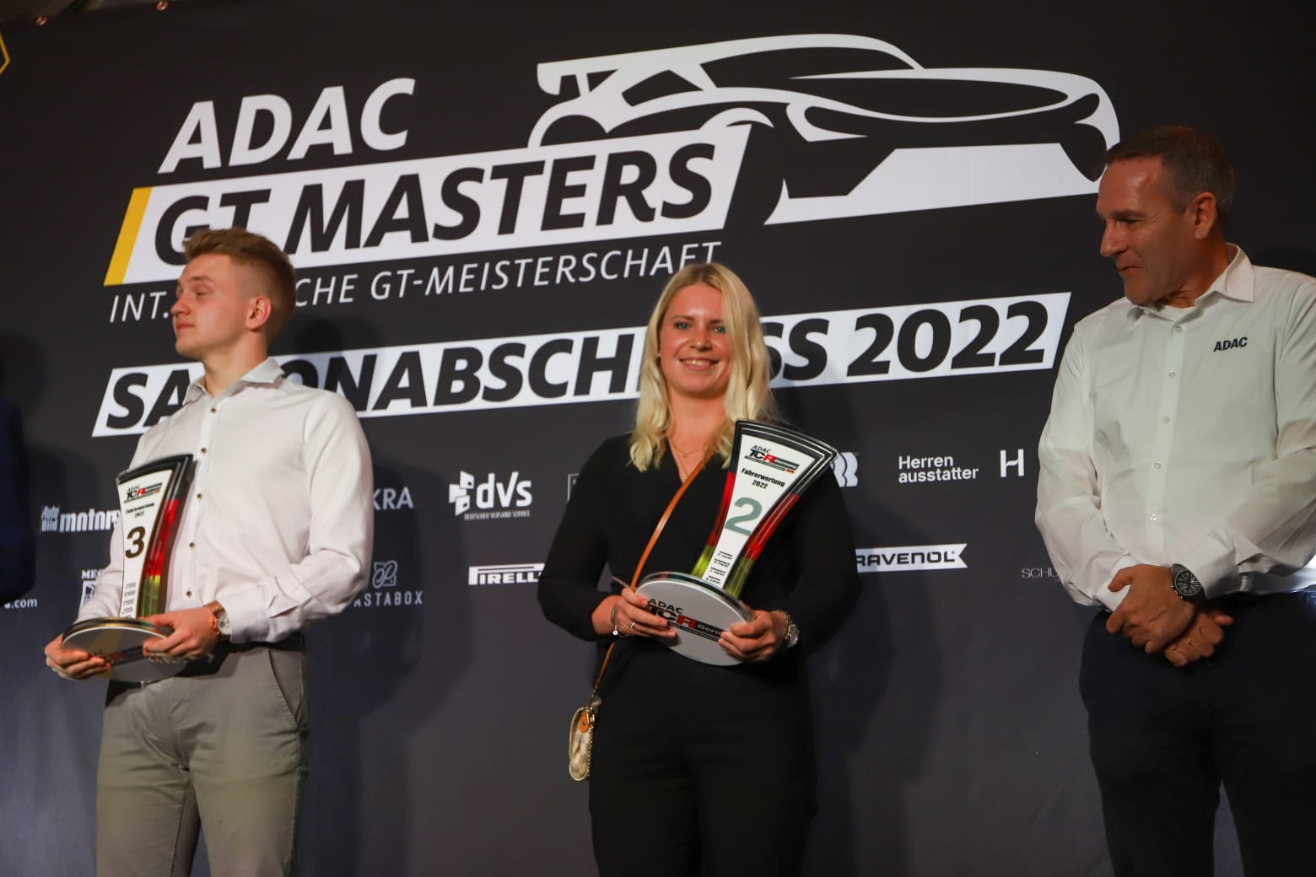
Jessica Bäckman is historical
With Jessica's Vice Title in ADAC TCR Germany, she makes history as the most successful female driver in ADAC TCR Germany and the only woman to take a top 3 position in the drivers' championship. With a total of 4 wins, 9 podiums, 2 pole positions and 3 fastest laps, the Sweden National Team driver summarizes the season.
-In summary, it has been an incredibly good season. I had two goals when I started the season, it was to get my first win which I managed already in the season opener at Oscherleben in Germany and after that the wins just kept rolling in. Then another goal was to fight for the top 3 positions in the championship and I succeeded in that too. I have achieved and exceeded all goals this season so I am very happy and proud. Very good teamwork behind the season so would like to thank everyone involved, Jessica Bäckman says.
Jessica’s results:
Free Practice 1: 10th place
Free Practice 2: 5th place
Qualifying 1: DNS
Race 1: DNF
Qualifying 2: 3rd place
Race 2: 2nd place
Championship standings:
ADAC TCR Germany – Total (Top three)
ADAC TCR Germany 2022 (after 7 out of 7 raceweekends)
1: Martin Andersen (DKK), 420 p.
2: Jessica Bäckman (SWE), 313 p.
3: Szymon Ladniak (POL), 311 p.
TV links in case you missed last weekend’s races:
Click to watch Race 1
Click to watch Race 2
Free rights to use images.

