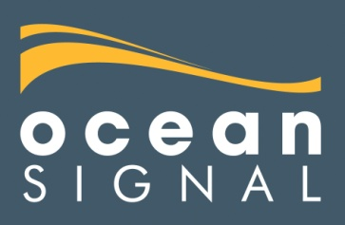
7th August 2019 | FOR IMMEDIATE RELEASE

PLB ACTIVATION SAVES WOUNDED TRANSCONTINENTAL HIKER

An unlucky stumble in a remote part of northern Norway might
have ended badly for hiker Karma Forester, but activating her
Ocean Signal rescueME PLB1 brought help in two hours
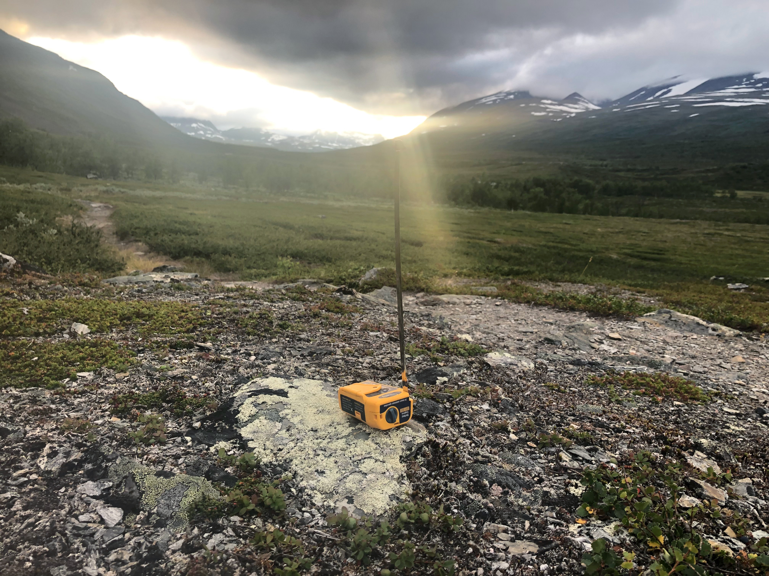
Swathed in a sleeping bag and a purple jacket, a hiker sits smiling at the camera. Next to her, a small yellow device sits on a rock, antenna extended, flashing a reassuring strobe light at two-second intervals.
The hiker is Karma Forester, and she’s in the Dividalen National Park in northern Norway, 33km from habitation and 80km from medical assistance. She has tripped, falling on a sharp rock and cutting her knee to the bone.
The device is an Ocean Signal rescueME PLB1 Personal Locator Beacon. This far from civilisation and miles from the nearest mobile phone mast, it’s the only reason that Karma can rest easy. Within two hours, a helicopter will land next to her and take her to hospital.
Karma comes from Sweden and her partner Scott Taylor from New Zealand. They describe themselves as ‘nomadic’, and after finding that it would take the Swedish authorities two years to decide whether Scott could settle in the country, making it impossible for them to live together in one place, they opted to hike between their two countries.
Walking the world might sound ambitious, and it is, but the couple are well prepared. They both have significant long-distance hiking experience, including completing the 4,265km Pacific Crest Trail in 2018. At the time of the accident, they had been on the trail for 28 days and completed 643km. Karma described the incident: “It was a very undramatic stumble on a non-technical section of the trail. We had already hiked 29km that day, so I was probably getting a little tired. I landed knee-first on a very sharp rock, splitting open my whole knee.”
“As soon as we realised the severity, we activated the Personal Locator Beacon (PLB). Then we wrapped the wound in sterile bandages. We always carry a compact first-aid kit and we were complimented by the doctors on how we took care of the injury in the field.”
Karma chose the Ocean Signal rescueME PLB1 because of its light weight, small size and global, subscription-free coverage. “I often hike in remote areas where I cannot rely on having cell phone reception,” she said. “I always carry a Personal Locator Beacon for personal safety and peace of mind for my family, but also out of respect for Search and Rescue teams who don’t have to waste time searching for me if I should go missing.”
A Norwegian Army helicopter arrived within two hours and airlifted Karma to a hospital, where the wound was investigated and closed with nine stitches. Karma and Scott hope to resume their journey in as little as four weeks. “Due to the fast response and rescue thanks to the PLB and Norwegian authorities, my recovery time will be shorter, the result more likely to be good, and I will be able to return to the trail sooner,” she said. “It was a very unlucky fall, but a lucky wound in the sense that it could have turned out so much worse.”
To view a video of the helicopter rescue, visit Reboot Life on YouTube. To find out more about Karma and Scott’s adventure, visit rebootlife.me, or find them
on Facebook @reboot.life.me.
For further information about Ocean Signal’s products, visit www.oceansignal.com.
Ends
Notes for editor

About the rescueME PLB1
Suitable for use on land or at sea, Ocean Signal’s rescueME PLB1 is the world’s smallest personal locator beacon and is specifically designed to be small and light enough to carry or attach to clothing for instant access to emergency services at the press of a button. Once activated, the PLB1 communicates the location of a survivor to search and rescue services via the designated 406MHz Cospas-Sarsat satellite system with position provided by a 66 channel GPS. The device also incorporates a 121.5MHz homing beacon, plus high intensity (1 candela) strobe light. It is waterproof up to 15m and has a seven-year battery life.
Ocean Signal provides a free replacement beacon for all owners of its rescueME and SafeSea devices who activate their PLB or EPIRB in an emergency.

For further information, please contact:
James Hewitt Jules Riegal
Ocean Signal Saltwater Stone
Tel: +44 (0)1843 282930 Tel: +44(0)1202 669244
E-mail: james.hewitt@oceansignal.com E-mail: j.riegal@saltwater-stone.com
www.oceansignal.com www.saltwater-stone.com

About Ocean Signal
Communication and safety at sea specialist Ocean Signal™ is dedicated to providing the technology and quality of product that will set industry standards.
Ocean Signal’s product portfolio consists of the rescueME range of products, including the rescueME PLB1, the rescueME MOB1, the rescueME EPIRB1 and the rescueME EDF1 electronic distress flare, plus the AIS Alarm Box and the SafeSea range of GMDSS products, including the E100 and E100G EPIRB, S100 SART and V100 handheld VHF radio, as well as the M100 and M100X professional MSLD and E101V float-free EPIRB with integrated voyage data record memory capsule. They provide both recreational and commercial mariners with simple to use, compact and affordable life-saving solutions. All products are engineered by a highly experienced team of marine electronics professionals.
Safety and communication products from Ocean Signal offer exceptional value, meeting or exceeding international technical and safety standards. Careful design and innovation provide commercial shipping, fishing and recreational users with the confidence that their Ocean Signal equipment will both meet and exceed their expectations when it is needed most.

