PRESS RELEASE
A Hearty Celebration of International Flavours
With Pacific Marketplace’s Revitalised Menu
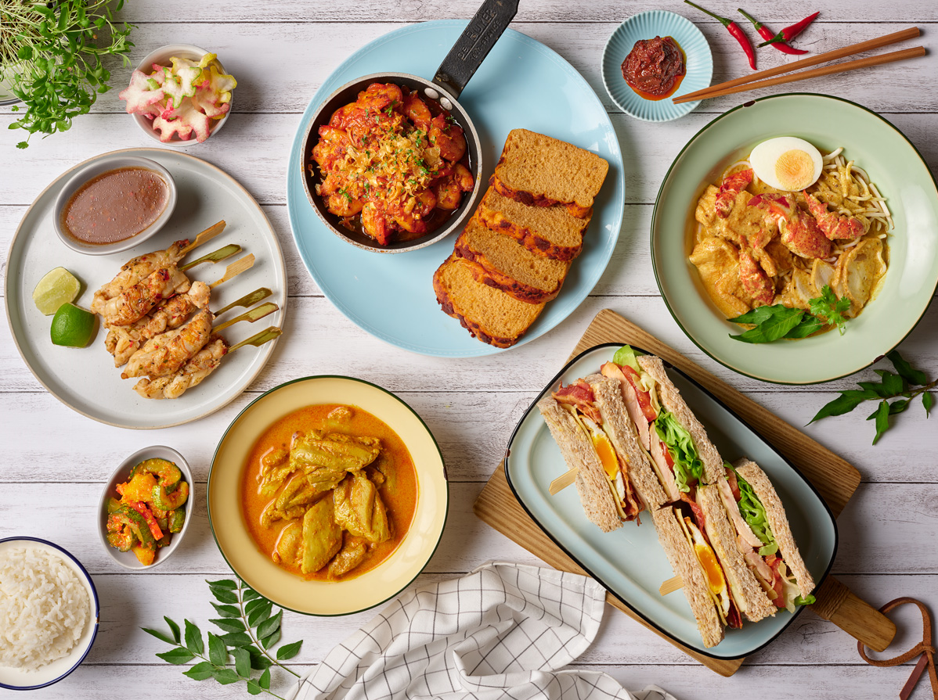
Singapore, 4 April 2019 – This coming 8 April, patrons of Pacific Marketplace will be able to please their palates with the gourmet café’s revamped dining menu, indulging in a tasty assortment of Asian favourites, salads, sandwiches as well as internationally-inspired sharing dishes in an exclusive and relaxing ambience.

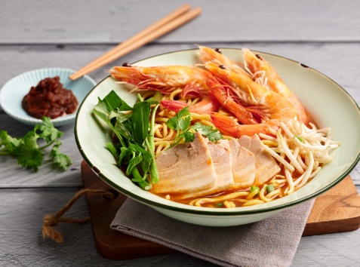
Flavourful Asian Delights
Pacific Marketplace serves an excellent array of popular Asian Delights that are reminiscent of heritage flavours. A must-try is the newly introduced Penang-style Prawn Noodle Soup boasting tantalising ingredients of sweet fleshy Tiger prawns, succulent pork belly and crunchy water spinach. To prepare the delightfully flavourful broth, tiger prawn heads are sautéed till fragrant then simmered for six hours. Diners will also love the comforting Wonton Noodle Soup, made with fragrant homemade char siew and chewy egg noodles.

Well-loved signature delicacies of aromatic Nyonya Chicken Curry, Lobster Laksa, Rickshaw Noodles and the meat-free Mixed Mushroom and Tofu Noodles are still available for enjoyment.

Refreshing Salads
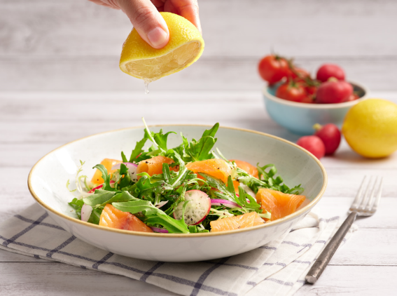
For diners who prefer a lighter and healthier dish, a delicious variety of fresh flavourful salads are available at Pacific Marketplace. A refreshing new addition to the repertoire is the Loch Fyne Salmon salad which features a harmonious blend of ingredients including homemade lemon dressing made with lemon juice and honey mustard, premium Loch Fyne smoked salmon providing a subtle sweet flavour and freshly tossed greens.

Comforting Gourmet Sandwiches
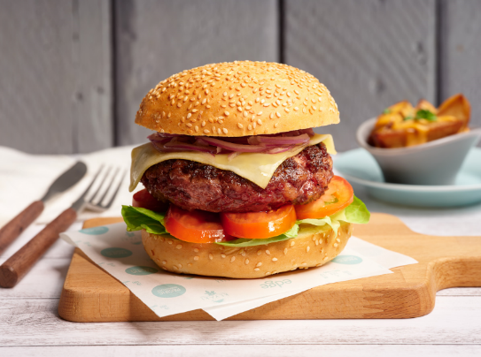
Pacific Marketplace’s refreshed menu features a mouth-watering selection of sandwiches crafted with quality ingredients and using bread freshly-baked in-house. A noteworthy highlight is the finger-licking good yet meat-free Impossible™ burger, featuring tasty patties derived from plants. A winning combination of grilled onions, cheese, pickles, lettuce, tomatoes and umami miso mustard spread, take the taste up a notch.

Diners can also get their burger fix with the sumptuous Wagyu Beef Burger which features juicy grilled beef patties paired with spicy sweet mango chutney to balance the flavours.

Another sandwich specialty is the classic Reuben, where toasted caraway seed rye bread is stuffed with homemade smoked beef brisket, gruyere cheese, sauerkraut and Russian dressing.

Delicious Sharing Dishes
Perfect for enjoyable communal dining with friends and loved ones, Pacific Marketplace’s myriad of sharing dishes from the Provence, Middle Eastern and Asian regions will enhance any gathering.

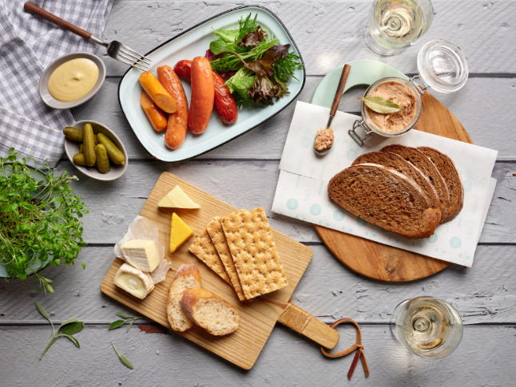
On top of the popular highlights of Homemade Sausage Platter, French Black Mussels, Hummus and Baba Ganoush as well as Lemongrass Crayfish Skewers, diners will now have the opportunity to enjoy the specialty Pork Rillette. Specially crafted by Pan Pacific Singapore’s in-house Master Butcher Kurt Roelli, the rillette is created using a variety of spices including Nutmeg, Thyme, Rosemary and Paprika. This requires a laborious one-day process of cooking the meat, smashing, mixing the meat with spices, fat and sauce then finally coating the delicacy with a thin layer of lard.

For a complete dining experience, an assortment of exquisite desserts from the Pâtisserie Counter is also available for enjoyment.

This dining menu is also available at Atrium. For the full menu, please click here.

Time: 11:00am to 10:00pm daily (sharing dishes are only available from 6:00pm to 11:00pm)
Prices: Asian Delights start from SGD14, salads start from SGD16, sandwiches start from SGD17, sharing dishes start from SGD13
Venues: Pacific Marketplace and Atrium (Ground Level), Pan Pacific Singapore, 7 Raffles Boulevard, Singapore 039595

Prices may vary during special occasions determined by the hotel, unless otherwise stated. All prices are subject to 10% service charge and 7% GST, unless otherwise stated.

For dining reservations and enquiries, please speak with us at +65 6826 8240 or email dining.ppsin@panpacific.com.

High-resolution Images can be downloaded here.

Media Contact
Ms. Gillian Teo
Assistant Director
Pan Pacific Singapore
E-mail: gillian.teo@panpacific.com
Tel: +65 6826 8095

Melissa Ng
Senior Marketing Communications Executive
Pan Pacific Singapore
Email: melissa.ng@panpacific.com
Tel: +65 6826 8094
Hotel Facebook: https://www.facebook.com/panpacificsingapore
Hai Tien Lo Facebook: https://www.facebook.com/HaiTienLo.Singapore
Twitter: https://twitter.com/panpacificsgp
Instagram: http://instagram.com/panpacificsingapore

Pan Pacific Hotels and Resorts
With hotels, resorts and serviced suites across Asia, Oceania and North America, Pan Pacific provides a safe harbour in an ever-changing world. Places with less to worry about because, when you stay with us, rest assured that all will be taken care of. For this is where you will find your balance.

Pan Pacific Hotels Group
Pan Pacific Hotels Group is a wholly-owned hotel subsidiary of Singapore-listed UOL Group Limited, one of Asia’s most established hotel and property companies with an outstanding portfolio of investment and development properties.
Based in Singapore, Pan Pacific Hotels Group owns and/or manages 40 hotels, resorts and serviced suites with more than 12,000 rooms including those under development in Asia, Oceania, North America and Europe.

Voted “Best Regional Hotel Chain” by readers in Asia in 2017, Pan Pacific Hotels Group comprises two acclaimed brands: its signature brand, Pan Pacific and its deluxe brand, PARKROYAL.

Sincerity is the hallmark of Pan Pacific Hotels Group. The Group is known to its guests, partners, associates and owners for its sincerity in people and the sense of confidence which alleviates the stresses of today’s complex world.

About Pacific Marketplace
This gourmet grocery and café provides classic three-tier afternoon tea, croissants and pastries, as well as an extensive selection of cakes, chocolates, Asian delights, sandwiches and salads. The hotel’s signature Pan Pacific sausages and other exquisite deli goods are available for purchase at pacificmarketplace.sg.

