**THE HISTORY® CHANNEL TO PREMIERE NEW SERIES *GREAT ESCAPES WITH MORGAN FREEMAN***

**ON MONDAY 14 MARCH AT 21.00**

**NEW AND EXCLUSIVE TO THE HISTORY® CHANNEL THIS MARCH**

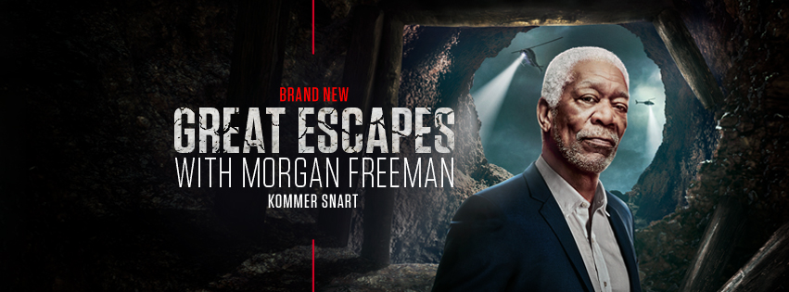

**HOSTED BY FREEMAN AND PRODUCED BY HIS PRODUCTION COMPANY REVELATIONS ENTERTAINMENT SERIES TO SHOWCASE HISTORY’S GREATEST PRISON ESCAPES**

**STARTS MONDAY 14 MARCH AT 21.00 (8x1hr)**

Website: <https://www.historytv.dk/da> | <https://www.historytv.no/nn> | https://www.historytv.fi/fi

The HISTORY Channel social pages Facebook [@HISTORYdanmark](https://www.facebook.com/HISTORYdanmark) [@HISTORYnorge](https://www.facebook.com/HISTORYnorge)

#GreatEscapes

LONDON, UK – 21 February, 2022 – The HISTORY® Channel will premiere the new nonfiction series ***Great Escapes with Morgan Freeman,*** hosted and executive produced by the Academy Award®-winning actor, on Monday 28 February at 21.25. Produced by Freeman and producer Lori McCreary’s production company, Revelations Entertainment, the eight one-hour episode series will reveal in detail history’s greatest escapes from some of the most notorious prisons in the world.

Famous jailbreaks are the stuff of legend as their true stories are often untold. Now, with dramatic recreations, dynamic storytelling and cutting-edge visual effects, escapes from infamous prisons like Alcatraz will come to life in graphic detail. Hosted by Freeman, each episode will unearth every step of an inmate’s meticulous plan, the escape route and the intense manhunt that immediately followed. Episodes will feature escapes from prisons ranging from Alcatraz, Clinton Correctional Facility in Dannemora, NY, the HM Maze Prison in Northern Ireland, to the Brushy Mountain State Penitentiary in Tennessee and more.

The brand-new and exclusive 8-part series ***Great Escapes with Morgan Freeman*** premieres on The HISTORY Channel on Monday 14 March at 21.00.

**Programme Information**

**Episode One: Great Escapes with Morgan Freeman - Alcatraz TX Date: Monday 14 March**

Four men conspire to break out of one of the most notorious prisons in American history. Three make it to the water's edge... but what happened to them when they left the island remains a mystery to this day.

**Escapes with Morgan Freeman - North Country Breakout TX Date: Monday 21 March**

Stuck in prison on life sentences, two men used engineering smarts and psychological manipulation of several prison employees to escape Dannemora Prison.

**Episode Three: Great Escapes with Morgan Freeman - El Chapo TX Date: Monday 28 March**

El Chapo became one of the most notorious and murderous drug cartel kingpins in modern history. His audacious escapes from maximum-security prisons in Mexico became the stuff of legends. He is now in a US supermax prison in Colorado where he is remanded to this day.

**Episode Four: Escapes with Morgan Freeman - Conquering The Wall TX Date: Monday 4 April**

Six men, led by the mastermind, Nuno Pontes, escaped Pittsburgh State Penitentiary by tunnelling to freedom under the massive wall of the prison. They made it as far as Texas before being caught and returned to prison.

**Episode Five: Great Escapes with Morgan Freeman - Escaping Hitler TX Date: Monday 11 April**

Allied prisoners used all kinds of forgery and engineering tactics to tunnel out of a German Prisoner of War camp. Almost all were caught, fifty were executed and three made their way to freedom.

**Episode Six: Great Escapes with Morgan Freeman - Belfast Breakout TX Date: Monday 18 April**

Almost forty prisoners locked up in HM Maze prison for actions undertaken as members of the IRA, escaped in a food truck. Many were caught right away, some years later, and some were never seen again.

**Episode Seven: Great Escapes with Morgan Freeman - Fleeing Hellmira TX Date: Monday 25 April**

Two desperate murderers made an audacious rooftop escape from the forty-foot-high Elmira State Prison.

**Episode Eight: Great Escapes with Morgan Freeman - Assassin's Flight TX Date: Monday 2 May**

James Earl Ray, confessed killer of Martin Luther King Jr was a notorious escape artist. His most audacious escape involved manufacturing a ladder made of plumbing pipe and going over the wall of the Brushy Mountain State Prison.

**ENDS**

**For more information please contact:**

Jo Fellows at A+E Networks UK / [Joanna.Fellows@aenetworks.co.uk](mailto:Joanna.Fellows@aenetworks.co.uk) / +44 7583 022 665

**Editor’s Notes**

* All information correct at time of writing
* Key art available [here](https://www.dropbox.com/sh/mdpum28w4nbu9sw/AAD8dG_eXLfZQeoS_Tjsfftba?dl=0)
* Watch promo [here](https://youtu.be/OwM-grMKpqI)
* Digital asset promos available to use/embed [here](https://www.dropbox.com/sh/mdpum28w4nbu9sw/AAD8dG_eXLfZQeoS_Tjsfftba?dl=0)
* Interviews with production team available on request
* Social – Facebook [@HISTORYBenelux](https://www.facebook.com/HISTORYBenelux); Instagram [@HISTORYBenelux](https://www.instagram.com/historybenelux/)
* Website: <http://www.history.nl/>

**About The HISTORY® Channel**

The HISTORY Channel is the flagship brand of the A+E Networks UK portfolio which is made up of true crime channel Crime+Investigation®, entertainment channel Lifetime®, HISTORY2TM and free to air channel BLAZE®.

**About A+E Networks UK**

A+E Networks® UK is a joint venture between A+E Networks® and Sky. Its portfolio of quality factual and entertainment channels includes HISTORY®, Lifetime®, Crime + Investigation®, H2® and free-to-air channel BLAZE™. A+E Networks UK launched in November 1995 and now operates 18 channels, broadcasting into 56 million homes across 102 countries in the UK, Scandinavia, Benelux, Central & Eastern Europe, Africa and the Middle East. The venture has offices in London, Warsaw and Johannesburg. [www.aenetworks.tv](http://www.aenetworks.tv) @AENetworksUK