Press release
Düsseldorf, 30/04/2024
How to find the right used machine: What to consider when buying
From manufacturer to runtime: Avoid expensive mistakes and risks with used machines.
The demand for used machines is growing. More and more businesses are turning to used machines for their own production. This is not only more sustainable than buying new, but also offers other benefits.
Used machines are cheaper, which can be an advantage especially for smaller or new companies with limited budgets. Additionally, they are readily available and unaffected by the long wait times that occur with the current full order books of machine manufacturers. Especially in times of rising energy and raw material costs, budget can be saved by investing in a used machine. And due to bankruptcies, even new and thus energy-efficient facilities are available used.
But what should you look out for when buying a used machine? The days when machines were only bought and sold in one's own region with direct contact are long gone. Through used machine portals like Surplex.com, businesses have access to a huge range of machines from other countries and industries. It's easy to lose track and be faced with an almost endless selection without knowing which factors are crucial for the purchase of used machines.
The key points when buying a used machine
The central factors for assessing the value of a used machine are its age, manufacturer, and condition.
Used machines can have been in operation in production for many years. Before purchasing a machine, it should be checked how many operating hours the machine has and what remaining useful life can be expected. Do these conditions match expectations and plans? However, the number of operating hours alone is not an indicator of the condition of a machine. Many machines such as printing machines, CNC machines, or construction and agricultural machinery can still be used effectively even with a high number of operating hours.
The second point that interested parties should consider is the manufacturer of the machine. With well-known manufacturers, it is often easier to obtain spare parts. This makes it easier to maintain the machines and extend their lifespan. In addition, the reputation of major manufacturers ensures that they pay attention to the high quality of their machines. This enables long-term use.
And finally, the condition of the machine is crucial. It's worth inspecting the machine or, if offered, using a 3D online inspection. Are there any noticeable signs of wear that could affect the machine's performance? It is often also crucial where a machine was used. Was it in a hall? Or was the machine exposed to weather conditions, with some parts possibly affected by rust or showing signs of accidents?
The basic rule is important: If a used machine is older but has always been well maintained and serviced, it still has a higher value than a newer model that has been exposed to harsh weather conditions and rarely serviced.
The professional partner for buying used machines
Those interested in buying a used machine should work with professionals. This is especially true if you are still unsure what to look for. The industrial auction house Surplex specializes in the sale of used machines. Whether for the construction, metal, wood, plastic, or other specialized industries, Surplex.com offers a large selection of high-quality used machines from reputable providers. The machines can be inspected on-site by appointment or, in many cases, inspected in advance via a 3D inspection. The competent expert team from Surplex is available for detailed questions at any time and supports buyers at every step towards their new used machine.

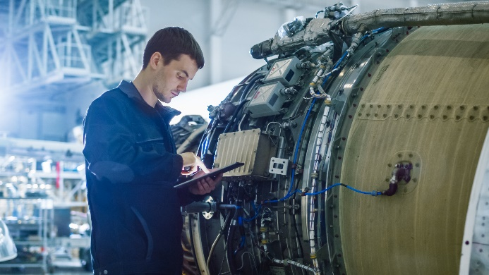 | Photo 1  Maintenance matters: Even older machines can lead a successful second life as used machines with the right care.  (© Gorodenkoff/Shutterstock.com).
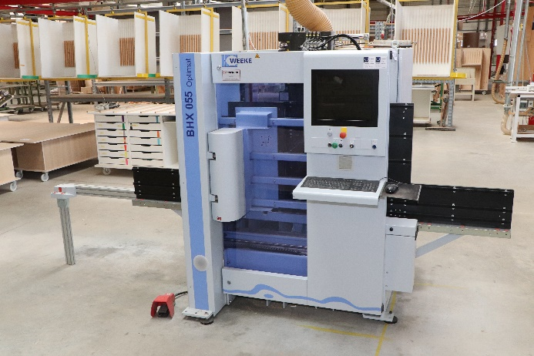 | Photo 2  Surplex offers high-quality used machines for auction.  (© Surplex).

