L.I.M GTX SHAKEDRY HOOD – A ONE OF A KIND JACKET

*(Stockholm, November 2019)*

**This fall, Haglöfs introduces the L.I.M GTX SHAKEDRY Hood to its collection. This jacket hides a secret in plain sight - a unique combination of high-performance GORE-TEX**® **SHAKEDRY™ and breathable body-mapped Quadfusion™ ƞ for warmth. It’s an essential mid layer and a fully-featured shell jacket, in one.**

This lightweight jacket dries like the fur of a wild animal: by being shaken. Its secret is hiding in plain sight. Instead of having the waterproof membrane embedded in the fabric, it’s right on the surface, meaning that absorption of moisture is eliminated. The water simply beads up and rolls off.

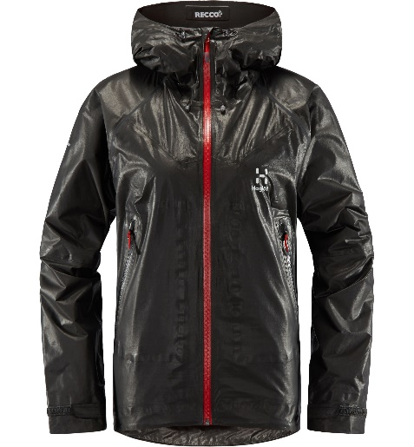*“The L.I.M GTX SHAKEDRY Hood solves something we've found frustrating about being in the wilderness, by reducing the need to repeatedly put on and take off layers of clothing while on the go. Addressing this issue was my inspiration while developing this piece” Robert Olsson, Senior Designer at Haglöfs.*

The Quadfusion™ ƞ lining takes this piece's functionality to a whole new level. When you slow down or take a break it will keep you warm for longer, and when your pulse and temperature rise the breathable lining is engineered to wick away moisture.

Garments made from GORE-TEX® Active with SHAKEDRY™ technology, like the L.I.M GTX SHAKEDRY Hood, combine excellent breathability with exceptional wind and water protection. The L.I.M GTX SHAKEDRY Hood is equipped with a RECCO® reflector which makes you searchable in the wilderness, as well as a stretchy back panel that increases mobility without sacrificing breathability and waterproofing.

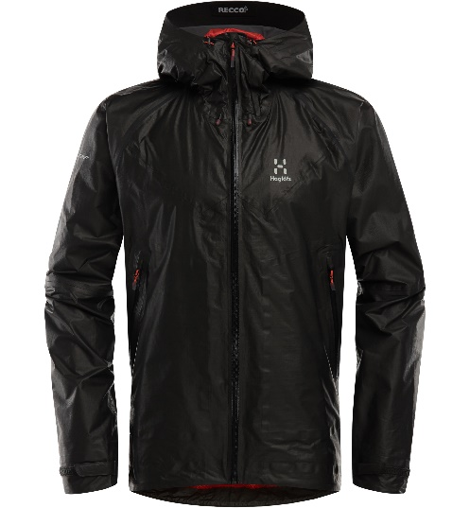The Haglöfs L.I.M GTX SHAKEDRY Hood will be available from Fall 2019 in Haglöfs’ own stores and online, as well as through selected retailers worldwide. Estimated retail price is 500€.

**For more information, please contact:**

Lisa Grübb  
*Publishing Coordinator*  
[lisa.grubb@haglofs.se](mailto:lisa.grubb@haglofs.se)  
+46 8 121 362 61

L.I.M GTX SHAKEDRY HOOD – PRODUCT SHEET

* Fabrics: GORE-TEX Active 2-layer construction with SHAKEDRY™ product technology, which provides excellent water repellency, minimal weight and outstanding breathability. 100% printed ePTFE membrane face laminated to a 100% Polyamide grid backer 49 g/m² Hydrostatic head: >28,000 mm, RET: < 3 QuadFusion™ ƞ 100% Polyester, High-loft, waffle structure liner designed to keep warmth in while letting all moisture evaporate, 98 g/m²
* Exterior: Body mapped design, made with GORE-TEX® SHAKEDRY™ and stretchy GORE-TEX® technologies
* Interior: Body mapped design, with QuadFusion™ ƞ and mesh lining for optimum breathability, wicking and warming capabilities
* RECCO® reflector in hood brim.
* Water repellent front zip with inner placket. Mid-mounted torso pockets with water-repellent zippers. Adjustable hood. Articulated elbows Cuffs with Velcro adjustment. One-handed adjustable hem. Internal elastic mesh stow pocket
* Centre back length 78 cm (men's size L)
* RECCO®: This tech makes you searchable in the wilderness. The RECCO® Rescue System is a two-part technology; ski resorts and mountain rescue teams carry RECCO® detectors, which send out a search signal. RECCO® reflectors, worn by skiers, riders and other outdoor people, bounce back a directional signal that points the rescuer straight to the reflector. When RECCO® is used on our trekking boots, it is placed on the tongue for best searchability.
* Weight: Approx 400g
* Available in size ranges:  
  Women: XS-XXL  
  Men: S-XXL