Get the latest on maritime digital solutions with Kongsberg Digital’s webinar week
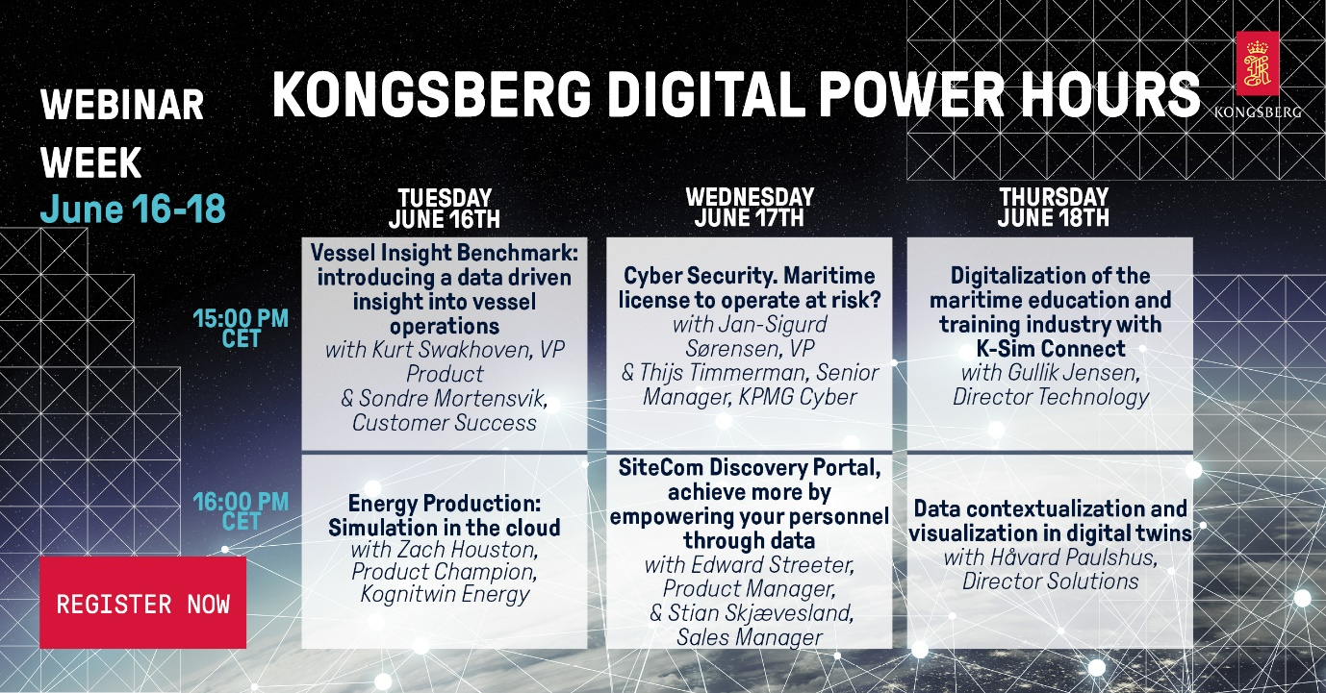
Experts from Kongsberg Digital will host a series of Power Hours for digital maritime technologies

Kongsberg, Norway, June 11th, 2020 – Kongsberg Digital are delighted to announce another week of live webinars, following the success of a similar initiative in April. Open to everyone, especially those within the maritime, energy or drilling industries, the sessions will help attendees to stay informed and continue their professional development, wherever they are working.
Hosted by some of the leading experts in the industry, the webinars – which will run from Tuesday 16th June to Thursday 18th June inclusive – take the form of ‘Power Hours’ with two consecutive sessions, the first starting at 3:00pm CET and the second at 4:00pm CET. An opportunity for Q&A is included within each webinar, making them a time-efficient way to obtain the latest information about Kongsberg Digital’s wide range of digital solutions, and to learn how digitalization can help your business.
Topics include:
- Vessel Insight Benchmark: Introducing a data driven insight into vessel operations
- Kurt Swakhoven, VP Product, Kongsberg Digital
- Sondre Mortensvik, Customer Success Manager, Kongsberg Digital
- Energy Production: Simulation in the cloud
- Zach Houston, Product Champion, Kognitwin Energy, Kongsberg Digital
- Cyber security: Maritime license to operate at risk?
- Thijs Timmerman, Senior Manager, KPMG Cyber
- Jan-Sigurd Sørensen, VP Maritime Digital Solutions, Kongsberg Digital
- SiteCom Discovery Portal: Achieve more by empowering your personnel through data
- Edward Streeter, Product Manager, Kongsberg Digital
- Stian Skjævesland, Sales Manager, Kongsberg Digital
- Digitalization of the maritime education and training industry with K-Sim Connect
- Gullik Jensen, Director Technology, Kongsberg Digital
- Energy production: Data contextualization and visualization in digital twins
- Håvard Paulshus, Director Solutions, Kongsberg Digital
The webinars are open to all, and there are no restrictions on how many you can attend. For those unable to join the live sessions, recordings will be made available.
For more information and to register your interest, click here.
Ends

For further information, please contact:

Mathilde Vik Magnussen
VP Communications & Marketing
Kongsberg Digital
Tel: +47 4567 8255
mathilde.magnussen@kdi.kongsberg.com

David Pugh
Saltwater Stone
Tel: +44 (0)1202 669244
d.pugh@saltwater-stone.com

About Kongsberg Digital
Kongsberg Digital is a provider of next-generation software and digital solutions to customers within maritime, oil and gas, and renewables and utilities. The company consists of more than 500 software experts with leading competence within the internet of things, smart data, artificial intelligence, maritime simulation, automation and autonomous operations.
Kongsberg Digital is subsidiary of KONGSBERG (OSE-ticker: KOG), an international, knowledge-based group delivering high-technology systems and solutions to clients within the oil and gas industry, subsea, merchant marine, defence and aerospace. KONGSBERG has 11.000 employees located in more than 40 countries.
Web: Kongsberg Gruppen | Kongsberg Digital
Social media: LinkedIn | Twitter | Facebook

