Kongsberg Maritime wins contract with CMHI to deliver CSOV design and equipment to Awind for offshore wind
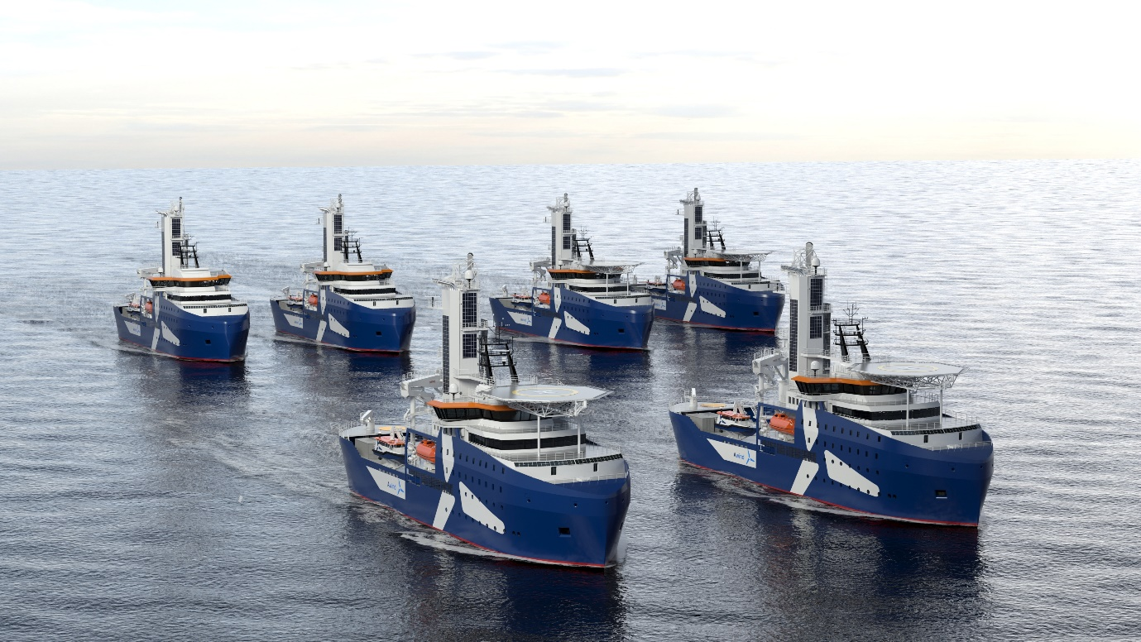
Kongsberg Maritime is to design and equip two specialist double-ended CSOV/SOVs for Awind
Kongsberg, Norway, 11th June 2021 – Kongsberg Maritime (KM) is delighted to announce that it has secured contracts with China Merchant Heavy Industries (CMHI) to design and equip two construction service operation vessels (CSOV) for the Norway-based shipowner Awind AS, a fully-owned subsidiary of Integrated Wind Solutions AS. The combined contract value is approximately NOK 250 million.
Destined for the renewable offshore wind market, the new CSOVs will be built to Kongsberg Maritime’s UT 5519 DE design by CMHI, with which KM has a long and close relationship. Scheduled to be delivered in 2023, the vessels are designed with a clear focus on reduced emissions and enhanced sustainability.
This focus is reflected by the comprehensive Kongsberg Maritime integrated equipment solution, which includes permanent magnet Azimuth thrusters, generators, electrical systems, a fully integrated bridge with navigation, DP and automation, deck machinery equipment and control systems.
This extensive portfolio will contribute to activity across the entire company and the subcontractor supply chain network. “We greatly appreciate the collaboration we have developed with Awind,” says Per Ståle Nykrem, Senior Sales Manager, and Martijn de Jong, Chief Designer in Ship Design, Kongsberg Maritime.
“Awind’s determination to promote humane, environmentally-friendly safe and efficient operation is entirely consistent with KONGSBERG’s mission to incorporate sustainability in everything we do,” adds Jørn Heltne, Vice President, Integrated Solutions – Ship Design Sales, Kongsberg Maritime. “This cooperation will have positive ripple effects across the entire organisation, as well as reinforcing Kongsberg Maritime’s market position in the growing renewable energy segment.”
The UT 5519 DE has a novel hull form and propulsion set-up, incorporating results from research and development projects as well as operational experience from KM’s wind farm service vessel designs.
Propulsion is provided by four KM type US 255 L azimuthing thrusters, two forward and two aft. The thrusters are powered using highly efficient permanent magnet electric motors, mounted vertically. This set-up provides excellent manoeuvrability and station keeping capability and efficiency, important for a vessel that visits a large number of wind turbines each day, with operations comprising close quarters manoeuvring, station keeping and short transits.
The hybrid power system features energy storage systems and a DC main switchboard configured to provide spinning reserve, as well as actively delivering efficiencies during vessel operation through peak shaving, power boost and the possibility of short-term battery operation. This minimises the number of generators running and optimises fuel efficiency. The generator sets are variable RPM, allowing optimum specific fuel consumption even at low loads.
The vessel is also designed to minimise environmental impact in other ways, including underwater noise covered by the DNV Silent(E) class notation, further representing how KM’s next-generation CSOV/SOV designs are prepared for the shift towards zero-emission operation.
The layout of the vessel provides good separation between work and living areas, allowing 24-hour operation and maintaining a high level of living comfort, with accommodation for up to 120 persons.
“We are very pleased to strengthen and build on our relationship with Kongsberg Maritime, both through the design and development phase and in the future, as we look forward to continuing to work together to ensure that our vessels operate as sustainably, humanely and efficiently as possible,” says Christopher Andersen Heidenreich, Managing Director, Awind.

Ends

For further information, please contact:
Gunvor Hatling Midtbø, VP Communication
Kongsberg Maritime
Tel: +47 9921 4209
gunvor.hatling.midtbo@km.kongsberg.com
David Pugh
Saltwater Stone
Tel: +44 (0)1202 669244
d.pugh@saltwater-stone.com

About Kongsberg Maritime
Kongsberg Maritime is a global marine technology company providing innovative and reliable ‘Full Picture’ technology solutions for all marine industry sectors including merchant, offshore, cruise, subsea and naval. Headquartered in Kongsberg, Norway, Kongsberg Maritime has manufacturing, sales and service facilities in 34 countries.
Kongsberg Maritime solutions cover all aspects of marine automation, safety, manoeuvring, navigation, and dynamic positioning as well as energy management, deck handling and propulsion systems, and ship design services. Subsea solutions include single and multibeam echo sounders, sonars, AUV and USV, underwater navigation and communication systems.
Training courses at locations globally, LNG solutions, information management, position reference systems and technology for seismic and drilling operations are also part of the company’s diverse technology portfolio. Additionally, Kongsberg Maritime provides services within EIT (Electro, Instrument & Telecom) engineering and system integration, on an EPC (Engineering, Procurement & Construction) basis.
Kongsberg Maritime is part of Kongsberg Gruppen (KONGSBERG), an international, knowledge-based group that celebrated 200 years in business during 2014. KONGSBERG supplies high-technology systems and solutions to customers in the oil and gas industry, the merchant marine, and the defence and aerospace industries.
Web: Kongsberg Gruppen | Kongsberg Maritime
Social media: LinkedIn | Twitter | Facebook

