Kyma joins Kongsberg Digital’s Kognifai
Partner Program

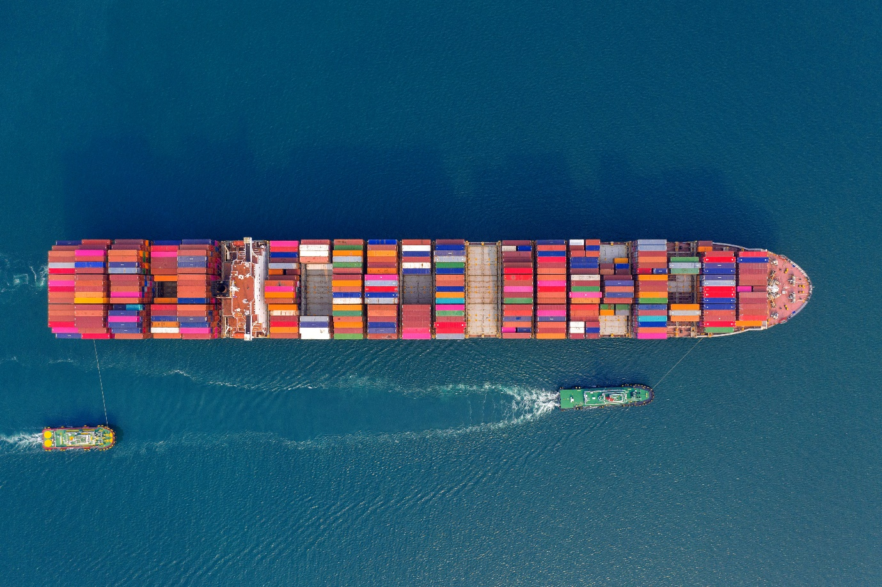
Kyma’s specialized vessel monitoring applications will shortly become available to Vessel Insight customers
via the Kognifai Marketplace
Oslo, Norway, February 18th, 2020 – Kongsberg Digital is pleased to announce that, through the Kognifai Partner Program, Vessel Insight users will now gain access to Kyma’s specialized vessel monitoring applications. Data Analysis, an advanced tool to enable statistical modelling of ship performance data, will be the first of several Kyma applications to become available to Vessel Insight customers via Kognifai.
Previously offered exclusively to Kyma’s premium online customers, Data Analysis will now also be accessible as a standalone application in the Kognifai Marketplace. The application helps customers to gain insight into their power distribution, speed and fuel consumption, enabling them to reduce emissions. Kyma’s Charter Party and Notification applications are expected to follow shortly.
“Having Kyma AS join the Kognifai Partner Program means giving our customers access to sophisticated tools for overall vessel performance monitoring and evaluating fleet performance,” says Eirik Næsje, SVP Vessel Insight, Kongsberg Digital. “We are very happy to have Kyma AS join us, and know that this development will benefit customers looking to reduce emissions and increase cost-efficiency through Vessel Insight.”
For customers, the partnership will deliver immediate value, with KONGSBERG’s vessel-to cloud data infrastructure feeding high-frequency data seamlessly to Kyma’s applications. The Data Analysis application uses this data to generate reports as required, comparing it with available parameters and including graphical, numerical, and predicted values. This ability to establish relational comparisons and conduct statistical analysis of the variables available enables the user to take actions to optimize ship efficiency and improve vessel performance.
“We are pleased to extend our long cooperation with KONGSBERG and excited to join the Kognifai Partner Program to accelerate the pace of maritime digitalization. This extended cooperation will increase the accessibility of Kyma’s solutions by offering parts of our well-proven performance optimization software in the Kognifai Marketplace as standalone applications,” says Halldor Rongve, Managing Director at Kyma AS.
The Kyma Data Analysis application will be available for Vessel Insight customers from April 2021. Learn more here.
Ends
For further information, please contact:

Mathilde Vik Magnussen
VP Communications & Marketing
Kongsberg Digital
Tel: +47 456 78 255
mathilde.magnussen@kdi.kongsberg.com

David Pugh
Saltwater Stone
Tel: +44 (0)1202 669244
d.pugh@saltwater-stone.com
Tim Fredrik Hagen-Johansen
Area Sales Manager
Kyma AS
Tel: +47 918 66 128
sales@kyma.no

About Kongsberg Digital
Kongsberg Digital is a provider of next-generation software and digital solutions to customers within maritime, oil and gas, and renewables and utilities. The company consists of more than 500 software experts with leading competence within the internet of things, smart data, artificial intelligence, maritime simulation, automation and autonomous operations.
Kongsberg Digital is subsidiary of KONGSBERG (OSE-ticker: KOG), an international, knowledge-based group delivering high-technology systems and solutions to clients within the oil and gas industry, subsea, merchant marine, defence and aerospace. KONGSBERG has 11,000 employees located in more than 40 countries.
Web: Kongsberg Gruppen | Kongsberg Digital
Social media: LinkedIn | Twitter | Facebook
About Kyma
Kyma AS is a company that specializes in the production and development of products for vessel performance monitoring. Since being established in its current form in 1995, Kyma AS has been an independent limited company that supplies the marine industry with accurate and reliable ship performance systems. With highly qualified personnel and production facilities in the outskirts of Bergen, Norway, Kyma AS can refer to an installed base exceeding 5000 vessels worldwide.
Web: Kyma
Social media: LinkedIn | YouTube | Facebook

