Kongsberg Maritime wins contract to deliver deck machinery for Novatek Ice Class LNGC
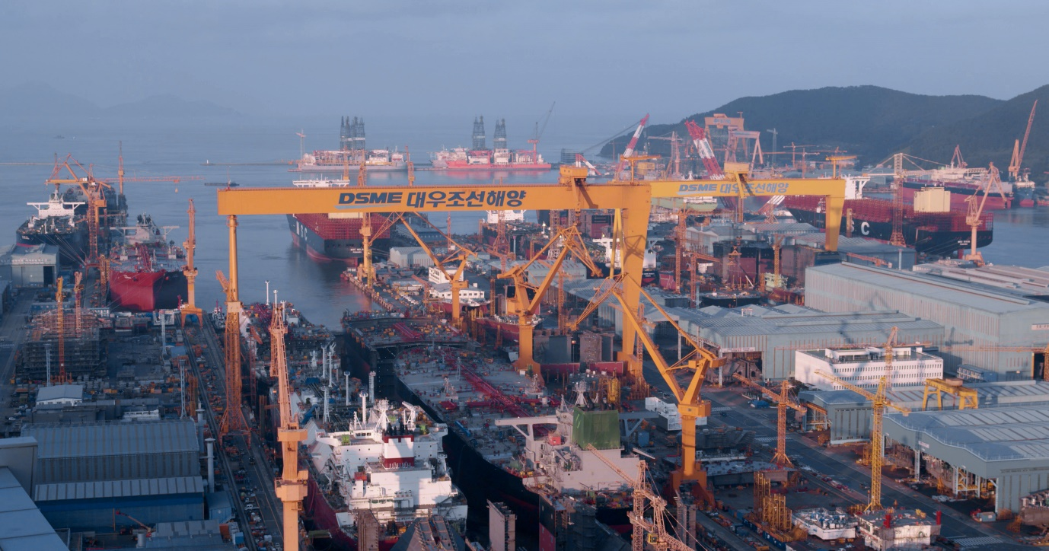Kongsberg Maritime will supply deck machinery for six LNGC, in build for Novatek at DSME, South Korea
Kongsberg, Norway, 10th February 2021 – Kongsberg Maritime is pleased to announce a significant and strategic new equipment contract with Russian LNG producer Novatek. Under the terms of the deal, KM will supply a range of electric frequency converter-driven deck machinery for six Ice Class LNG carriers, with an option for a further four, chartered by Novatek LNGC and destined for operation in the waters of northwest Siberia.
The vessels are to be built by Korean shipyard Daewoo Shipbuilding & Marine Engineering (DSME) and will each be equipped with two combined windlasses and mooring winches capable of handling a 17-tonne anchor with 111mm anchor chain, plus a further seven mooring winches. Designed to operate under extreme ambient temperatures as low as
-52°C, the windlasses and mooring winches will also feature a specially-developed modification in the form of an electrically-operated, spring-loaded band brake, as requested by Novatek.
Espen Liset, Kongsberg Maritime SVP Deck Machinery Motion Control, said: “These Ice Class Arc7 are made to navigate winter/spring ice thickness of up to 1.8m. Our customised deck machinery system is designed for ease of installation and reliable operation in such harsh environments. Selecting our stainless-steel brake drum surfaces allows consistent smooth operation.”
Kongsberg Maritime will also supply control systems and load monitoring for the winches, with further integration to KONGSBERG automation systems available as an option.

“This contract represents an important endorsement of our advanced technologies as well as signposting our future growth,” says Leo Pantazopoulos SVP Sales & Regional Operations, APAC, Kongsberg Maritime. “Working with Novatek will sharpen our competitive edge in the fast-growing, Russian-owned Arctic market, reinforcing our reputation as a reliable supplier with a provably efficient support infrastructure. I would like to thank our teams for working so well collaboratively, and with such a dedicated sense of purpose, to bring this contract agreement to fruition.”
Ends

For further information, please contact:
Gunvor Hatling Midtbø, VP Communication
Kongsberg Maritime
Tel: +47 9921 4209
gunvor.hatling.midtbo@km.kongsberg.com
David Pugh
Saltwater Stone
Tel: +44 (0)1202 669244
d.pugh@saltwater-stone.com

About Kongsberg Maritime
Kongsberg Maritime is a global marine technology company providing innovative and reliable ‘Full Picture’ technology solutions for all marine industry sectors including merchant, offshore, cruise, subsea and naval. Headquartered in Kongsberg, Norway, Kongsberg Maritime has manufacturing, sales and service facilities in 34 countries.
Kongsberg Maritime solutions cover all aspects of marine automation, safety, manoeuvring, navigation, and dynamic positioning as well as energy management, deck handling and propulsion systems, and ship design services. Subsea solutions include single and multibeam echo sounders, sonars, AUV and USV, underwater navigation and communication systems.
Training courses at locations globally, LNG solutions, information management, position reference systems and technology for seismic and drilling operations are also part of the company’s diverse technology portfolio. Additionally, Kongsberg Maritime provides services within EIT (Electro, Instrument & Telecom) engineering and system integration, on an EPC (Engineering, Procurement & Construction) basis.
Kongsberg Maritime is part of Kongsberg Gruppen (KONGSBERG), an international, knowledge-based group that celebrated 200 years in business during 2014. KONGSBERG supplies high-technology systems and solutions to customers in the oil and gas industry, the merchant marine, and the defence and aerospace industries.
Web: Kongsberg Gruppen | Kongsberg Maritime
Social media: LinkedIn | Twitter | Facebook

