KM strengthens its position in the offshore wind sector with an innovative solution for installation vessels
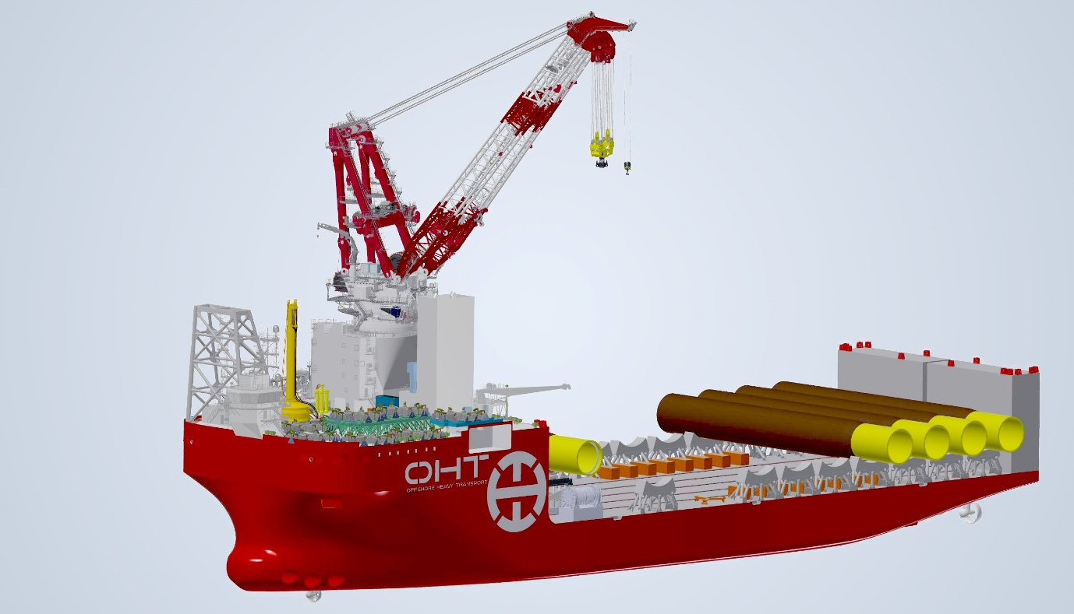
Kongsberg Maritime is to supply a PGGS for the Ulstein-designed OHT Alfa Lift offshore wind
foundation installation vessel
Kongsberg, Norway, 20th October 2020 – Kongsberg Maritime (KM) has just signed a new contract with the maritime services and solutions provider MacGregor to deliver a Pile Gripper Guidance System (PGGS) for the OHT Alfa Lift. Scheduled for delivery in 2021, Alfa Lift will be the world’s largest custom-built offshore wind foundation installation vessel, equipped with a 3,000t main crane. The ship’s 10,000+ m² ‘smart’ deck will carry up to 14 XL monopiles per voyage and will also be fully submersible to a depth of 14.66m.
Under the terms of the contract, MacGregor will deliver a motion-compensated pile gripper frame, while KONGSBERG’s PGGS will integrate the gripper with the many other KM systems on board the OHT Alfa Lift. A K-Pos dual-redundant dynamic positioning system will interface with a K-Chief marine automation system and K-Thrust thruster control system, bringing all the technical and economic benefits which result from the integration of a vessel’s monitoring and control functions, while a K-Bridge integrated navigation system will provide a single, intuitive user interface for the ship’s multiple connected systems. A full suite of safe, reliable, compact and cost-effective K-Power products will accommodate the main switchboard, generators and drives, while KM’s azimuth and tunnel thrusters will take care of the vessel’s propulsion, steering and positioning thrust.
Kongsberg Maritime and MacGregor have both been working in close collaboration to develop this new, integrated monopile installation solution, incorporating KM’s most sophisticated, up-to-date automated handling functionality. By removing the need for temporary mooring procedures during installation operations, the solution will enhance safety, productivity and mission consistency, generating substantial savings in time and money for the specialist transport and installation contractor OHT. In time, these positive changes will be reflected in a wider sense when the concept is rolled out across the offshore wind energy market.
“Working with Kongsberg Maritime and OHT on this solution has been a mutually rewarding process,” says Kristina Arutjunova, Director Sales and Marketing Innovations, MacGregor. “We’re significantly raising the bar for safety, sustainability, precision and efficiency by dispensing with so many of the challenges traditionally posed by complex offshore operations of this nature.”
“This order secures KM’s role as a leading technology provider for heavy offshore vessels,” adds Birger Evensen, Sales Director Offshore, Kongsberg Maritime. “Working closely with MacGregor, we have developed an innovative solution that improves the efficiency of foundation installation vessels by replacing lengthy, temporary mooring processes with full DP, in combination with an integrated guidance system and hydraulic frame mechanism.
“The interdependence such enterprises require will benefit us all. Our technology, solutions and expertise will continue to make harnessing wind power safer and more efficient by streamlining installation processes, while the lessons we learn from our work with offshore energy clients will contribute considerably towards creating a cleaner and more sustainable future.”
Ends

For further information, please contact:
Gunvor Hatling Midtbø, VP Communication
Kongsberg Maritime
Tel: +47 9921 4209
gunvor.hatling.midtbo@km.kongsberg.com
David Pugh
Saltwater Stone
Tel: +44 (0)1202 669244
d.pugh@saltwater-stone.com

About Kongsberg Maritime
Kongsberg Maritime is a global marine technology company providing innovative and reliable ‘Full Picture’ technology solutions for all marine industry sectors including merchant, offshore, cruise, subsea and naval. Headquartered in Kongsberg, Norway, Kongsberg Maritime has manufacturing, sales and service facilities in 34 countries.
Kongsberg Maritime solutions cover all aspects of marine automation, safety, manoeuvring, navigation, and dynamic positioning as well as energy management, deck handling and propulsion systems, and ship design services. Subsea solutions include single and multibeam echo sounders, sonars, AUV and USV, underwater navigation and communication systems.
Training courses at locations globally, LNG solutions, information management, position reference systems and technology for seismic and drilling operations are also part of the company’s diverse technology portfolio. Additionally, Kongsberg Maritime provides services within EIT (Electro, Instrument & Telecom) engineering and system integration, on an EPC (Engineering, Procurement & Construction) basis.
Kongsberg Maritime is part of Kongsberg Gruppen (KONGSBERG), an international, knowledge-based group that celebrated 200 years in business during 2014. KONGSBERG supplies high-technology systems and solutions to customers in the oil and gas industry, the merchant marine, and the defence and aerospace industries.
Web: Kongsberg Gruppen | Kongsberg Maritime
Social media: LinkedIn | Twitter | Facebook

