KONGSBERG and Shell sign JAWS agreement
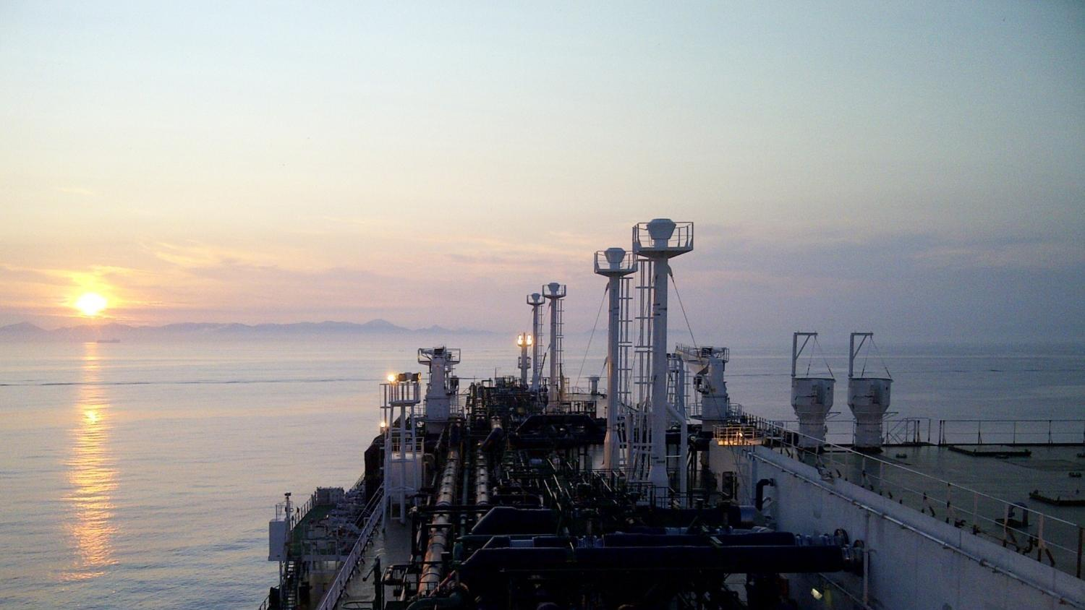
Kongsberg Maritime has signed an agreement with Shell to deliver JAWS hydrodynamic optimisation software
Kongsberg, Norway, 2nd September 2020 – Kongsberg Maritime, part of KONGSBERG, has signed an agreement with Shell International Trading and Shipping Company Limited (Shell), to deliver Shell’s patented draft and trim optimisation software, Just Add Water System (JAWS).
Kongsberg Maritime will deliver the software through its digital solution, including JAWS as an application in the K-IMS suite; a portfolio of specialised applications to support complex operations. This will enable JAWS to be immediately available to hundreds of LNG customers who are already benefiting from Kongsberg Maritime’s established, reliable K-IMS solution, as well as to new Kongsberg Maritime customers.
“We are looking forward to seeing JAWS and K-IMS contributing significantly to the reduction of greenhouse gas emissions and fuel costs for both vessel owners and charterers,” said Egil Haugsdal, President, Kongsberg Maritime. “The agreement between our companies sets an encouraging example to the industry, showing how shipping can become greener through close collaboration between different actors in the market, contributing to the creation of sustainable, value solutions which benefit everyone. From day one, the teamwork between Shell and Kongsberg Maritime has been of an excellent standard, and we are very excited to be kicking off this program.”
The technology has been developed by Shell, working with the University of Southampton, and has been deployed on more than 50 ships so far. Shell is increasing deployment of the software on its LNG fleet, starting with a further 20 vessels this year.
Grahaeme Henderson, Global Head of Shell Shipping & Maritime said, “Regardless of the different pathways to decarbonisation, efficiency technologies will be the foundation for a decarbonised shipping industry. JAWS is a low cost, quick to deploy software that can deliver fuel savings and emissions reductions today. We have achieved up to a 7% reduction in emissions on our own ships using the software and, working with Kongsberg Maritime, we hope to see JAWS implemented across the industry.”
The JAWS software uses historic, high-frequency data from the vessel to determine the optimal conditions on previous voyages, which enables the system to advise on how best to enhance a vessel’s draft and trim at any given speed to reduce fuel consumption and lower emissions. JAWS also monitors and reports live fuel and emissions savings back to managers, to give real-time insight into the benefits of deploying this technology across a fleet.
Real-life testing of the JAWS system, delivered through Kongsberg Maritime’s interactive, web-based K-IMS (Information Management System) application suite, demonstrates that the software is an invaluable source of situational awareness, lending new insights to vessel handling and decision making.
The DNV GL Technology Qualification (TQ) is the process whereby the developer can provide evidence to an independent third party to assess whether new technologies will meet safety and reliability criteria with an acceptable level of confidence. DNV GL has assisted the development of JAWS by assessing the methodologies employed and ensuring that the calculations provided by the software are based on the accurate and reliable use of data.
“It is clear that decarbonisation is going to be a generational challenge for the shipping industry,” said Knut Ørbeck-Nilssen, Maritime CEO, DNV GL. “This will require that the industry looks to unlock every efficiency to reduce fuel use, especially by taking advantage of the opportunities created by greater connectivity and digitalisation. At DNV GL we are proud to be able to help forward-looking companies like Shell and KONGSBERG realise these gains by ensuring that new technologies like JAWS can be deployed with confidence in their safety and reliability.”
By uniting all data-logging and communication channels into one secure solution, the collaborative K-IMS solution presents a comprehensive information flow which provides a common, user-friendly solution for fleet owners, charterers and third parties alike. To date, more than 200 deliveries of K-IMS have been made within the LNG sector, and K-IMS is also establishing an appreciable market footprint in the offshore segment.
Ends

For further information, please contact:
Gunvor Hatling Midtbø, VP Communication
Kongsberg Maritime
Tel: +47 9921 4209
gunvor.hatling.midtbo@km.kongsberg.com
David Pugh
Saltwater Stone
Tel: +44 (0)1202 669244
d.pugh@saltwater-stone.com

About Kongsberg Maritime
Kongsberg Maritime is a global marine technology company providing innovative and reliable ‘Full Picture’ technology solutions for all marine industry sectors including merchant, offshore, cruise, subsea and naval. Headquartered in Kongsberg, Norway, Kongsberg Maritime has manufacturing, sales and service facilities in 34 countries.
Kongsberg Maritime solutions cover all aspects of marine automation, safety, manoeuvring, navigation, and dynamic positioning as well as energy management, deck handling and propulsion systems, and ship design services. Subsea solutions include single and multibeam echo sounders, sonars, AUV and USV, underwater navigation and communication systems.
Training courses at locations globally, LNG solutions, information management, position reference systems and technology for seismic and drilling operations are also part of the company’s diverse technology portfolio. Additionally, Kongsberg Maritime provides services within EIT (Electro, Instrument & Telecom) engineering and system integration, on an EPC (Engineering, Procurement & Construction) basis.
Kongsberg Maritime is part of Kongsberg Gruppen (KONGSBERG), an international, knowledge-based group that celebrated 200 years in business during 2014. KONGSBERG supplies high-technology systems and solutions to customers in the oil and gas industry, the merchant marine, and the defence and aerospace industries.
Web: Kongsberg Gruppen | Kongsberg Maritime
Social media: LinkedIn | Twitter | Facebook

