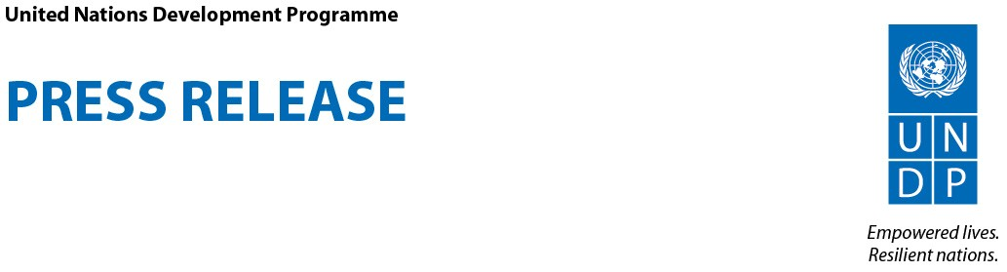

Game of Thrones star Nikolaj Coster-Waldau travels to the Amazon with UNDP to discover the real story behind the fires

For broadcast-quality video footage and high-resolution photos from Nikolaj Coster-Waldau’s mission to the Amazon, please click here: bit.ly/NCWPERU
Coster-Waldau and UNDP have produced a mini-documentary for the web on his mission to the Amazon, which can be viewed and shared here: bit.ly/NCWPERUWEBVIDEO

New York, NY, September 19 – Game of Thrones star and UNDP Goodwill Ambassador Nikolaj Coster-Waldau has just returned from a fact-finding journey to Peru, where he traveled deep into the jungles of the Amazon with the UN agency to get to the bottom of the causes – and the impacts – of the fires. His mission also offered insights into the effects of climate change on the hard-to-reach communities living in the Amazon.

“When I saw those images of the Amazon on fire, like everyone else, I felt shocked, powerless and angry. It didn’t make sense to me,” Coster-Waldau said. “Which is why I wanted to come to Peru and find out why the Amazon is on fire.”

What Coster-Waldau discovered was that the deforestation in the Peruvian Amazon, to which the fires are attributed, can be traced back to economic and social inequalities facing the communities living in this region.

Indigenous and local communities play a key role in safeguarding the Amazon rainforest, which covers more than 60 percent of Peru and is critical for our planet because it holds about 20 percent of the river water on Earth.

But in the Peruvian Amazon, many of these communities also face high levels of poverty and inequality and lack basic infrastructure and resources. Most are small farming or fishing villages whose residents live off the forest and often rely on deforesting their plots to grow food and earn a living

“What I found when I traveled to Peru is that the burning of the Amazon, the deforestation is incredibly complex. But at the core is social inequality,” Coster-Waldau said.
___________________________________________________________________________________________
For broadcast-quality video footage and high-resolution photos from Nikolaj Coster-Waldau’s mission to the Amazon, please click here: bit.ly/NCWPERU
___________________________________________________________________________________________

“I met indigenous communities, and they explained the awful dilemma they face: They are farmers. They need to farm, not for great profit but simply to feed their families,” Coster-Waldau said “These communities are often living in extreme poverty and have an impossible choice: they are the guardians of the Amazon, but they also have little choice but to clear sections of it in order to plant crops just to survive.”

“The problems indigenous communities face in the Amazon are a window into not just the impacts of climate change, which have intensified over the past 20 years, but one of its biggest causes: inequality,” said Coster-Waldau.

“If we don’t address inequality on a global scale, then we won’t be able to fix climate change. It’s complex, but there’s hope. We have the resources, we have the technology. We just need to do it. We need to come together as individuals, as communities, as nations. And if we do that, we can solve the problem.”

“Development challenges are complex, and in Peru, home to the second largest portion of Amazon forest, we have to pursue integrated solutions that ensure that vulnerable communities can accelerate progress towards equality and resilience to climate change,” said Maria del Carmen Sacasa, Resident Representative of UNDP in Peru.

UNDP is supporting government, private sector and communities in their efforts to reduce deforestation and address climate change in the Peruvian Amazon. Aligned with Peru’s national policy framework, UNDP and partners address the root causes of environmental degradation through supporting inclusive governance, by providing technical assistance to stimulate sustainable economic growth and climate proof livelihoods, and through facilitating multi-stakeholder partnerships to align public and private finance in support of sustainable development.

Coster-Waldau and UNDP have produced a mini-documentary for the web on his mission to the Amazon, which can be viewed and shared here: bit.ly/NCWPERUWEBVIDEO

For broadcast-quality video footage and high-resolution photos from Nikolaj Coster-Waldau’s mission to the Amazon, please click here: bit.ly/NCWPERU

Contact Information: Adam Cathro, UNDP, +1 212 906 5326, adam.cathro@undp.org.
***
UNDP partners with people at all levels of society to help build nations that can withstand crisis, and drive and sustain the kind of growth that improves the quality of life for everyone. On the ground in nearly 170 countries and territories, we offer global perspective and local insight to help empower lives and build resilient nations. www.undp.org.

