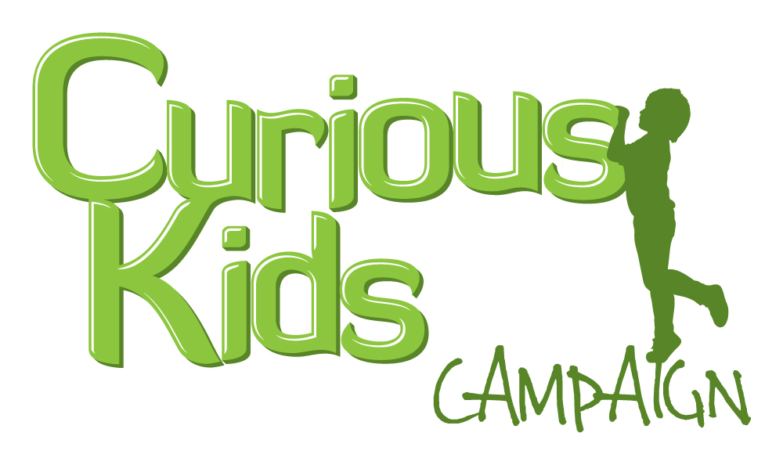

**Curious Kids Campaign Press Release**

**London, 7 March 2012**

**Campaign seeks 1 million signatures to put curiosity at the top of the education agenda**

London-based Stealth Education believes that being curious is the key to success and happiness in life and is launching a global campaign to put curiosity at the top of the agenda for kids all over the world.

They argue that children are born curious, their thirst for new experiences and information is unquenchable, but that as they grow up, that spark can be lost and as a result they become bored and disinterested in learning.

So the Curious Kids Campaign is on a mission to encourage everyone from app and game developers through to schools and education policy makers to put curiosity at the heart of every child’s experience.

As developers and publishers, Stealth Education believes that too many educational apps and games offer kids passive, repetitive experiences – and that children deserve better. They are forming alliances with other companies who share their philosophy, including Made in Me, the team behind the BAFTA-nominated The Land of Me, as well as hot new start-up Night Zookeeper.

But their campaign is not just about apps and games: Stealth Education’s CEO, Henry Playfoot explains:

“I’ve been thinking a lot about my own kids’ development and realised that what matters most is a curious mindset. Nothing makes me happier than seeing my own kids in that state of wonderment that comes from discovering the world, and I want their education – at school and at home – to nurture, protect and reward this most precious quality.”

The aim of the Curious Kids Campaign is not only to influence developers and designers to produce engaging apps and games for children, but to challenge policy makers and schools around the world to explicitly teach, assess and reward curiosity at every stage of education.

You can find out more and show your support for the Curious Kids Campaign at

<http://www.curiouskidscampaign.com>

**ENDS**

**Notes to Editors**

**About Stealth Education**

**Stealth Education was founded by education and technology experts** Henry and Jim Playfoot to meet a need to provide children with mobile games and apps that are both fun and educational. Backed by a team of advisors including UK games guru Ian Livingstone and Professor Mark Alter from New York University, they bring together expertise from the worlds of education, gaming and technology. Working with robust research and evidence and a range of partners in Europe, the US and Asia, Stealth Education is building a platform for compelling educational apps and games that children really want to play.

**Support for the Curious Kids Campaign:**

*“The central question for 21st century education is 'Can we foster curiosity?' I think Stealth Education's Curious Kids Campaign is a perfect way to alert the world to the importance of understanding and fostering curiosity in children, and in everyone.”*

**- Jesse Schell, CEO Schell Games, Asst. Prof. of Entertainment Technology, Carnegie Mellon University**

*“Children are naturally curious and parents need to empower and respect their children’s curiosity. I support this campaign and urge parents, teachers, kids and anyone committed to educating children to explore the site and allow their curiosity to transform their behavior!”*

*-*  **Prof Mark Alter, New York University**

*"We passionately support the Curious Kids philosophy and mission. Technology isn't about inspiring kids to use more technology, but providing them with more ways to indulge their boundless curiosity. We don't need to teach children to be courageous or creative. Our job is to ensure they stay that way."*

**- James Huggins, CEO Made In Me**

**For more information on the Curious Kids Campaign or Stealth Education, please contact:**

**Henry Playfoot –** [**henry@stealtheducation.com**](mailto:henry@stealtheducation.com) **+44 (0)207 183 0916**