 | News Release
  - 20 March 2012

Investors urged: Stop throwing money away and beat the Budget blues
- £42 billion wasted on investment charges -

With higher rate tax payers anticipated to take some of the pain in this week’s budget, financial planning website rplan.co.uk today warns investors that they could offset the Budget blues by saving thousands that they already throw away in investment charges and commissions.

With rplan.co.uk research indicating that people tend to respond to austerity measures by cutting back, the elephant in the room is that millions of people could save thousands by taking simple steps in the way they manage their investments.

rplan.co.uk is urging people to make the use of tax efficient investing options and take some simple steps to save thousands that they might be unknowingly paying in investment charges and commissions. For some the savings could offset the Budget hikes they get hit with this week.

rplan.co.uk’s four-point plan for investors comprises:

- Know your charges: An ISA investor putting £10,000 away for 10 years would likely pay £7,561 over this term to have their money serviced by an IFA, but could save £6,334 by switching to a cheaper alternative such as rplan.co.uk. With 14% of people investing in stocks and shares ISAs, this represents more than £40billion in savings that could easily be made over 10 years. Given ISA investors say they are only prepared to pay £1,419 to have their money serviced over a 10-year period, the rplan research suggests most investors are unaware of the charges and commissions they might actually be paying.

- Go for growth: Whilst many people have a natural tendency to feel more comfortable with a cash ISA, benchmarking growth against RPI helps the consumer make an informed decision on likely returns. With £192 billion invested in cash ISAs, market data suggests 97% of cash ISAs currently fail to beat RPI, meaning savers will only see their hard earned savings become worth less and less in real terms in a low interest rate environment.

- Use your ISA allowance. As at the end of February 2012, 40% of people didn’t have an ISA in place for the current tax year and, of those that did, only 12% of ISA Investors intended to use their full stocks and shares allowance this year. An investor using only half their ISA allowance for ten years would be throwing away the ability to protect over £50,000 from Capital Gains Tax

- Take control: 24% of UK adults said they would take financial planning more seriously if they had access to online tools and calculators so they could work out what they were paying for things. rplan.co.uk offers a range of online tools and apps to help people find out how much they need to put away for a specific plan and to check how much they are paying in charges for funds they already hold.

Andy Creak, Director at rplan.co.uk commented: “Everyone is having a tough time at the moment and the natural tendency is to cut back. But millions of investors can invest in a better way, making their money go further and avoiding the prospect of having large amounts of money gobbled up in needless charges. A spring clean on investments, following our simple four point plan would help investors make their money go further – and at a time when every pound really counts.”

rplan.co.uk’s commission and charges made clear: Try it here

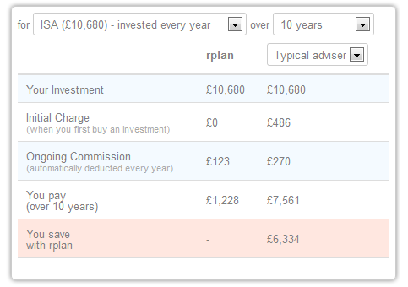

For more information, more regional findings or to arrange interviews with rplan.co.uk contact
guy@elephantcommunications.co.uk 07766 775216
Lindsay@elephantcommunications.co.uk 07851 180501

Methodology and Sources
- Research into Investor charges, ISA investing this tax year and taking financial planning more seriously were conducted by Vision Critical and YouGov among a GB representative sample of 2,000 people.
- £192bn invested in Cash ISAs - HMRC
- 97% of cash ISAs have failed to beat RPI – cash ISAs sourced from www.moneysupermarket.com

About rplan.co.uk
A new market entrant, rplan.co.uk is a financial planning business. rplan.co.uk helps the 38% of Britons that have no financial plan in place to get back in control of their finances and, for the financially savvy, it connects like-minded people. At rplan.co.uk everyone saves money on commissions that many don't even know they are paying and nobody pays more than £15 per month.rplan.co.uk brings together four essential elements:
- Plan. For each life goal, people can put together a financial plan and keep track of how close they are to achieving it.
- Save money: rplan refunds at least 50% of the ongoing commissions people pay for the investments they hold through the site. With rplan people can also check for free the charges they are already paying (www.rplan.co.uk/charges ).
- Analyse: Simple tools and free mobile apps to keep people up to date on their savings.
- Share: In addition to expert commentary, people can share insights and experiences with like-minded people.

rplan.co.uk of 2 Frederick Place, London N8 8AF is authorised and regulated by the Financial Services Authority ("FSA") under reference number 529879.
-ENDS-

