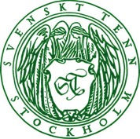

Press Release

Stockholm, September 15, 2016

**Svenskt Tenn adds five new locally made items to its range**

**At the autumn season exhibition ”Local Design” now opening, Svenskt Tenn introduces five new products handcrafted in shops across Sweden. The new items are a mix of classic and contemporary designs, including a revolving bookcase by Folkform, a vase designed by Tim Karlsson, a cake stand by Benjamin Curtis, a carpet by Jakob Solgren, and the 2238 Chair by Josef Frank – revived from the Svenskt Tenn archive.**

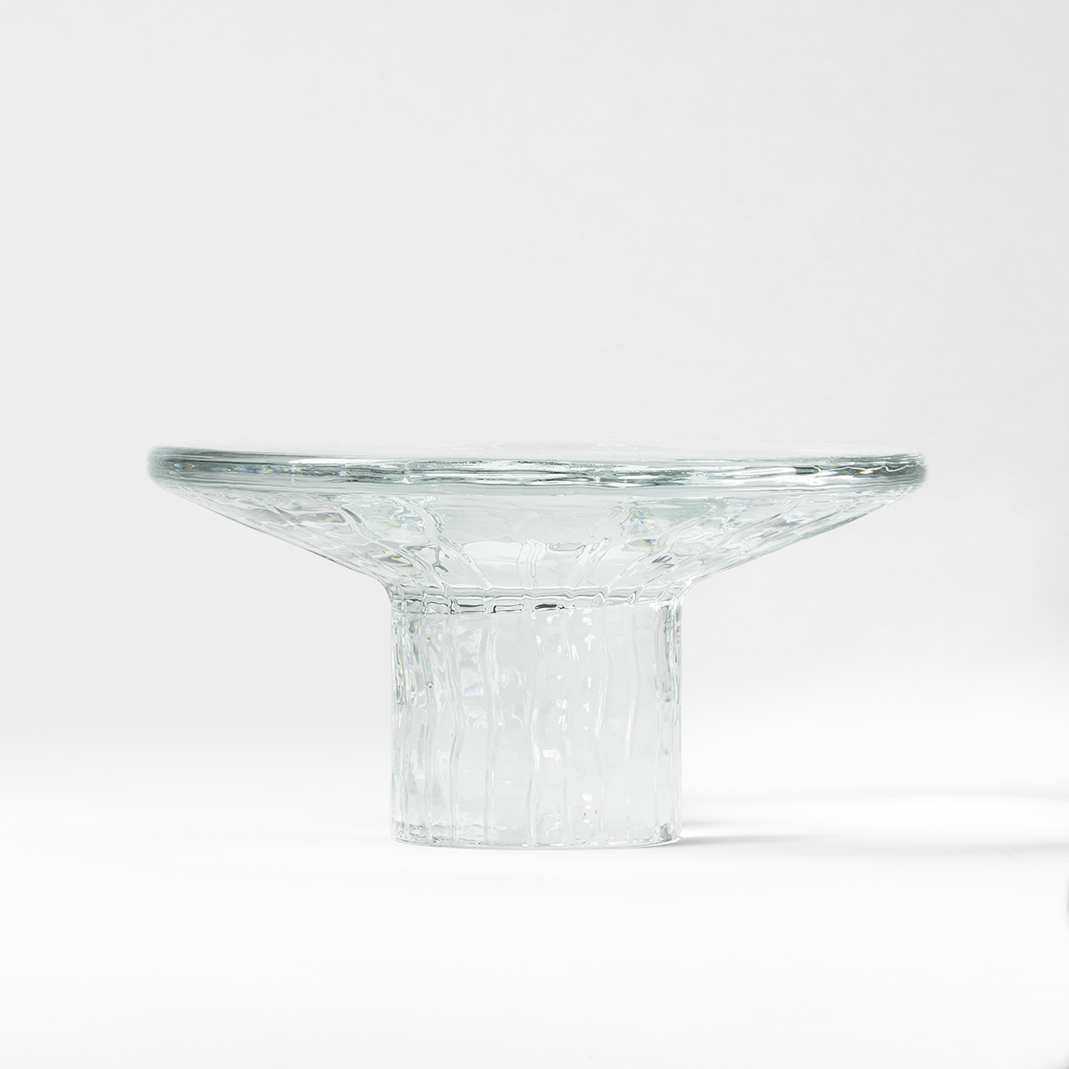Tim Karlsson and Benjamin Curtis both earned their degrees from Beckman’s College of Design in 2016, and were selected for Svenskt Tenn glass scholarship this year. They have now created two new pieces for Svenskt Tenn’s range, the ”Kontur” vase and the cake stand ”Tratt”, both manufactured by the Rejmyre glassworks.

”With this launch, we intend to highlight the wide scope of Svenskt Tenn’s range,” says Thommy Bindefeld, marketing manager at Svenskt Tenn. “We have developed new products together with fresh graduates such as Tim and Benjamin, collaborated with established designers Jakob Solgren and Folkform, and recreated Josef Frank’s classic design from 1957.”

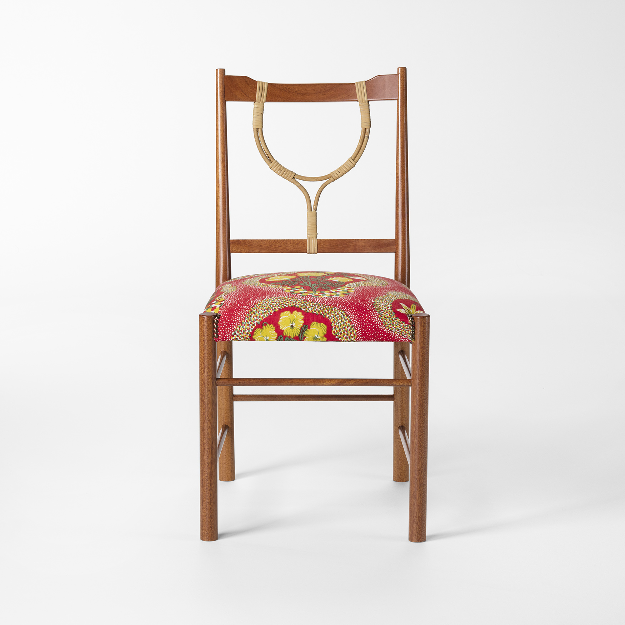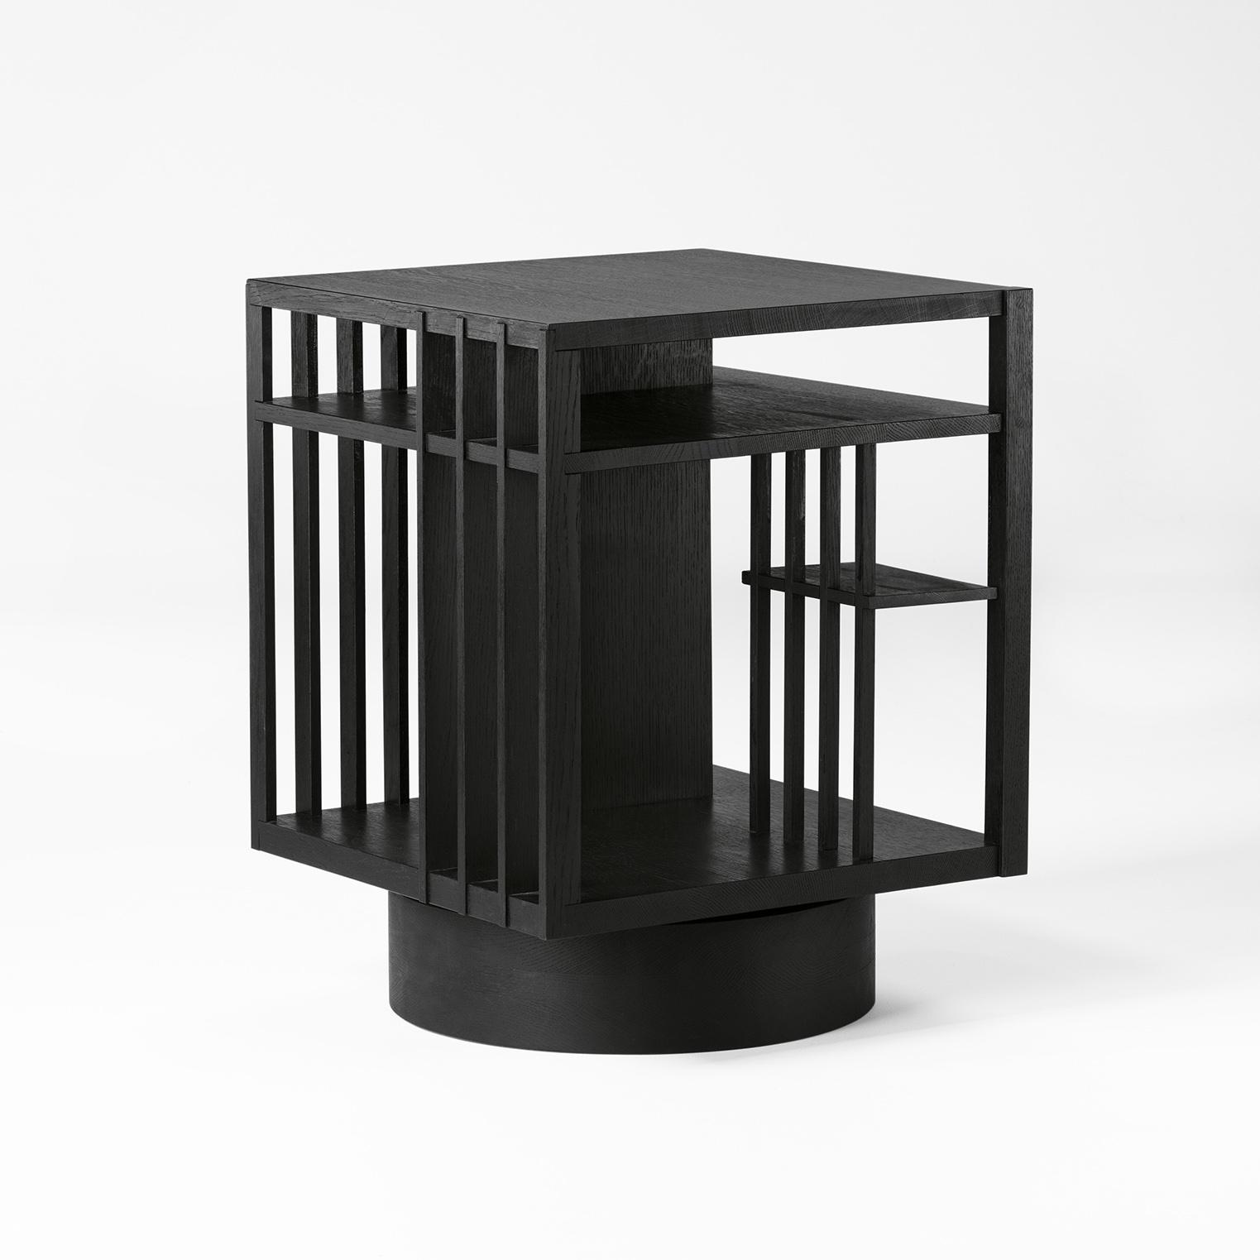The ”Revolving Bookcase” by designer duo Folkform is a reinterpretation of an archetypal piece of furniture, inspired by architecture and revolving bookcases of the past.

Jakob Solgren, who previously has designed pewter items for Svenskt Tenn, now makes his first effort in textiles, resulting in the ”Trädgårdsmattan” (Garden carpet), produced by Kasthall.

Josef Frank’s ”2238” chair – which is likely his last design of this kind – is adorned by a rattan lyre, handmade by basket makers Larsson Korgmakare.

At the ”Local Design” exhibition, visitors are taken behind the scenes at the workshops where the new products are manufactured. The exhibition opens September 16 and runs through November 6, in the Svenskt Tenn store at Strandvägen 5 in Stockholm.

**For further information, please contact:**

Vicky Nordh, Marketing Assistant: +46 8-670 16 23 or vicky.nordh@svenskttenn.se

Thommy Bindefeld, Marketing Director: +46 8 670 16 02 or thommy.bindefeld@svenskttenn.se

Images can be downloaded from [svenskttennpress.se](http://www.svenskttennpress.se). Username: *Press*. Password: *Tenn*

Svenskt Tenn is an interior design company with retail stores at Strandvägen in Stockholm and online. Since 1975, Svenskt Tenn is owned by the Kjell and Märta Beijer Foundation, which provides research grants within ecology, medicine and the preservation of Swedish interior design tradition.