Media Release
SINCRO ENERGY SYSTEMS LAUNCHES IN SINGAPORE
22 May 2013 – Singapore – Sincro Energy Systems launched in Singapore yesterday, with an event held for 50 of its esteemed business partners. Enrico Soga, CEO of Soga S.p.A, was in attendance for the launch. Soga S.p.A is the leading company of Soga Energy Team for Soga, Sincro, Agrowatt and Soga energies branded products, which will be distributed in Asia by Sincro Energy Systems.
Sincro Energy Systems is based in Singapore as Soga’s hub for Asia. The purpose of the office is strategic to the company for further business development. Enrico Soga said that “We want to be here to stay as close as possible to our customers, to understand what they want and to reinforce our presence and service offering. By being close to the market, we believe we can offer better engineering solutions.”
Soga S.p.A is a totally independent company, with 47 years of manufacturing experience. Their products are known for their quality, reliability and durability. They offer continuous innovation, customized solutions, an international presence and an active after sales service.
“To create great products, you need power behind the process”, says Enrico Soga. “No one knows better how to harness power for industrial use than the Soga Energy Team. Made in Italy, our products have the quality guaranteed that comes from being manufactured in Europe.”
Soga Energy Team is a leading innovator of rotating electrical machines with a broad range of applications in a wide group of industries. Creator of the Soga and SINCRO brands of electrical motors, both synonymous with quality in production and performance, the Soga Energy Team creates both standard and customised products for customers around the world.
The power solutions distributed by Sincro Energy Systems are suitable for use in applications for Industry, Marine and Energy. The brands distributed include:
- SOGA, asynchronous electric motors
- SINCRO, synchronous alternators and rotating welders
- AGROWATT, PTO generators and pumps
- SOGAENERGIES generators for wind turbines and energy for special projects, and
- E.K. ELEKTROAGREGATI, special generating sets for Croatia.
Manufactured in northern Italy using modern manufacturing techniques, SINCRO’s quality products are made in accordance with ISO 9001 certification and come with a firm guarantee of reliability. All stages of manufacture, from die-casting of lightweight aluminum bodies to winding of stators and rotors and final assembly are done by the Italian factory’s own production staff, enabling stringent quality control.
- END -

NOTES TO EDITORS
For more product information, please visit http://www.sogaenergyteam.eu/

MEDIA CONTACT
Illka Gobius
Principal Consultant, PINPOINT Public Relations
illka@pinpoint-pr.net
mobile +65 9769 8370

IMAGES

Opening Ceremony

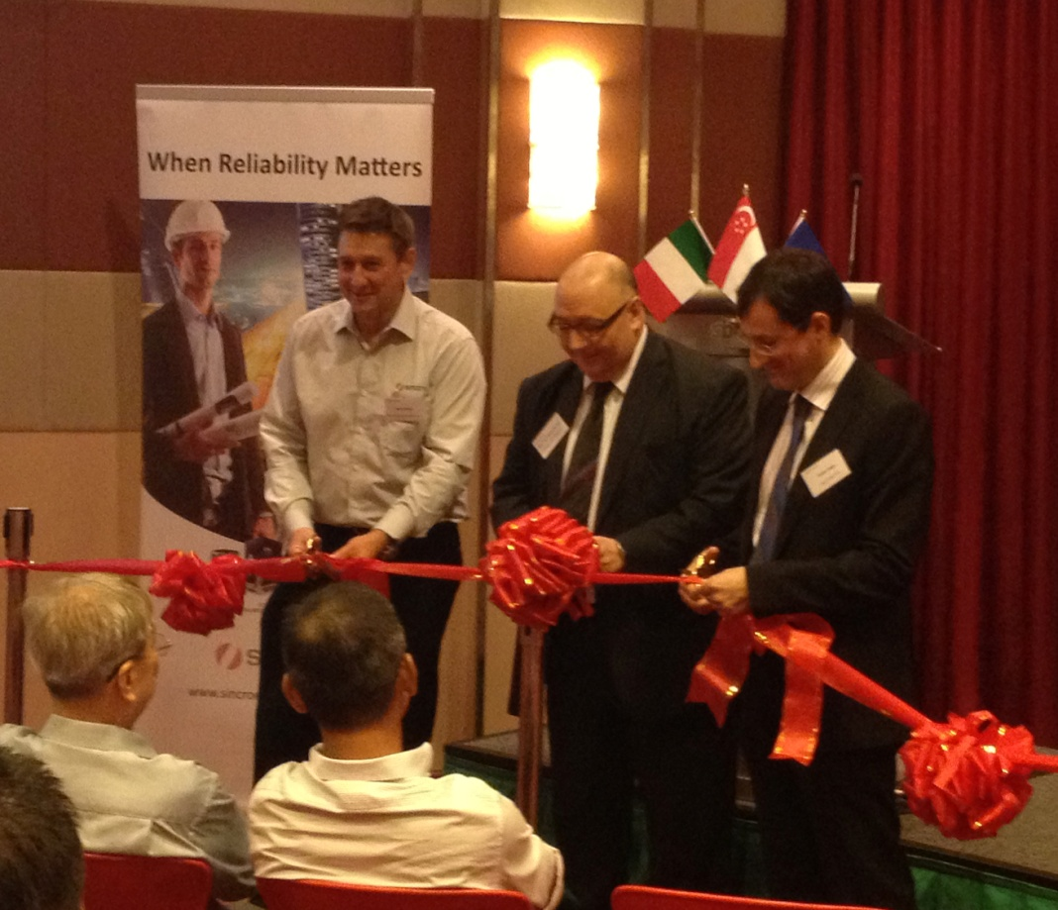

Mr Terry Parker, Managing Director, Sincro Energy Systems Pte Ltd; Mr Giovanni Rosso, Head of Commercial, Embassy of Italy; Mr Enrio Soga, CEO of Soga S.p.A

Opening Speech
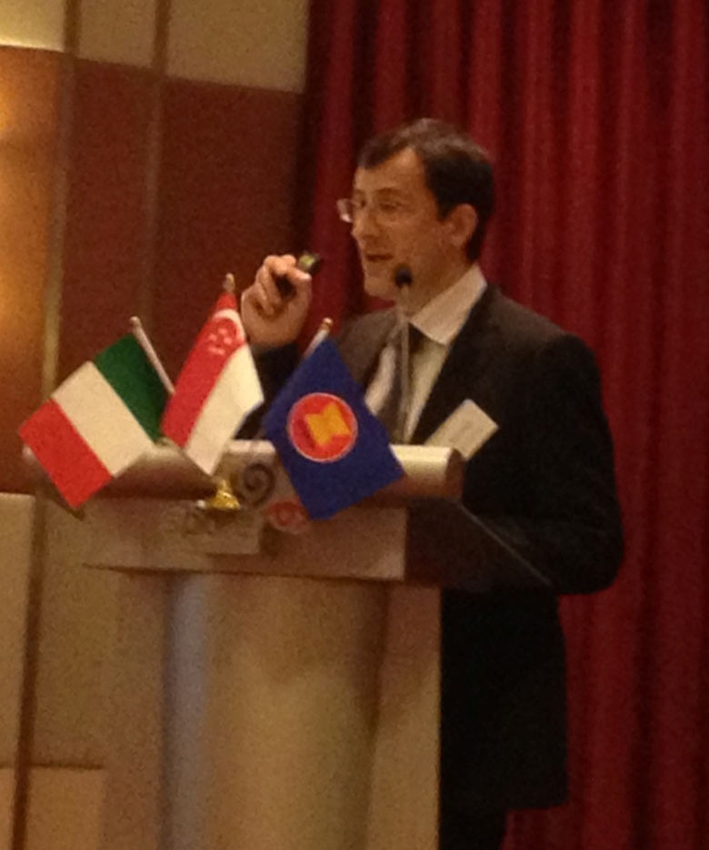
Mr Enrio Soga, CEO of Soga S.p.A

