PRESS RELEASE FOR IMMEDIATE RELEASE

**CLARKE QUAY DAILY SET LUNCHES 2016**

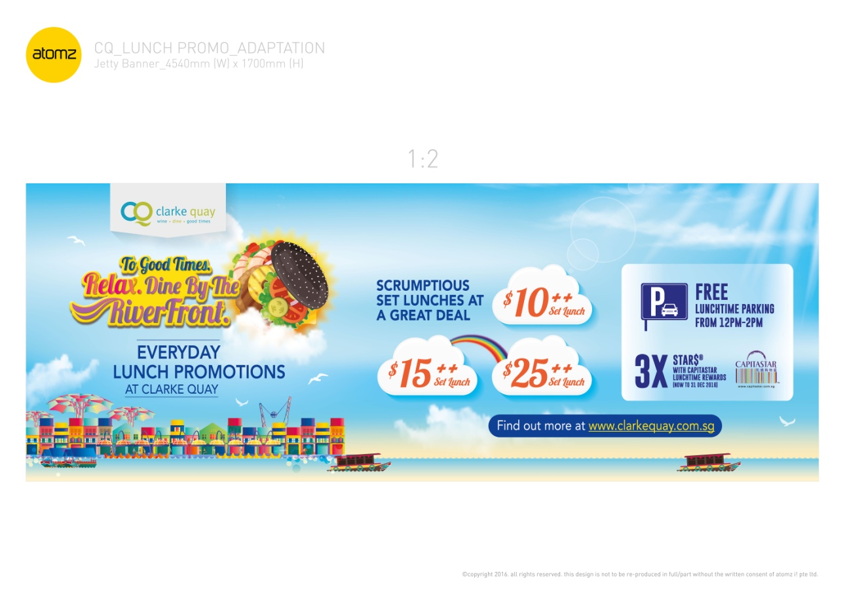

#### SINGAPORE, 01 MAY 2016 – Great food can be affordable at Clarke Quay’s as our **daily set lunches** returns with new tastes and wider selection!

#### Take a stroll by the Singapore River for a perfect alfresco luncheon with your office colleagues for a leisure lunch without breaking your wallet. These restaurants in Clarke Quay are serving scrumptious set menus leaving your belly and your wallet full. Priced at ****$10++, $15++ or $25++****, Clarke Quay offers the most varied options of quality set lunch offerings in one destination.

#### New in 2016, we are rolling out the “No More Monday Blues” promotion to help curb your melancholy Monday! All these made possible with the amazing 1-for-1* deals on the first Monday of every month! Dine in outlets such as McGettigan’s , Little Saigon, Fremantle Seafood Market and many more!

#### D:\Users\aarongoh\Desktop\2016 LUNCH DOCUMENTS\Tenants promotions\Fremantle Seafood Market ( With 1for1)\Fremantle-151554.jpg

#### For just $10++, you will find a quaility mix of continental and international favourites! At Fremantle Seafood Market, you get to enjoy the freshest catch of Japanese Black Cod Fish served with Fries and Coleslaw! If you are a wings lover, swing by Hooters to enjoy Signature Hooters Specialty Wings & Fries. To get your comfort food cravings fixed, visit Xiao Chen Gu Shi小陳故事for a Bak Kut Teh set at an unbeatable price of $10++! For many other more choices, refer to [Appendix A](http://www.mynewsdesk.com/sg/clarke-quay/documents/download/resource_document/34325).

#### D:\Users\aarongoh\Desktop\2016 LUNCH DOCUMENTS\Tenants promotions\Tomo Izakaya (with 1 for 1)\Bento copy.jpg

#### Moving up a notch at **$15++**, this daily set offer a host of old and new favorites selections from ****Bayang, Catch Beer & Batter, The Butchers Club Burger****, ****Tomo Izakaya and more.****  Nasi Goreng Indonesia with Satay Ayam, Signature Ale Battered Fish & Chips and The Wu Tang Style Sliders are just some of the perennial favourites on menu. Refer to [Appendix B](http://www.mynewsdesk.com/sg/clarke-quay/documents/download/resource_document/34325) for more details.

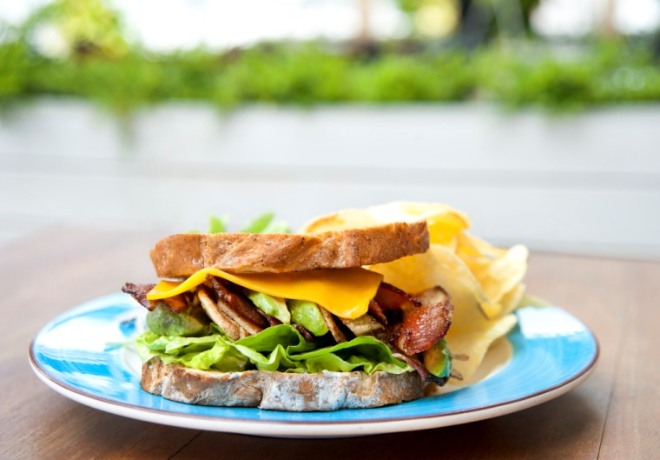Another great option for a **business lunch** is the **$25++ set lunch which** offers a heartier taste of their menu from outlets such as **Maziga Café, RAS The Essence of India , Peony Jade** and many more. **Peony Jade** offers a 5-course ala-carte Set lunch with selections like Peony Jade’s Signature Smoked Duck with Black Peppercorn Sauce, Cappuccino Pork Spare Ribs with Roasted Almond, Crabmeat Boullion with Golden Mushroom and more! Refer to **Appendix C** for more details.

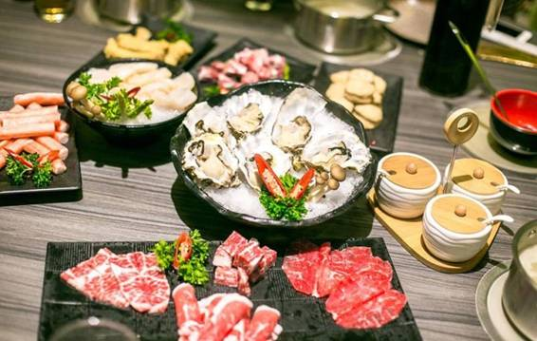For the ultimate lunch indulgence, drop by **Faigo Hotpot小辉哥**, a well known and popular chain of premier hotpot restaurants from China. Their unbelievable lunch special is at $19++, $29++ and $39++ for the freshest catch of seafood and poultry! Not forgetting the all time popular **Hai Di Lao Hotpot 海底捞火锅**! From the attentive services to the freshest ingredients, this is a wonderful get together place for your executive lunches!

Lastly, drop by **tcc- The Connoisseur Concerto** to get your after-meal caffeine fix or if you have not satisfy your desserts craving. With the breeze from Singapore River and the aroma from their Gourmet Syphon Brew, I am sure you will be wishing that you could spend the whole afternoon here in Clarke Quay.

To compliment the experience at Clarke Quay, there is **Free Lunchtime Parking** every **Mondays to Fridays from 12.30pm to 1.30pm, excluding Public Holidays**. Lastly all **CapitaStar** members receive **3 X STAR$\*** for all your lunch receipts at Clarke Quay.

So forget about the hawker fares or long queue at the busy shopping malls and head down to Clarke Quay for a simply delectable lunch in a tranquil setting. For more details on the set lunch available at Clarke Quay, simply log on to www.clarkequay.com.sg/lunch

* Terms & conditions apply. All information is correct at time of release and may be subjected to change.

– End –

About Clarke Quay ([www.clarkequay.com.sg](http://www.clarkequay.com.sg))

Located along the iconic Singapore River at the fringe of Singapore’s Central Business District, Clarke Quay sits on a historical commercial site dating back to the 19th Century. Today, Clarke Quay has been boldly restored and refurbished into five beautiful waterfront godowns under a climate controlled canopy illuminated by coloured lighting, creating a modern and cosmopolitan ambience amidst the tradition and history. Owned by CapitaLand Mall Trust and managed by CapitaLand Mall Asia, Clarke Quay plays host to a wide array of about 60 restaurants, wine bars and entertainment outlets, attracting about one million visitors every month.

Clarke Quay was crowned Singapore’s best nightspot at the 2014 AsiaOne People’s Choice Awards, organised by AsiaOne, Singapore’s leading news portal. Last year, Clarke Quay was awarded the 2015 Certificate of Excellence by TripAdvisor and identified by TripAdvsor as one of 50 iconic places to visit in Singapore, based on the travel website’s data on the most-reviewed attractions and eateries.

**Clarke Quay Media Contact**

Elene Foo (Ms)   
Marketing Communications (Manager)

DID: 6557 7063 FAX: 6334 8423

Email: [elene.foo@capitaland.com](mailto:elene.foo@capitaland.com)

Sarah Cai (Ms)

Marketing Communications (Executive)

DID: 6557 7052 FAX: 6334 8423

Email: [sarah.cai@capitaland.com](mailto:sarah.cai@capitaland.com)

Aaron Goh (Mr)

Marketing Communications (Executive)

DID: 6557 7061 FAX: 6334 8423

Email: [aaron.goh@capitaland.com](mailto:aaron.goh@capitaland.com)

Appendix A

**SET LUNCHES AT $10++ (Daily unless otherwise stated)**

1. **FREMANTLE SEAFOOD MARKET**

Block E, #01-05/06

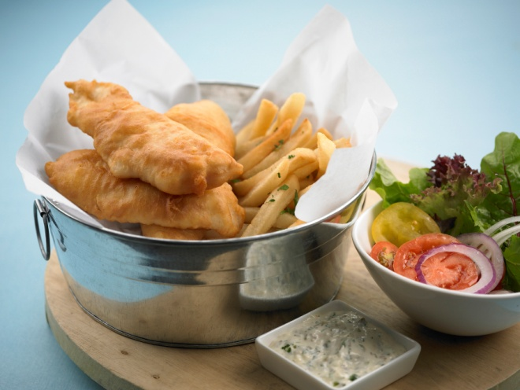

**Grilled Chicken with Roasted Potatoes and Mixed Greens with Passionfruit Dressing** OR **Japanese Black Cod Fish and Chips served with Fries and Coleslaw**

Promotion is only valid daily from Mondays to Sundays from 12pm to 3pm. Dine-in only.

1. **HOT STONES STEAK AND SEAFOOD**

Block D, #01-06

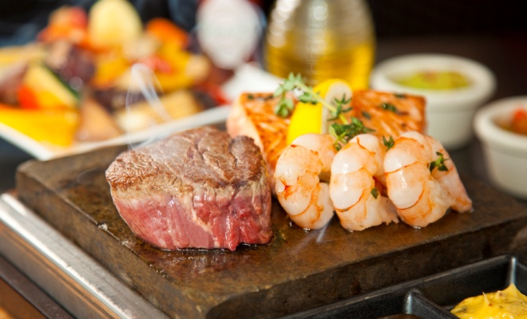

**Salmon Fillet OR Seafood Aglio Olio.**

Promotion is only valid daily from Mondays to Sundays from 12pm to d3pm. Dine in only.

1. **LITTLE SAIGON**

Block E, #01-02

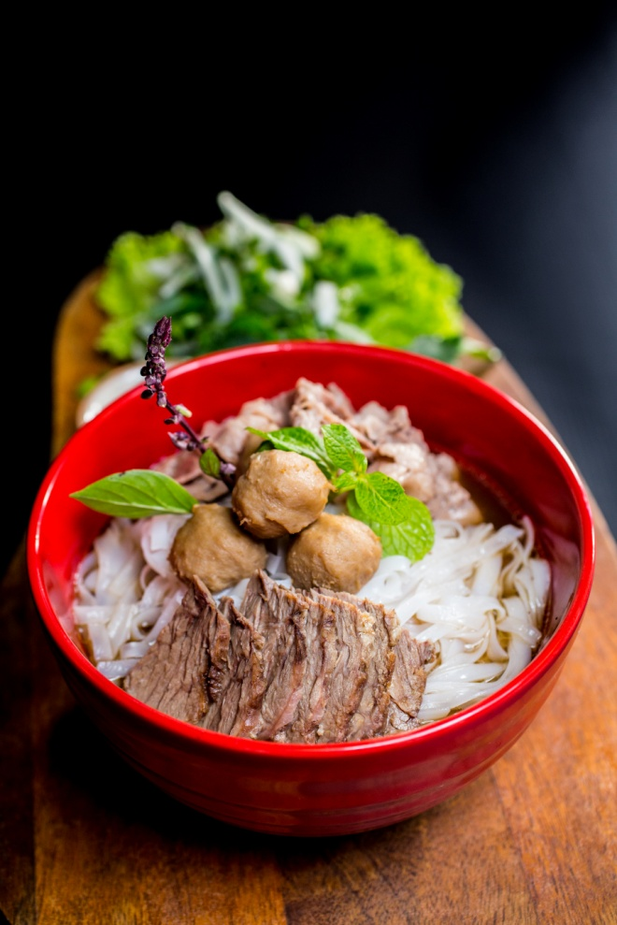

**Pho Bo (Beef Noodle Soup)** & a **Glass of Soft Drinks/ Juice**

Promotion is only valid daily from Mondays to Sundays from 12pm to 3pm.

1. **HOOTERS**

Block D, #01-03

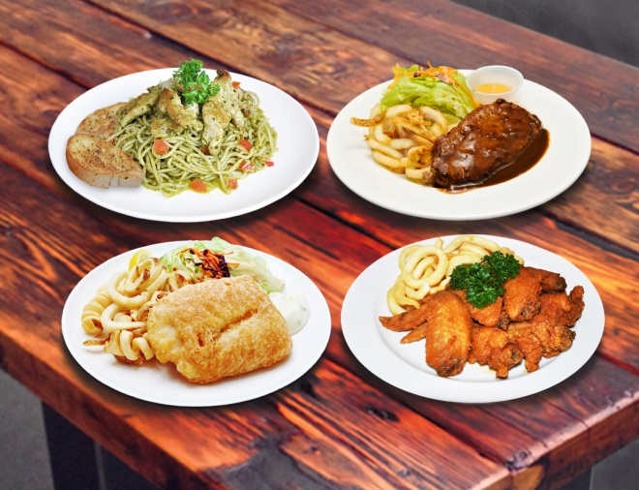

**Main Course + Ice-Cream + Soft Drink**

**Choice of Wings & Fries, Fish, Chicken, Pasta, Sandwich, Salad and more**

**Promotion is only valid daily from Mondays to Sundays from 11pm to 3pm.**

1. **The BUTCHERS CLUB BURGER**

Block A, #01-01B

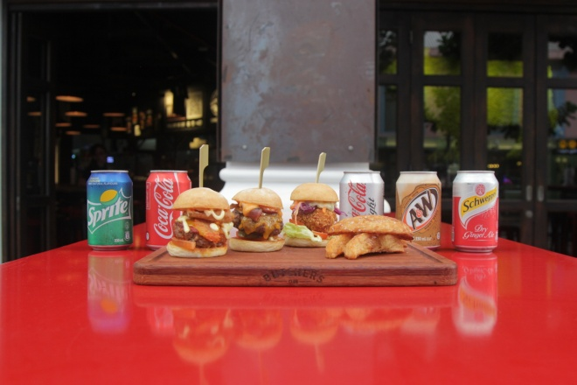

**1 slider (choice of: The Burger/Wu Tang Style/ Captain Ahab) + 1 serving of Duck Fat Fries + 1 Soft Drink**

Promotion is only valid daily from Mondays to Fridays from 12pm to 3pm. No Service charge.

1. **小陳故事(Xiao Chen Gu Shi)**

Block E, #01-08

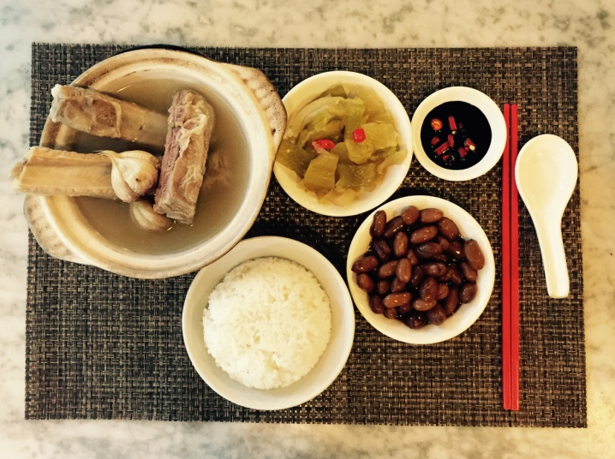

**Chicken Rice Set + 4 Sides + 1 Soup**

**OR**

**Bak Kut Teh Set with 2 sides (Braised Peanuts & Salted Vegetables) served with white rice**

Promotion is only valid daily from Mondays to Fridays from 12pm to 3pm.

**Terms & conditions**

-Photos are for illustration purposes only

-Promotions are not valid with other promotions, discounts and credit card privileges.

-All information is correct at the time of release and may be subjected to change.

-Prices may be subjected to GST and service charge.

-Outlet reserve the right to amend the terms and conditions without prior notification.

-Other terms and conditions apply. Check with individual outlets for more information.

Appendix B

**SET LUNCHES AT $15++ (Daily unless otherwise stated)**

1. **RAS THE ESSENCE OF INDIA**

Block D, #01-05A

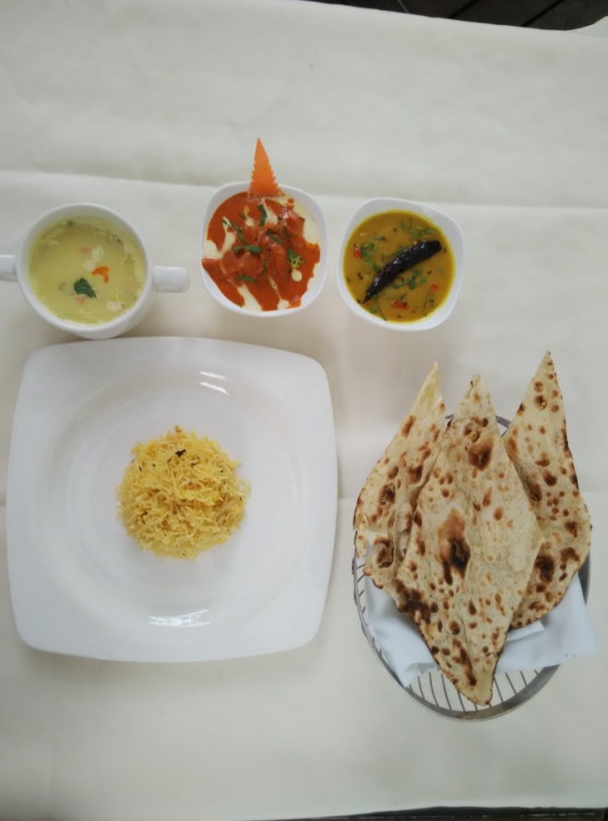

**-Soup of the Day**

**-Chicken Curry of the Day /Paneer of the Day**

**-Dal of the Day**

**-Rice**

**-Naan/Roti**

Promotion is only valid daily from Mondays to Fridays from 11pm to 2pm.

1. **MCGETTIGAN’S**

Block A, #01-01C/D

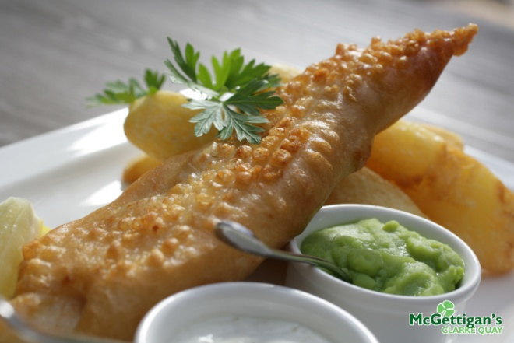

**-Soup of the Day**

**1 choice of the following:**

**-Fish & Chips**

**-Bangers + Mash**

**-Open Steak Sandwich**

Promotion is only valid daily from Mondays to Sundays from 12pm to 3pm.

1. **FREMANTLE SEAFOOD MARKET**

Block E, #01-05/06



**2 Course Set Lunch –**

**- Soup of the day**

**- 1 choice of Main**

**Grilled Barramundi with Spinach Pesto Risotto OR Salmon Wellington with Lemon Cream Sauce and Meslun Green**

Promotion is only valid daily from Mondays to Sundays from 12pm to 3pm. Dine in only.

1. **HOT STONES STEAK AND SEAFOOD**

Block D, #01-06



**2 Course Set Lunch –**

**Soup of the day + 1 choice of Main**

**Australian Sirloin OR Chicken Breast OR Beef Bolognese Ricotta Lasagna**

Promotion is only valid daily from Mondays to Sundays from 12pm to 3pm.

1. **TOMO IZAKAYA** (nett price)

Block A, #01-04

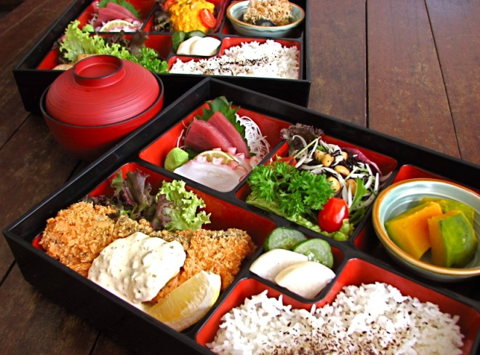

**Choice of Bento A OR B**

|  |  |
| --- | --- |
| **Bento A :** | **Bento B** |
| **2 kinds of Sashimi**  **1x Daikon Mizuna Salad**  **1x Avocado Kimchee**  **1x Gohan**  **1X Buta Niku to Nasu Itame** | **2 kinds of Sashimi**  **1x Daikon Mizuna Salad**  **1x Dashimaki Tamago**  **1x Gohan**  **1X Saba no karaage** |

Promotion is only valid daily from Mondays to Sundays from 12pm to 3pm.

Menu might change due to availability of ingredients. Check in store for more information.

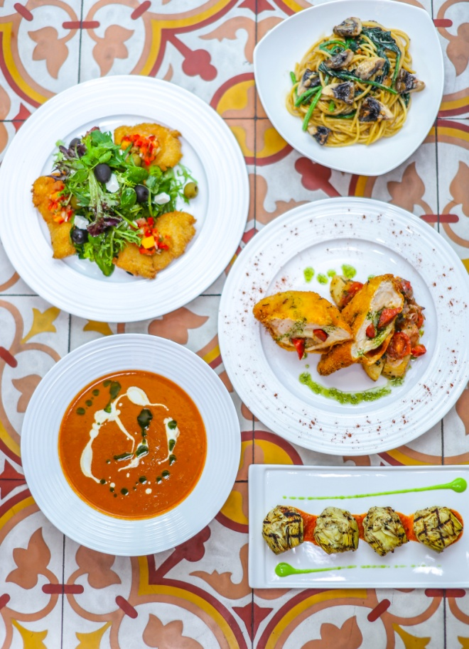

1. **OCTAPAS, SPANISH TAPAS BAR**

Block D, #01-08

**$15++ for any Choice of 2 Tapas from selected Tapas menu**

**$18 ++ for any Choice of 3 Tapas from selected Tapas menu**

Promotion is only valid daily from Mondays to Fridays from 12pm to 3pm.

1. **THE BUTCHERS CLUB BURGER**

Block A, #01-01B



**2 sliders (choice of: The Burger/ Wu Tang Style/ Captain Ahab) + 1 serving of Duck Fat Fries + 1 Soft Drink**

Promotion is only valid daily from Mondays to Fridays from 12pm to 3pm. No service charge.

1. **Harry’s**

Block D, #01-01

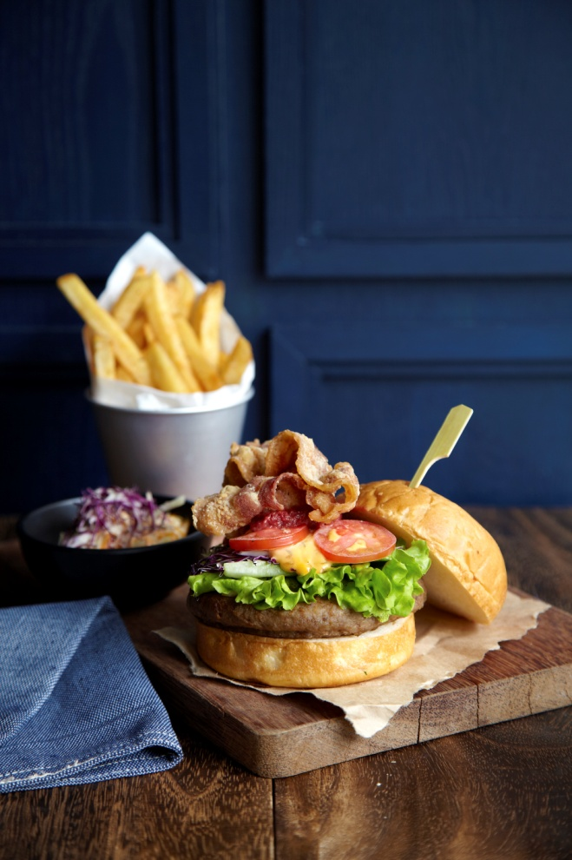

**Enjoy any Big Plate (choose from any big plates excluding Curried Lamb Shank and Steak & Eggs) with a complimentary drinks (choose from Soft Drinks, Coffee, Tea, Iced Coffee & Iced Tea)**

Promotion is only valid daily from Mondays to Sundays from 12pm to 3pm.

1. **Catch Beer & Batter**

Block A, #01-01

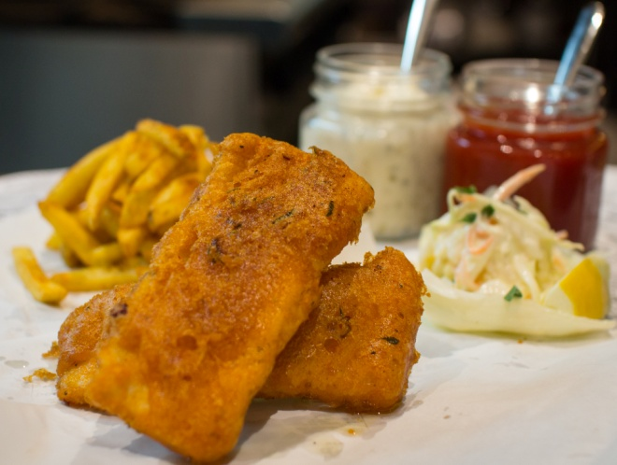

**2 Course Set Menu:**

**- Mix Garden Green Salad with Garlic Toast**

**- Signature Ale Batter Fish and Chips OR Pasta of the day**

**- Includes selected soft drink**

Promotion is only valid daily from Mondays to Sundays from 12pm to 3pm.

1. **HUTONG**

Block D, #01-07

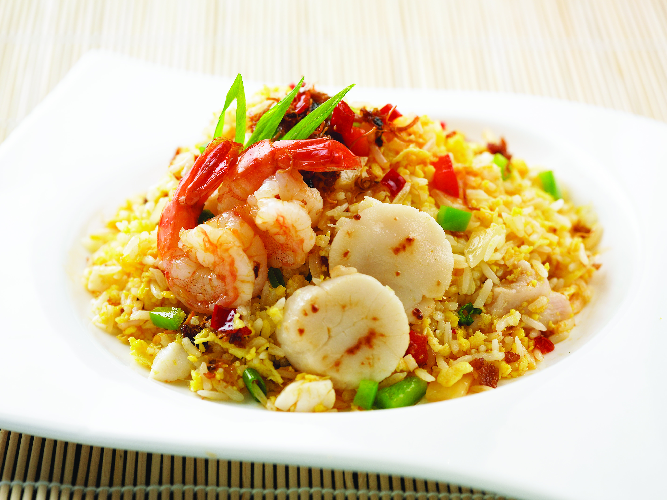

**SOUP: Cream Of Corn**

**Choice Of Appertizer:**

**1) Steamed Spicy Shrimp Wanton**

**2) Deep Fried Spring Roll**

**Choice Of Main Course:**

**1) XO Seafood Fried Rice**

**2) Fried Noodle with Beef in XO Sauce**

**3) Crispy Noodle with Vegetables & Mushroom**

**Choice Of Beverage:**

**1) Hot Tea**

**2) Fresh Lime Juice**

Promotion is only valid daily from Mondays to Fridays from 12pm to 3pm.

1. **RENNTHAI**

Block D, #01-05

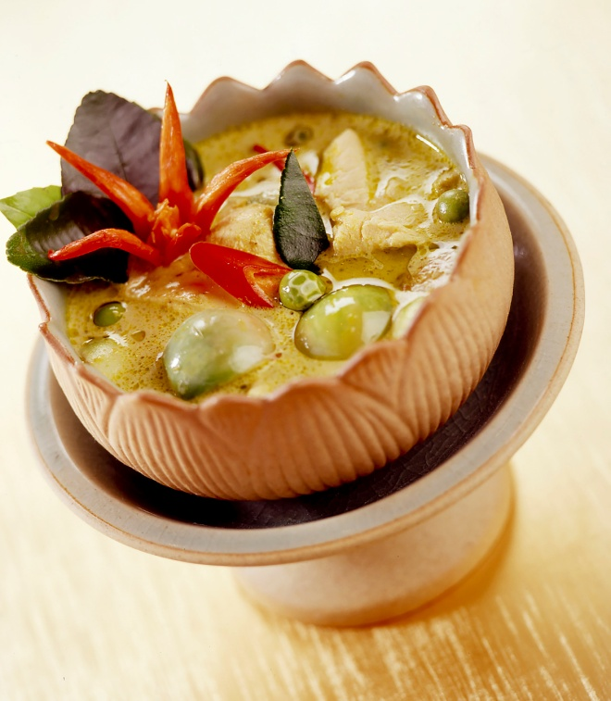

**SOUP: Tom Yum Chicken Or Vegetarian**

**Choice Of Main Course:**

**1) Thai Pineapple Rice with Chicken Skewers**

**2) Black Olive Rice with Fried Chili Fish Fillet**

**3) Green Curry Chicken or Vegetarian with Jasmine Rice**

**Choice Of Beverage:**

**1) Iced Lime Tea**

**2) Calamansi Juice**

Promotion is only valid daily from Mondays to Fridays from 12pm to 3pm.

1. **MUCHOS**

Block D, #01-04

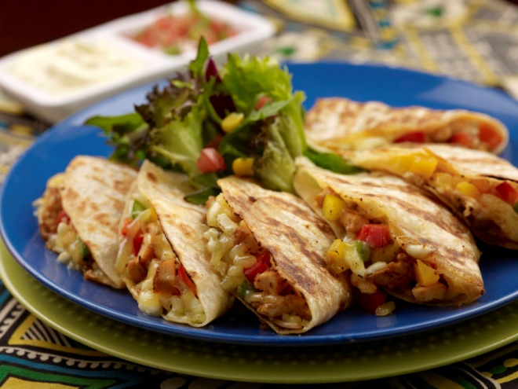

**SOUP: Soup of the Day**

**Choice Of Main Course:**

* **Quesadillas (Choice of grilled chicken, grilled beef or vegetarian)**
* **Burritos (Choice of grilled chicken or pan-fry vegetables)**
* **Chile Con Carne Served w spinach rice**

**Dessert: Single Ice Cream Scoop topped w chopped nuts**

**\* Chocolate**

**\* Vanilla**

Promotion is only valid daily from Mondays to Fridays from 12pm to 3pm.

1. **BAYANG**

Block A, #01-05

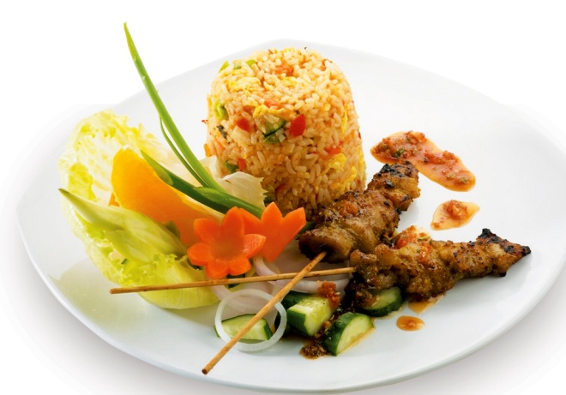

**Salad :**

**Gado -Gado Salad**

**Choice Of Mains:**

**1) Bakmee Ayam with Popiah Goreng**

**(fried chicken noodle with Spring Roll)**

**2)Nasi Goreng Indonesia w Sate Ayam & Crackers**

**( Indonesian fried rice style with grilled Chicken Skewers & Crackers)**

**3) Laut Bumbu Kuning / Laut Sayur with Nasi Kuning**

**( Yellow Curry with Seafood or Vegetables served with Coconut Rice)**

**Choice Of Drinks:**

**1) Iced Lemon Tea**

**2) Fresh Lime Juice**

**Daily Dessert of the Day**

Promotion is only valid daily from Mondays to Fridays from 12pm to 3pm.

1. **MAZIGA CAFÉ & CLUB**

Block c, #01-10/#02-03

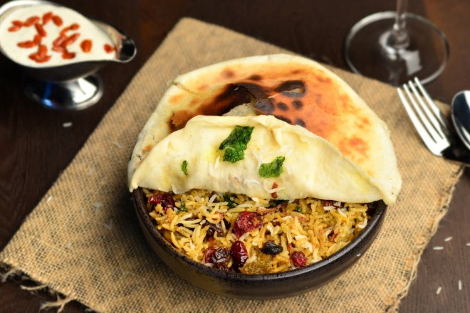

**Choice Of Salad**

**-Caesar Salad Chicken Tikka Roasted**

**-Kachumber Avacoda Salad**

**Choice Of Main Course**

**-Chicken Tikka cooked in rich tomato and Nutty Gravy served with Mini Methi Butter Naan**

**-Tava grilled fish wraps in banana leaves served with coconut creamy sauce and curry leaves tempered rice.**

Promotion is only valid daily from Mondays to Sundays from 12pm to 3pm.

1. **MOTORINO**

Block A, #01-01A

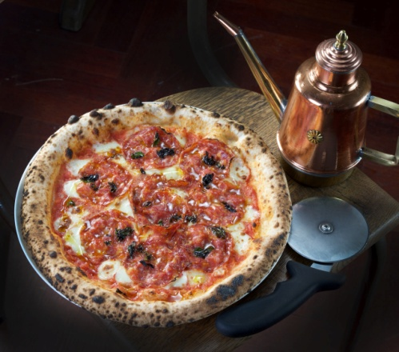

**Set includes:**

**Choice of 1 pizza:**

**- Margherita**

**- Marinara**

**-Iced Lemon Tea**

Promotion is only valid daily from Mondays to Sundays from 12pm to 3pm.

**Terms & conditions**

-Photos are for illustration purposes only

-Promotions are not valid with other promotions, discounts and credit card privileges.

-All information is correct at the time of release and may be subjected to change.

-Prices may be subjected to GST and service charge.

-Outlet reserve the right to amend the terms and conditions without prior notification.

-Other terms and conditions apply. Check with individual outlets for more information.

Appendix C

**SET LUNCHES AT $25++ (Daily unless otherwise stated)**

1. **PEONY JADE**

Block A, #02-02

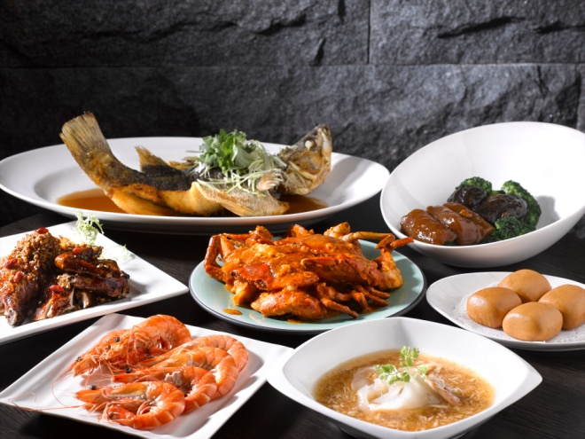

**Set Lunch Selection includes :**

* **Smoked Duck with Black Peppercorn Sauce**
* **Cappuccino Pork Spare Ribs with Roasted Almond**
* **Crabmeat Boullion with Golden Mushroom**
* **Stewed Egg-plant with Minced Pork in Special Sauce**
* **Hot Sweetened Read Bean Cream with Lotus Seed**

Promotion is only valid daily from Mondays to Fridays from 12pm to 2pm. Minimum of 4 pax. For dine in only.

1. **RAS THE ESSENCE OF INDIA**

Block D, #01-05A

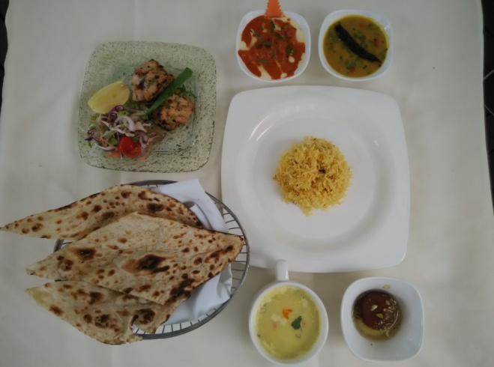

**4 course Set Meal:**

* **Soup of the Day**
* **Non Veg Kebab / Veg Kebab**
* **Chicken Curry of the Day /Paneer of the Day**
* **Dal of the Day**
* **Rice**
* **Naan/Roti**
* **Dessert of the Day**

Promotion is only valid daily from Mondays to Sundays from 11pm to 2pm.

1. **FREMANTLE SEAFOOD MARKET**

Block E, #01-05/06



**3 Course Set Lunch :**

* **Soup of the day**
* **Choice of Main Course**

**Penne Seafood Arrabbiata OR Grilled Salmon with Puy Lentils Salad and Lemon Beurre Blanc**

* **Dessert of the Day**

Promotion is only valid daily from Mondays to Sundays from 12pm to 3pm.

1. **HOT STONES STEAK AND SEAFOOD**

Block E, #01-06



**3 Course Set Lunch – Soup of the day + Main + Dessert**

**Surf & Turf Australian Sirloin, Tiger Prawns and Chicken Breast OR Mixed Grill Australian Sirloin, Pork Loin and Chicken Breast OR Seafood Linguine in Tomato Base Sauce**

Promotion is only valid daily from Mondays to Sundays from 12pm to 3pm.

1. **LITTLE SAIGON**

Block E, #01-02

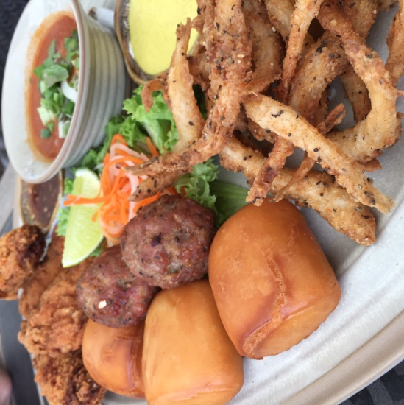

**Saigon Lunch Platter & a Glass of Soft Drinks/Juice**

**(Crispy Wings, Golden White Baits, Pork Meatballs, Chili Crab)**

Promotion is only valid daily from Mondays to Sundays from 12pm to 3pm.

1. **PRIVÉ CLARKE QUAY**

Block C, #01-09A

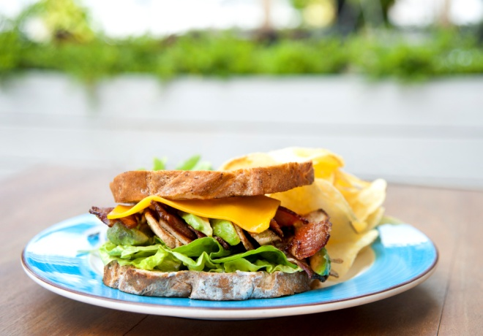

**Sandwich + Soup Or Salad + Soft Drink**

Promotion is only valid daily on Saturdays & Sundays from 12pm to 3pm only.

1. **THE BUTCHERS CLUB BURGER**

Block A, #01-01B



**Any choice of regular burgers including from Secret Menu (except for Double Happiness) + 1 serving of Duck Fat Fries + 1 Soft Drink**

Promotion is only valid daily from Mondays to Fridays from 12pm to 3pm. No service charge.

1. **MAZIGA CAFÉ & CLUB**

Block C, #01-10/#02-03



**Starters**

-**Maziga magical Chaat**

**-Papdi Nachos Chaat**

**Choice of Salad**

* **Caesar Salad Chicken Tikka Roasted**
* **Kachumber Avacoda Salad**

**Choice of Main Course**

* **Chicken Tikka cooked in Rich Tomato and Nutty Gravy served with Mini Methi Butter Naan**
* **Tava Grilled fish wraps In banana leaves served with coconut creamy sauce and Curry leaves tempered rice.**

**Dessert**

**-Masala Chai Kulfi**

**-Indian Breakfast tea version creamy frost**

Promotion is only valid daily from Mondays to Sundays from 12pm to 3pm.

**Terms & conditions**

-Photos are for illustration purposes only

-Promotions are not valid with other promotions, discounts and credit card privileges.

-All information is correct at the time of release and may be subjected to change.

-Prices may be subjected to GST and service charge.

-Outlet reserve the right to amend the terms and conditions without prior notification.

-Other terms and conditions apply. Check with individual outlets for more information.