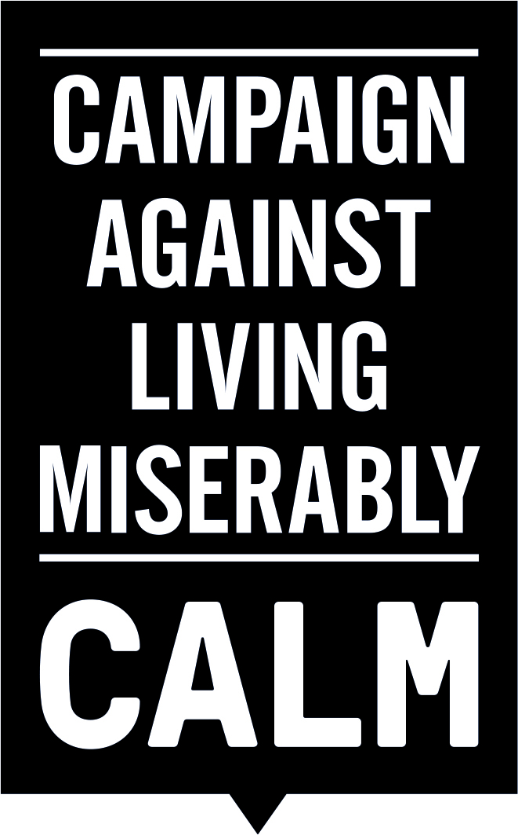

**International Men’s Day Debate Parliamentary Briefing Note : 17.11.15.**

*This campaign is supported by the following charities and alliances:* Campaign Against Living Miserably, Samaritans, Rethink Mental Illness, National Suicide Prevention Alliance, Papyrus Prevention of Young Suicide, Suicide Bereavement Support Partnership, Movember, The Helplines Partnership, British Psychological Society, Survivors of Bereavement by Suicide, James Wentworth-Stanley Memorial Fund, Matthew Elvidge Trust, If U Care Share Foundation, Harmless, Judi Meadows Memorial Fund, Hector’s House, Grassroots Suicide Prevention, Childhood Bereavement Network, The British Association of Social Workers, Pete’s Dragons, Healthcare Conferences, IMAGO Community, Imago Suicide Awareness for Everyone (SAFE), Barnett, Enfield & Haringey MHT, Haringey Suicide Prevention Group, Mind in Haringey, Dr Sharon McDonnell,  Research Fellow & Winston Churchill Fellow, Barry McGale, Florence Nightingale Fellow, Dr Alys Cole-King, Dr Rory O’Connor, Leeds Mind, Golden Tree CIC, Rotherham United Community Sports Trust, Recovery Focus, McPin Foundation, Suicide Liaison Service, Outlook South West (Cornwall & Isles of Scilly), The Tomorrow Project.

**On Thursday 19th November** 2015, a historic Parliamentary debate will be held in Westminster Hall to coincide with International Men’s Day.

It will be the first time that Members of Parliament have marked International Men’s Day with a debate on the issues that are more likely to affect men, such as poor educational attainment, involvement with the criminal justice system and male suicide.

**Male Suicide:**

Male suicide is the biggest single killer of men under the age of 45. In 2014, more than three quarters (76 per cent) of all suicides were men, 4,623 deaths.

A major new YouGov poll found more than four in 10 men (42 per cent) had considered suicide, with two fifths (41 per cent) never talking to anyone about their problems.

The survey of over 2000 men found half (49 per cent) of those who didn’t seek help “didn’t want people to worry about me”. A third (32 per cent) felt ashamed, nearly four in 10 (37 per cent), did not want to make a fuss and four in 10 (43 per cent) didn’t want to talk about their feelings.

According to the Department of Health’s Impact Assessment each suicide costs society an estimated £1.7 million.

We believe that without a revolution in attitudes towards suicide, treating it as a major public health issue, these figures are unlikely to improve. So CALM launched a campaign aimed at raising awareness of the male suicide.

**#BiggerIssues**

The #BiggerIssues advertising campaign compared the huge attention that society pays to relatively trivial topics such as the weather, type of coffee consumed in the morning, or what’s for lunch with its unwillingness to engage openly with male suicide.

Digital posters featuring the hashtag BiggerIssues were posted up across the UK and changed every two hours to represent the fact that every two hours a man will take his life. People were encouraged to lend their support at [www.biggerissues.co.uk](http://www.biggerissues.co.uk) and retweet the adverts.

The campaign was run in association with men’s grooming brand Lynx. Those supporting #BiggerIssues included people such as Stephen Fry, David Baddiel, Professor Green, Stuart Broad, Tulisa, Frank Turner, Matt Johnston, Rob da Bank, Jonny Benjamin, MistaJam and Zane Lowe.

**Support for the debate:**

This debate is backed by the country’s leading suicide prevention charities and alliances.

**Will you take part?**

We believe that Members of Parliament can play an important role in raising awareness of this problem, in discussing the solutions and breaking down the stigma that prevents too many men from seeking the help they need.

**When and where:**

The debate will take place in Westminster Hall, House of Commons, on International Men’s Day (19th November) commencing at 1.30pm.

**What we are asking for:**

We believe that four simple changes can make a difference to what are preventable deaths:-

1. **Count** – We need timely and accurate information to enable agencies to respond better. At the moment it can take up to two years to obtain an estimate of suicide numbers. We have a significant concern these are under-reported.

1. **Contain** – According to the World Health Organisation and over 50 research papers, there is a strong element of contagion with regard to suicide. We should treat it so and respond and support those impacted by suicide to prevent further loss of life, consequent illness, family breakup and job loss.
2. **Enforce** – All local authorities need to develop and implement a suicide prevention plan. Those that do not should be named and shamed.
3. **Accountability** – If national and local suicide prevention plans are to be effective there must be accountability.

**Campaign Against Living Miserably**

CALM, is an award-winning charity dedicated to preventing male suicide in the UK.  Founded in 2006 the charity seeks to prevent male suicide by providing a service for men who are down, and by pushing for cultural change so that any man considering suicide feels able to seek help.

In the past 12 months, CALM has taken over 40,000 calls to its helpline and webchat service.

**Suicide Fact Sheet:**

Male suicide is the biggest single killer of men under the age of 45. In 2014, more than three quarters (76 per cent) of all suicides were men, some 4,623 deaths.

According to the ONS in 2013 The UK suicide rate was 11.9 deaths per 100,000 people. The north-east had the highest rate in England at 13.8 deaths per 100,000, while London had the lowest with 7.9.

The male suicide rate has increased significantly since 2007, the ONS said, while female rates have stayed relatively constant and were consistently lower than those for men.

In 1981, 63% of UK suicides were male, but in 2013 the figure was 78%. The proportion of male to female deaths by suicide has increased steadily since 1981

|  |  |  |  |  |  |  |  |  |  |
| --- | --- | --- | --- | --- | --- | --- | --- | --- | --- |
| **Age-standardised suicide rates (with 95% confidence limits): by sex, United Kingdom, 1981 to 20131,2,3,4,5,6** | | | | | | | | | |
|  |  |  |  |  |  |  |  |  |  |
|  | **Male** | | | |  | **Female** | | | |
| **Year** | **Deaths** | **Rate** | **LCL** | **UCL** |  | **Deaths** | **Rate** | **LCL** | **UCL** |
| 1981 | 4,129 | 20.8 | 20.1 | 21.4 |  | 2,466 | 11.2 | 10.8 | 11.7 |
| 1982 | 4,066 | 20.6 | 19.9 | 21.2 |  | 2,404 | 10.9 | 10.5 | 11.3 |
| 1983 | 4,085 | 20.4 | 19.8 | 21.0 |  | 2,256 | 10.2 | 9.8 | 10.6 |
| 1984 | 4,148 | 20.4 | 19.8 | 21.1 |  | 2,241 | 10.1 | 9.7 | 10.5 |
| 1985 | 4,413 | 21.4 | 20.8 | 22.1 |  | 2,328 | 10.5 | 10.1 | 10.9 |
| 1986 | 4,471 | 21.7 | 21.0 | 22.3 |  | 2,131 | 9.4 | 9.0 | 9.8 |
| 1987 | 4,370 | 20.9 | 20.2 | 21.5 |  | 1,979 | 8.7 | 8.3 | 9.1 |
| 1988 | 4,846 | 22.8 | 22.2 | 23.5 |  | 2,021 | 8.8 | 8.4 | 9.2 |
| 1989 | 4,377 | 20.3 | 19.7 | 20.9 |  | 1,773 | 7.7 | 7.3 | 8.0 |
| 1990 | 4,717 | 21.5 | 20.9 | 22.1 |  | 1,720 | 7.4 | 7.0 | 7.7 |
| 1991 | 4,672 | 21.0 | 20.4 | 21.6 |  | 1,645 | 7.0 | 6.7 | 7.4 |
| 1992 | 4,720 | 21.2 | 20.6 | 21.8 |  | 1,658 | 7.0 | 6.7 | 7.3 |
| 1993 | 4,594 | 20.4 | 19.8 | 21.0 |  | 1,618 | 6.8 | 6.5 | 7.1 |
| 1994 | 4,498 | 20.0 | 19.4 | 20.6 |  | 1,547 | 6.5 | 6.1 | 6.8 |
| 1995 | 4,564 | 20.1 | 19.5 | 20.7 |  | 1,519 | 6.3 | 6.0 | 6.7 |
| 1996 | 4,385 | 19.3 | 18.7 | 19.8 |  | 1,492 | 6.1 | 5.8 | 6.4 |
| 1997 | 4,320 | 18.8 | 18.2 | 19.3 |  | 1,496 | 6.2 | 5.9 | 6.5 |
| 1998 | 4,799 | 20.5 | 19.9 | 21.1 |  | 1,555 | 6.4 | 6.0 | 6.7 |
| 1999 | 4,749 | 20.5 | 19.9 | 21.1 |  | 1,506 | 6.1 | 5.8 | 6.4 |
| 2000 | 4,581 | 19.6 | 19.0 | 20.2 |  | 1,543 | 6.2 | 5.9 | 6.6 |
| 2001 | 4,469 | 19.1 | 18.5 | 19.6 |  | 1,463 | 5.9 | 5.6 | 6.2 |
| 2002 | 4,347 | 18.2 | 17.7 | 18.8 |  | 1,479 | 5.9 | 5.6 | 6.2 |
| 2003 | 4,267 | 18.0 | 17.4 | 18.5 |  | 1,464 | 5.8 | 5.5 | 6.1 |
| 2004 | 4,288 | 18.0 | 17.5 | 18.6 |  | 1,562 | 6.2 | 5.9 | 6.5 |
| 2005 | 4,192 | 17.4 | 16.9 | 18.0 |  | 1,479 | 5.8 | 5.5 | 6.1 |
| 2006 | 4,196 | 17.2 | 16.7 | 17.8 |  | 1,358 | 5.3 | 5.0 | 5.6 |
| 2007 | 4,085 | 16.6 | 16.1 | 17.1 |  | 1,292 | 5.0 | 4.8 | 5.3 |
| 2008 | 4,331 | 17.4 | 16.8 | 17.9 |  | 1,375 | 5.3 | 5.0 | 5.6 |
| 2009 | 4,304 | 17.1 | 16.6 | 17.6 |  | 1,371 | 5.2 | 4.9 | 5.5 |
| 2010 | 4,231 | 16.8 | 16.3 | 17.4 |  | 1,377 | 5.2 | 4.9 | 5.5 |
| 2011 | 4,552 | 17.8 | 17.3 | 18.4 |  | 1,493 | 5.6 | 5.3 | 5.9 |
| 2012 | 4,590 | 17.9 | 17.3 | 18.4 |  | 1,391 | 5.2 | 4.9 | 5.5 |
| 2013 | 4,858 | 19.0 | 18.4 | 19.5 |  | 1,375 | 5.1 | 4.8 | 5.4 |
|  |  |  |  |  |  |  |  |  |  |
| 1 The National Statistics definition of suicide is given in the 'Suicide definition' tab. | | | | | | | |  |  |
| 2 Figures are for persons aged 15 years and over. | | | | | | | |  |  |
| 3 Age-standardised suicide rates per 100,000 population, standardised to the 2013 European Standard Population. Prior to 1994, the upper age group was 85+ rather than 90+. Age-standardised rates are used to allow comparison between populations which may contain different proportions of people of different ages. | | | | | | | | | |
| 4 The lower and upper confidence limits have been provided. These form a confidence interval, which is a measure of the statistical precision of an estimate and shows the range of uncertainty around the estimated figure. Calculations based on small numbers of events are often subject to random fluctuations. As a general rule, if the confidence interval around one figure overlaps with the interval around another, we cannot say with certainty that there is more than a chance difference between the two figures. | | | | | | | | | |
| 5 Figures include deaths of non-residents. | | | | | | | |  |  |
| 6 Figures are for deaths registered in each calendar year. | | | | | | | |  |  |

Suicide remains the biggest single killer of men under the age of 45.

Hanging, strangulation and suffocation are the most common method of suicide in 2013, accounting for 56.1% of male suicides and 40.2% of female suicides.

There has been a downward trend in the suicide rate between 1981 and 2007, but since then there has been a steady increase stabilising in the 2014.

Men aged 45 to 59 show the highest suicide rate, 25.1 per 100,000, overtaking those aged 30 to 44, who had previously recorded the highest rate from 1995 to 2012.

The rate among men aged 60-74 rose significantly from 2012 to 14.5 per 100,000.

A review by the Samaritans in 2012 found that men in lower

socioeconomic groups are at particularly high risk of suicide.

The Samaritans pointed to evidence that suicidal behaviour results from a complex interaction of numerous factors such as, bereavement, divorce, unemployment and the influence of a historical culture of masculinity.

Worryingly a major new poll, published in November 2015, found more than four in 10 men (42 per cent) had considered suicide’, with two fifths (41 per cent) never talking to anyone about their problems. The YouGov survey of more than 2000 men found half (49 per cent) of those who did not seek help “didn’t want people to worry about me”. While a third (32 per cent) felt ashamed, nearly four in 10 (37 per cent), did not want to make a fuss and four in 10 (43 per cent) didn’t want to talk about their feelings.

According to the Department of Health each suicide costs society an estimated £1.7 million.

|  |  |  |  |  |  |  |  |  |  |  |  |  |  |  |  |  |  |  |  |  |  |  |  |  |  |  |  |  |  |  |  |  |  |
| --- | --- | --- | --- | --- | --- | --- | --- | --- | --- | --- | --- | --- | --- | --- | --- | --- | --- | --- | --- | --- | --- | --- | --- | --- | --- | --- | --- | --- | --- | --- | --- | --- | --- |
| **Simulated suicide rates - Scenario 1: by sex and region, England and Wales, 20131,2,3,4,5,6** | | | | | | | | | | | | | | | | | | | | | | | | | | | | | | | | | |
|  | | | | | |  | | | | | | | | | |  | | |  | | | | | | | |  |  | | | | | | |
|  | **Males** | | |  | | | | |  | **Females** | | | | | | |  | | | **Persons** | | | | | | | | | | | |
|  | **Deaths** | | | **Rate** | | | | |  | **Deaths** | | | | **Rate** | | |  | | | **Deaths** | | | | | **Rate** | | | | | | |
| **England** | | 3,925 | | | 18.2 | | |  | | | 1,154 | | 5.1 | |  | | | 5,079 | | | | | | 11.5 | | | | |
| North East | | 237 | | | 22.9 | | |  | | | 71 | | 6.3 | |  | | | 308 | | | | | | 14.4 | | | | |
| North West | | 601 | | | 21.2 | | |  | | | 166 | | 5.6 | |  | | | 767 | | | | | | 13.2 | | | | |
| Yorkshire and The Humber | | 433 | | | 20.3 | | |  | | | 119 | | 5.4 | |  | | | 552 | | | | | | 12.7 | | | | |
| East Midlands | | 332 | | | 18.0 | | |  | | | 84 | | 4.4 | |  | | | 416 | | | | | | 11.0 | | | | |
| West Midlands | | 406 | | | 18.2 | | |  | | | 101 | | 4.3 | |  | | | 507 | | | | | | 11.1 | | | | |
| East of England | | 390 | | | 16.5 | | |  | | | 119 | | 4.8 | |  | | | 509 | | | | | | 10.4 | | | | |
| London | | 424 | | | 13.3 | | |  | | | 136 | | 4.1 | |  | | | 560 | | | | | | 8.6 | | | | |
| South East | | 659 | | | 18.9 | | |  | | | 206 | | 5.6 | |  | | | 865 | | | | | | 12.0 | | | | |
| South West | | 443 | | | 20.4 | | |  | | | 152 | | 6.6 | |  | | | 595 | | | | | | 13.3 | | | | |
| **Wales** | | 330 | | | 27.2 | | |  | | | 79 | | 6.0 | |  | | | 409 | | | | | | 16.3 | | | | |
|  | | |  | | | |  | | | | |  | |  | | | | | | |  |  | | |  | | | | |  | | |
| 1 Suicide rates were calculated assuming all deaths where a hard-to-code narrative verdict meant that the death been coded as an accidental hanging (ICD-10 codes W75-W76) or accidental poisoning (ICD-10 codes X40-X49) were intentional self-harm. These deaths were added to those already included in the National Statistics suicide definition, and suicide rates were recalculated. | | | | | | | | | | | | | | | | | | | | | | | | | | | | | | | | | |
| 2 Figures are for persons aged 15 years and over. | | | | | | | | | | | |  | |  | | | | | | |  |  | | |  | | | | |  | | |
| 3 Age-standardised suicide rates per 100,000 population, standardised to the 2013 European Standard Population. Age-standardised rates are used to allow comparison between populations which may contain different proportions of people of different ages. | | | | | | | | | | | | | | | | | | | | | | | | | | | | | | | | | |
| 4 Figures exclude deaths of non-residents. | | | | | | |  | | | | |  | |  | | | | | | |  |  | | |  | | | | |  | | |
| 5 Based of boundaries as of November 2014. | | | | | | | | | | | |  | |  | | | | | | |  |  | | |  | | | | |  | | |
| 6 Figures are for deaths registered in 2013. | | | | | | |  | | | | |  | |  | | | | | | |  |  | | |  | | | | |  | | |
|  | | |  | | | |  | | | | |  | |  | | | | | | |  |  | | |  | | | | |  | | |
| *Source: Office for National Statistics* | | | | | | | | | | | | | | | | | | | | | | |  | | |  | | | | |  | | |