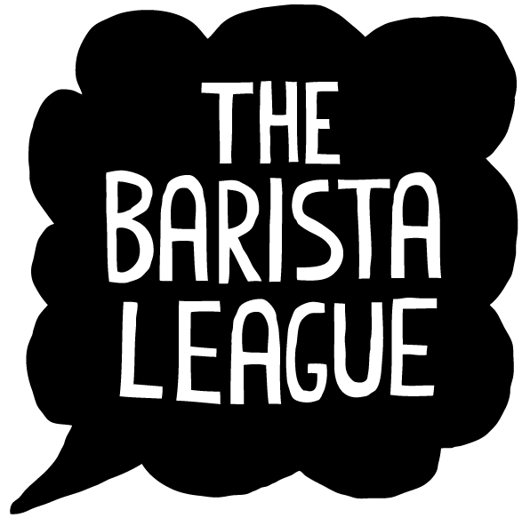

A REAL CONVERSATION ABOUT HOW ETHICAL YOUR CUP OF COFFEE IS.

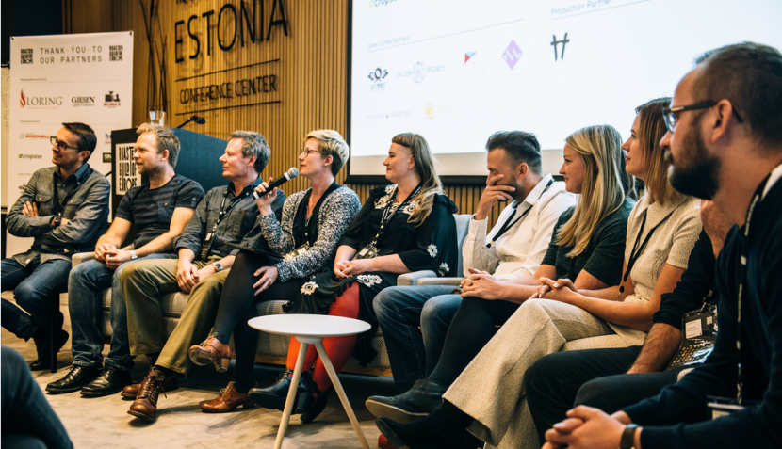

On March 26 from 12:00 to 14:30, The Barista League will host a special educational panel discussion about certifications in specialty coffee.

Starting with the question, “why is talking about certifications so difficult?”, the voices of producers, certifying bodies, and green coffee buyers will build a fuller picture of certification, from their aims to their achievements, as well as the considerations that producers and green buyers take into account when making decisions.

This event will offer the unique opportunity to ask how ethical are we really being in the specialty coffee industry when we buy, sell and drink our coffee.

|  |  |
| --- | --- |
| **What:** | Cracking Certifications |
| **Who:** | Sara Marocci, Independent consultant, Vuna Coffee Consulting Angel Mario Martinez, Producer Development Program, Progreso. Elizabet Lim, Business Development Manager, Fair Trade Sweden Joanna Alm, VD, Drop Coffee Roasters |
| **When:** | Sunday 26 March. 2017. 12:00- 14:30 |
| **Where:** | Kafferostere Per Nordby. Korpralsgatan 2. Gothenburg. |
| **Why:** | Shed light on the complex and important subject of how we buy our coffee, what certification means and why it is or is not important in ensuring that we respect the producers |

**For more information, contact Steven Moloney at +46 739 479 939.**

THE BARISTA LEAGUE

The Barista League – established in 2015 by by two-time Swedish barista champion, Steven Moloney – is Scandinavia’s fastest growing barista competition and community hub. With no entry fees or indecipherable rulebooks, the event focuses on three rounds of controlled coffee chaos and across its four main events per year; it is now promoting a more vibrant and connected community all over northern Europe.