

Larox Flowsys Introduces Progressive Cavity Pump
The Solution You´ve Been Looking For

Lappeenranta, Finland – Larox Flowsys. Larox Flowsys has launched a new series of pumps to supplement its hose pump family. Larox Flowsys is well-known also for its heavy duty pinch and knife gate valves. Larox Progressive Cavity pumps are engineered for demanding duties e.g. in pulp & paper (especially industrial slurry and paste pumping applications), mining & minerals and chemical industries. D-serie pumps are for dosing duties and E-serie is a very compact solution for environmental applications such as waste water treatment.

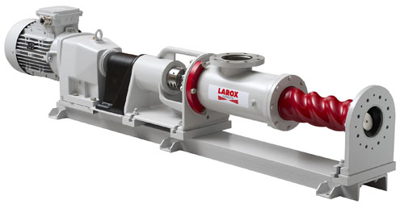
The Larox Flowsys progressive cavity pump was conceived by utilizing Larox Flowsys’ extensive experience in progress cavity pump service and its extensive experience as a peristaltic pump provider. Larox Flowsys is the industry benchmark for abrasive, corrosive or demanding pumping applications.

Patented Technology

- Our new pump has innovative and patented features making its efficiency significantly greater compared to conventional progressive cavity pumps, says Mr. Ismo Hämäläinen, Director of Pump Products at Larox Flowsys. - It is very easy to install, saves power and maintenance time and offers longer servicing intervals, he continues, better pumping availability at an expanded temperature range.

The precise Evenwall 3D-technology with 2-lobe rotor geometry offers rigid and tighter pumping unit compared to conventional progressive cavity pumps. – This makes it possible to use a smaller interference between the rotor and the stator, says Hämäläinen. By reducing friction between rotor and stator allows for a much lower starting torque and significantly higher efficiency.

- more -

The pump’s suction connection direction can be adjusted step less. The pump construction is shorter which facilitates easy installation in any new and existing pump installations. The most common failure in pumps is caused by shaft sealing problems. By utilizing the one of a kind patented shaft invention the mechanical shaft seal can be replaced quickly without dismantling the entire pump or its drive shaft and coupling.

Global service, local reach
Larox Flowsys Group has more than 90 employees and the number is growing. Headquartered in Lappeenranta, Finland Larox Flowsys Group has subsidiaries in Linthicum, Maryland (USA), Sydney (Australia) as well as in Kouvola (Finland). As more than 90% of the company's net sales come from global exports, the reliable and fast customer service is guaranteed by an international sales and service network, covering over 55 countries.
To learn more about Larox Flowsys and its expanded product offerings and brands, visit www.larox.fi.

# # #

