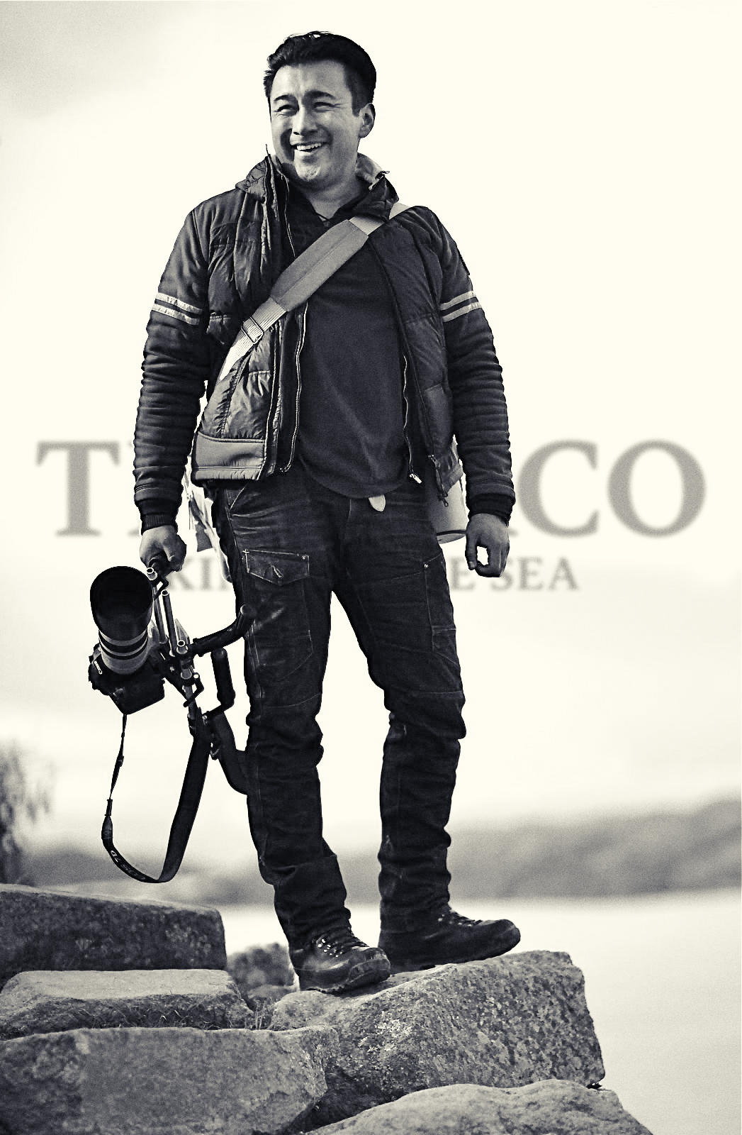
Why we should belive the world is doomed on Friday 21st of December 2012.
By Ivan Daza
Author of Titicaco - King of the Sea

The End of Time is good to imagine simultaneously. For so many reasons: take it from all of us that have experienced near death moments. That is when we decide to always have a clear conscious and to always be prioritizing what is important in life, the love, feelings, passion, friends and family. I remember my passed away father, the feeling when he received notice of his cancer 2002 and how he at that point realized that death was around the corner. At that point he also realized he had so many things to clear out before passing away. I already knew that. I always made those priorities since I did not take life for granted, but through my father’s actions I also realized that so many haven’t. And that’s the message that I send to you. And that is why we need to believe that the world will be ended in the way we know it and experiencing a new beginning December 21st for the simple fact that we all could make up and clarify our love for friends and family and clear out all old struggles and skip the small non important but focus on the important.
Let me give you another example; just as when a storm hits the city or a whole country, people reach out and help each other. This is what the chaotic environment brings out in us. We help each other. It might seem tragic that we need to meet chaos in order to start helping each other. When we actually should be doing that much more, all the time. Instead so many people act ill towards others, stab them from behind and act on malicious ways. Now is the time to be who you are. Now is the time to find you in harmony. Now is the time to show the real you. The love.
And is it not interesting that the center of our humongous universe has a black hole with the mass of 17 billion suns, newly discovered by the Max Planck Institute for Astronomy. This is the black hole that we will pass by the 21st of December. Perhaps it works like a huge clock that adjusts the entire spinning little axis everywhere once every 5126 years. Our tiny planet would experience a small adjustment by flipping the axis of the earth and setting it in line between the black hole in the center of the universe and our sun. And this small adjustment would have the effect that the continents would move into new positions, the poles would be set on new spots, oceans would rise and we would experience chaos as it was described in the Bible, the Baghdavadghita, by the Mayans and the Inca.

Maybe all these ancestors of ours actually knew something that we haven’t until recently been able to discover. No matter if these legends are scientifically correct or not. I believe that now is the time to reach harmony and that too would be the end of a time and a new beginning.
There is a story about a boy, Titicaco - King of the Sea, who saves the world before the catastrophe. You can see it for free on the internet now. Then, if the world is not doomed, we will release it in an app. See the story, read it, understand it, and get involved in developing the truth about how the legend, mythology and science related.
Ivan Daza
Author of Titicaco - King of the Sea
The Chronicles of Titicaco - King of Sea begins in the dawn of time 13.7 billion years ago. By reading, watching and understanding it you will uncover the greatest secrets of mankind as well as the world's greatest challenges. Watch the 47 short movies for free. As soon as iTunes approves the app you will be able to watch the movies in the Titicaco app only. There you can find texts and go deep sections that invites the audience to participate in the development of understanding our ancestors, binding legend, science and mythology into one.
Link to the 47 short movies:
https://vimeo.com/channels/titicaco
Facebook:
http://www.facebook.com/Titicaco.KingOfTheSea
Director of Public Relations & Media Relations Manager of Titicaco - King of the Sea: Annette Ericsdotter Bettaieb, annette@tgim.se, +46 70 777 91 00

