First contract for subsea innovation from KONGSBERG
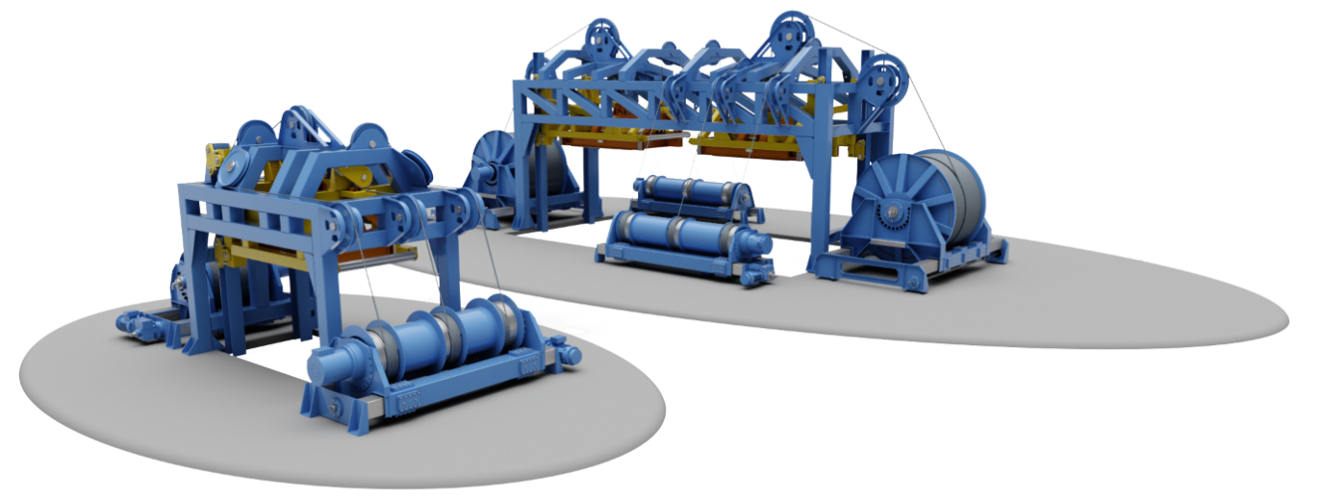
The new LARS from Kongsberg Maritime, in single and dual configurations
Kongsberg, Norway, 5th June 2020 – Kongsberg Maritime has signed its first contract for a state-of-the-art ROV launch & recovery system (LARS), specifically designed to handle remotely operated vehicles (ROVs) from unmanned vessels.
The contract has been signed with Ocean Infinity, who will install the system on their Armada fleet of cutting-edge robotic ships.
KONGSBERG’s LARS is an essential component in a system designed to ensure that no people are required at sea while carrying out subsea operations. This innovation enables the deployment of remotely operated vehicles (ROVs) and autonomous underwater vehicles (AUVs) by teams based onshore.
The system uses a pure electric drive system, making it more environmentally sustainable and significantly reducing the need for maintenance. Launch & recovery will happen through the moon pool, with the release and capture of the ROV occurring beneath the sea surface. This eliminates the possibility of damage to the ROV from impact with the vessel hull. Another benefit is that launching and recovery can be carried out in higher sea states.
Subsea expertise
“The new LARS solution is developed in close collaboration with the Ocean Infinity team. It benefits from a unique combination of our advanced subsea technologies, reinforced with years of accumulated offshore expertise,” says Lisa Edvardsen Haugan, Executive Vice President, Deck Machinery & Motion Control, Kongsberg Maritime.
“We believe this will be a game changer,” she continues. “The safety of ROV operations will be dramatically increased through the use of this system. We expect to see more companies transition to using unmanned vessels as a result.”
A video from Ocean Infinity that introduces their Armada fleet is available here.
Ends
For further information, please contact:
Gunvor Hatling Midtbø, VP Communication
Kongsberg Maritime
Tel: +47 9921 4209
gunvor.hatling.midtbo@km.kongsberg.com
David Pugh
Saltwater Stone
Tel: +44 (0)1202 669244
d.pugh@saltwater-stone.com

About Kongsberg Maritime
Kongsberg Maritime is a global marine technology company providing innovative and reliable ‘Full Picture’ technology solutions for all marine industry sectors including merchant, offshore, cruise, subsea and naval. Headquartered in Kongsberg, Norway, Kongsberg Maritime has manufacturing, sales and service facilities in 34 countries.
Kongsberg Maritime solutions cover all aspects of marine automation, safety, manoeuvring, navigation, and dynamic positioning as well as energy management, deck handling and propulsion systems, and ship design services. Subsea solutions include single and multibeam echo sounders, sonars, AUV and USV, underwater navigation and communication systems.
Training courses at locations globally, LNG solutions, information management, position reference systems and technology for seismic and drilling operations are also part of the company’s diverse technology portfolio. Additionally, Kongsberg Maritime provides services within EIT (Electro, Instrument & Telecom) engineering and system integration, on an EPC (Engineering, Procurement & Construction) basis.
Kongsberg Maritime is part of Kongsberg Gruppen (KONGSBERG), an international, knowledge-based group that celebrated 200 years in business during 2014. KONGSBERG supplies high-technology systems and solutions to customers in the oil and gas industry, the merchant marine, and the defence and aerospace industries.
Web: Kongsberg Gruppen | Kongsberg Maritime
Social media: LinkedIn | Twitter | Facebook

