PRESS RELEASE
Att: Head of News
2015-03-17
Inet sponsored BMG CS:GO Female victorious in Intel Challenge 2015
”The 15,000 dollar win that lifts women’s gaming”
The CS:GO team Bad Monkey Gaming won the Intel Challenge in Katowice on Sunday. With the victory, the team goes home to Sweden with a check for 15,000 dollars which is by far the highest prize pool ever in women’s e-sport.
– This is a real energy injection both for our team and for women’s gaming overall. With this level of prize money, we can afford to train even more and continue to improve our game. As we get better we attract a larger audience. That’s how the sport will develop and grow, says Julia ”Juliano” Kiran.
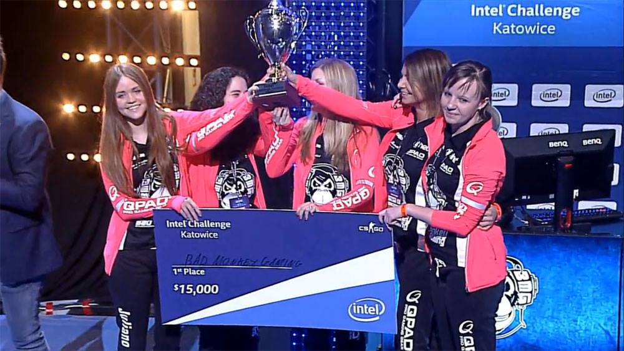
BMG arrived in Poland with brand new tactics and their sights set on finishing on top, which would mean taking home the largest prize pool ever in women’s e-sport. After knocking their biggest rival Ubinited out in the semifinals, BMG swiftly overcame German team CM Storm in the finals.
– We have improved every aspect of our game and we came to Katowice with a brand new game plan. Our goal was always to win and we’ve never prepared as extensively as before this tournament. This win gives us the chance to invest more of our time and train even harder for upcoming tournaments.
BMG CS:GO Female coped with the pressure and won Intel Challenge which included a record price sum of 15,000 dollars.
Foto: ESL TV

The fact that prize sums are beginning to approach the levels of men’s gaming is a major step forward, for women’s e-sport and for the players.
– This was the first of hopefully many major tournaments for women with a prize pool comparable with what the men are getting. Although the men’s prize pool was more than five times as high in Katowice, we still consider this a major step in the right direction. We at Inet are very happy and proud to be able to support BMG in the development of women’s e-sport, says Inet’s marketing manager Johan Wahlberg.
Next stop for BMG is the Copenhagen Games in two weeks, where BMG are reigning champions. After the win in Katowice, sights are of course set on finishing on top again.
– We’re going home to prepare for Copenhagen where our goal is to defend our title. But first we’re going to celebrate, says Julia “Juliano” Kiran.
BMG CS:GO Female: Julia Kiran (juliano), Zainab Turkie (zAAz), Irene Sanchez (iRene), Ksenia Klyuenkova (vilga) and Sonia Garcia (Sonia)

For further information
Johan Wahlberg, Marketing Manager Inet, +46 (0)739-88 27 29, johan.wahlberg@inet.se
Magnus Sjöbäck, Press Officer Inet, +46 (0)704-45 15 99, magnus.sjoback@inet.se
http://www.inet.se/

