Bäckman’s ready for full GT4 European Series program with racing one
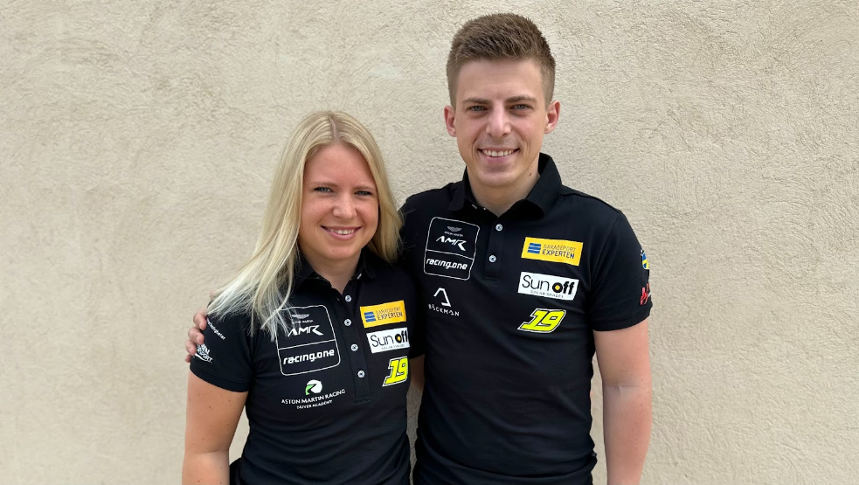
Andreas and Jessica Bäckman are ready for a full season in the GT4 European Series together with racing one.
Photo: Private (Free rights to use the image)

The Sweden National Team drivers Andreas and Jessica Bäckman from Sweden today present their big news that in 2023, in addition to their already announced program in ADAC GT4 Germany with PROsport Racing, they will also share a car and compete together in the GT4 European Series for racing one in an Aston Martin GT4 car.
- Super happy and grateful that we get this opportunity from racing one after our positive GT4 debut at Monza, this is exactly what we need to develop as drivers in GT4 racing, Jessica Bäckman says.

Since the siblings made the step to circuit racing five years ago, they have competed in Touring Car Racing. The previous season, Andreas competed in the Scandinavian Touring Car Championship and finished in third place overall in the championship with three wins, two pole positions, seven podium places and three fastest laps. While Jessica was competing in the ADAC TCR Germany Championship and finished second overall in the championship with four wins, two pole positions, three fastest laps and nine podiums. For this season, the siblings have instead chosen to go a completely different route and step into GT racing. Throughout Andreas and Jessica's motorsport careers, they have competed individually in each car. For this season, they will share a car with each other and race together in an Aston Martin Vantage GT4 car. The races are one hour long, with a mandatory driver change midway through the race, which will be something completely new for Jessica and Andreas to adjust to.

Bäckman’s debut race in GT4 Europe at Monza resulted in full season program
About a month ago, the siblings made their GT4 race debut together by making a guest entry in the first round of the GT4 European Series at Monza. They made an impressive qualifying debut by qualifying 6th and 9th in the two qualifying sessions out of 53 of the best drivers in Europe. Now the siblings present that they will make a full commitment and also compete in the remaining races of the European series for team Racing one in an Aston Martin GT4 car. The second round of the GT4 European Series is this weekend 2-4th of June at the well-known Formula 1 track Circuit Paul Ricard in France, where the Sweden National Team drivers compete against 57 of Europe's fastest GT4 cars.

- It will be exciting to make a full program in the GT4 European Series, we got a good first impression after the Monza race a month ago. We are very happy that racing one saw our potential already at the Monza debut and wanted to include us in their team for the rest of the European season, Andreas Bäckman says.

Team racing one welcomes Jessica and Andreas to the team
– We are very pleased to be working with Jessica and Andreas for the remainder of the GT4 European Series season. They are both very fast and talented. It's something special when brother and sister start together in a racing car. We are very excited and are sure that we can achieve top results together”, says Philipp Zakowski, team co-owner at racing one.

The structure of the GT4 European Series
The GT4 European Series consists of six races around Europe. The series is considered one of the toughest GT4 series in the world and has a high status among the drivers who come from several different countries around Europe. The start of the season went on the well-known Monza circuit in Italy, which is also called "The Temple of Speed" and will end on the well-known Formula 1 circuit Barcelona in Spain. In addition to Barcelona and Monza, the world-famous Formula 1 tracks Spa, Hockenheim, Misano as well as Paul Ricard where Bäckman will race on this weekend, will also be on the 2023 calendar.
Each race weekend consists of two free practice sessions, two time qualifying’s and two races of 60 minutes where a mandatory driver change is made halfway through the race. Points are awarded to the fastest car in the time qualifying’s and the top 10 cars in each race. The drivers in the car with the most points after the final race at Barcelona will take home the driver's title "GT4 European Series Drivers Title" in the GT4 European Series.

Time schedule for this weekend's races (GT4 Europe Round 2):
(all times CEST)

Friday June 2nd:
11:25 Free Practice 1 (60 min) – LIVETIMING
LIVE TIMING LINK
17:30 Free Practice 2 (60 min) – LIVETIMING
LIVE TIMING LINK

Saturday June 3rd:
09:15 Q1 & Q2 – Qualifying (20 min x 2) - LIVE TV
LIVE TV GT World Youtube
LIVE TV GT4 European Series Website
14:50 Race 1 (60 min) – driver change in the middle of the race - LIVE TV
LIVE TV GT World Youtube
LIVE TV GT4 European Series Website

Sunday June 4th:
11:30 Race 2 (60 min) – driver change in the middle of the race - LIVE TV
LIVE TV GT World Youtube
LIVE TV GT4 European Series Website

About the track (Circuit Paul Ricard):
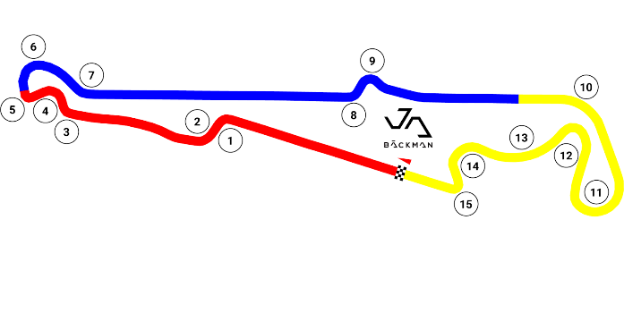
Location: Le Castellet, France
Length: 5,842 km
Corners: 15
GT4 Europe Calendar 2023:
April 22nd-23rd - Monza, Italy
June 2nd-4th - Paul Ricard, France
June 29th-July 2nd - Spa, Belgium
July 14th-16th - Misano, Italy
September 1st-3rd - Hockenheim, Germany
September 29th-October 1st - Barcelona, Spain

Free rights to use images.

Download press pictures here:
http://bit.ly/jabaeckman-photos
https://www.mynewsdesk.com/se/ja-backman/images

