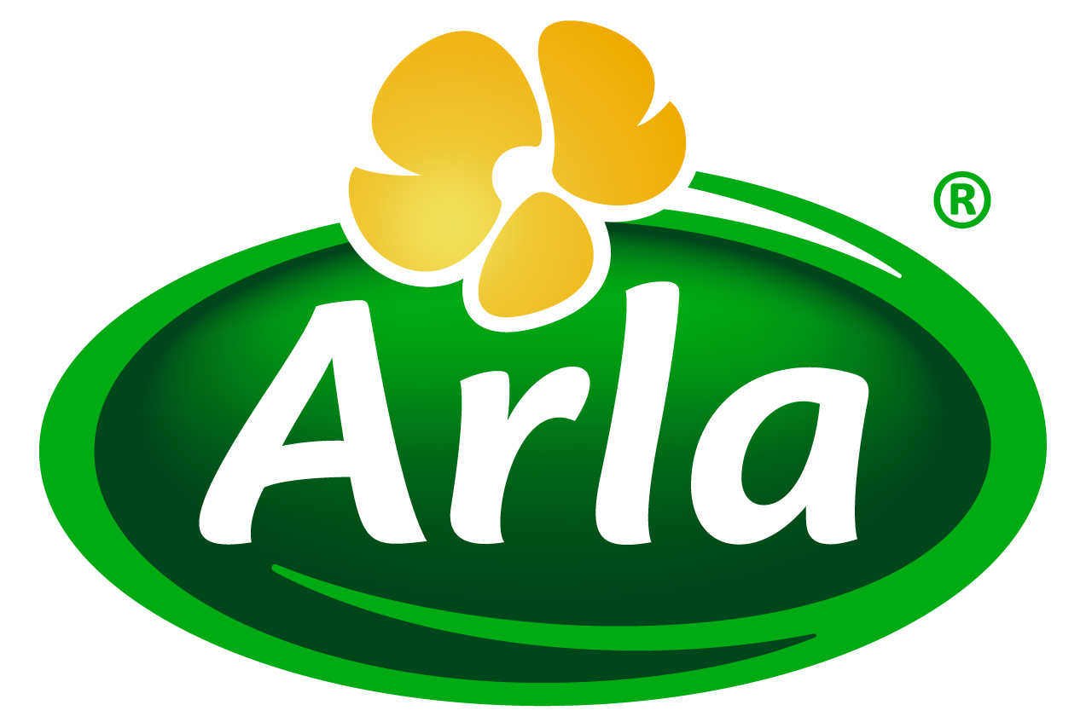
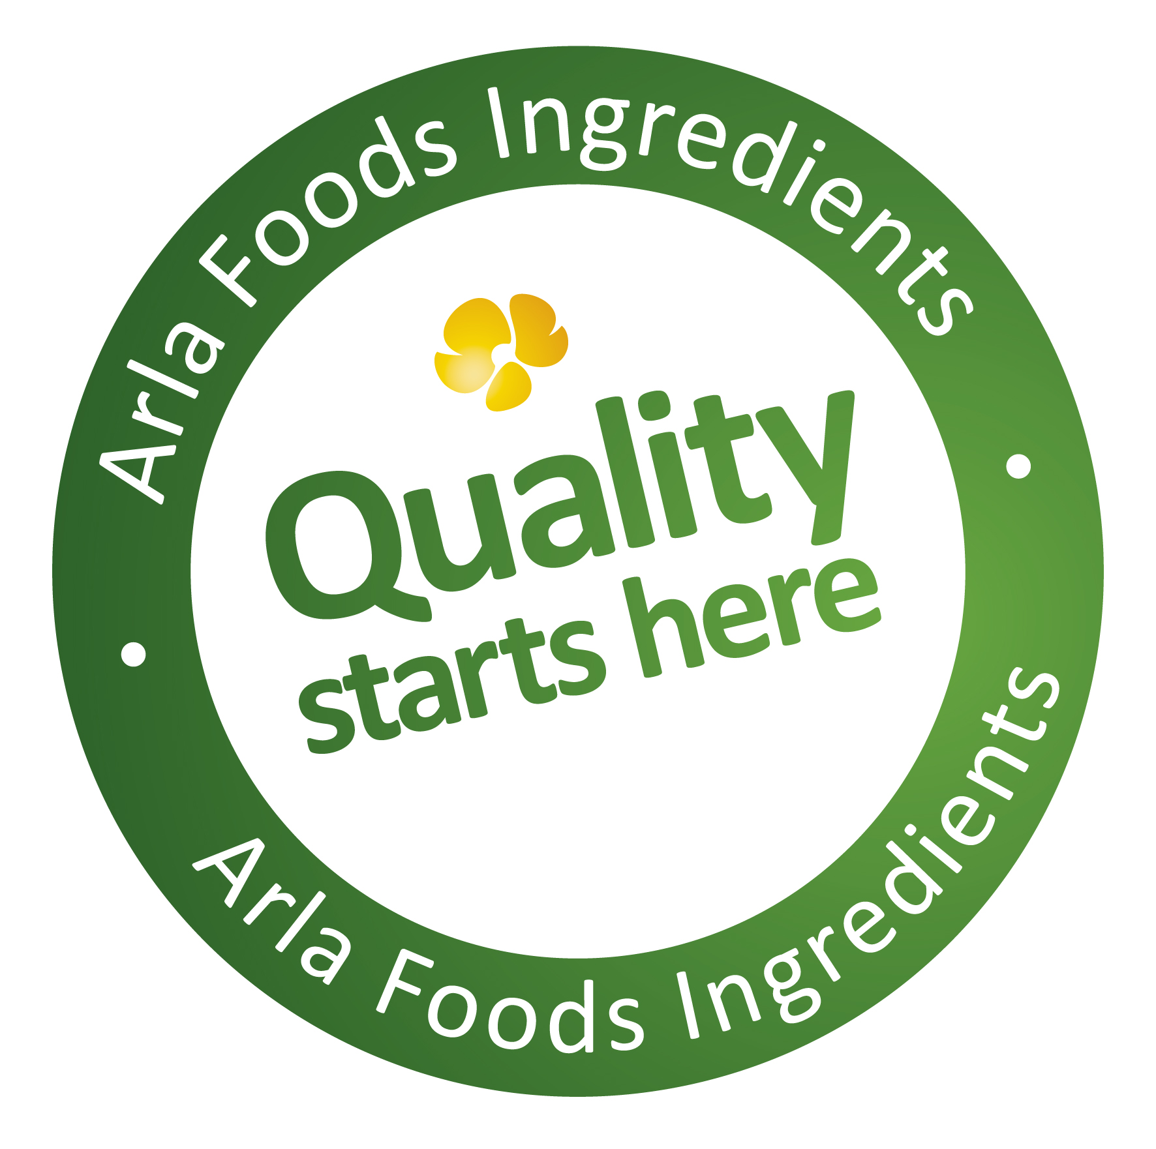

25 August 2015
PRESS RELEASE
New dairy protein solves watery
low-fat cottage cheese problem

Arla Foods Ingredients has developed a unique new clean-label protein solution that tackles the long-standing problem of watery low-fat cottage cheese.

Sales of cottage cheese are rising as consumers seek out healthy dairy products that are low in fat and high in protein. Just like Greek yoghurt and Skyr, cottage cheese falls into this category and is enjoying a surge in popularity. New launches of cottage cheese products globally increased by 39% between 2010 and 2014, according to Innova Market Insights. Growing numbers of consumers enjoy cottage cheese because it offers a tasty and healthy option for multiple occasions, including snack time, breakfast, lunch and even dessert.

Arla Foods Ingredients’ new dairy protein is simply added to the dressing (cream) that is combined with the curds to make cottage cheese. It reacts with the salt in the dressing to create a thicker texture and a creamier end product. This eliminates the need for the stabilisers frequently used to enhance the quality of low fat cottage cheese, which tends to have a runnier consistency than the standard version and is therefore more likely to require thickening. This is often done using starches and gums, which may mean sacrificing clean label status.

Because the cream dressing containing Arla Foods Ingredients’ dairy protein is better quality, the proportion of curds required in the recipe can be reduced without any negative impact on product quality – enabling manufacturers to optimize their production costs and maximize profitability.

Claus Andersen, Category & Application Manager for Cheese at Arla Foods Ingredients, said: “This is a unique solution for improving cottage cheese products, especially low fat cottage cheese, which often presents technical and quality challenges. Now manufacturers can achieve a thick, creamier and tastier end product, using a dairy-based ingredient that is clean label and familiar to consumers.”

Cottage cheese made with Arla Foods Ingredients’ new protein is also more stable and less likely to separate and lose its texture when it has been left to stand, improving its overall appearance and consumer appeal. The protein is easy to use in the production process and the cottage cheese is made in the usual way. As well as improving the quality of low fat cottage cheese, the protein also offers benefits to the standard version, in the form of improved flavour, texture and reduced costs.

ENDS

For more information, please contact:
Kine Bjoralt, Ingredient Communications
Tel: +44 141 280 4141
Email: kine@ingredientcommunications.com
@ingredientcomms

About Arla Foods Ingredients
Quality starts here: Arla Foods Ingredients is a global leader in natural whey ingredients for products in a range of categories – from sports, clinical and infant nutrition to beverages, bakery, dairy and ice cream.
The cornerstones of our business are innovative ingredients, world-class facilities and a staff of dedicated experts. Drawing on our portfolio of functional and nutritional whey proteins, milk minerals, lactose and permeate, our expert team delivers solutions that bring new food products quickly and efficiently to market. Our application centres run hundreds of customer product trials every week. All ingredients are produced using state-of-the-art processing technology at our plant in Denmark, or by one of our joint ventures in Argentina, Germany and the UK.
Arla Foods Ingredients Group P/S is a 100% owned subsidiary of Arla Foods, a global dairy company and cooperative owned by dairy farmers in Denmark, Sweden, the UK, Germany, the Netherlands, Belgium and Luxemburg.

RSS Feed
Visit our website at http://www.mynewsdesk.com/arla-foods-ingredients and sign up to our News RSS feed for all the latest developments – updated regularly.

Twitter
Follow us on twitter for all the latest updates @ArlaIngredients

LinkedIn
http://www.linkedin.com/company/arla-foods-ingredients

