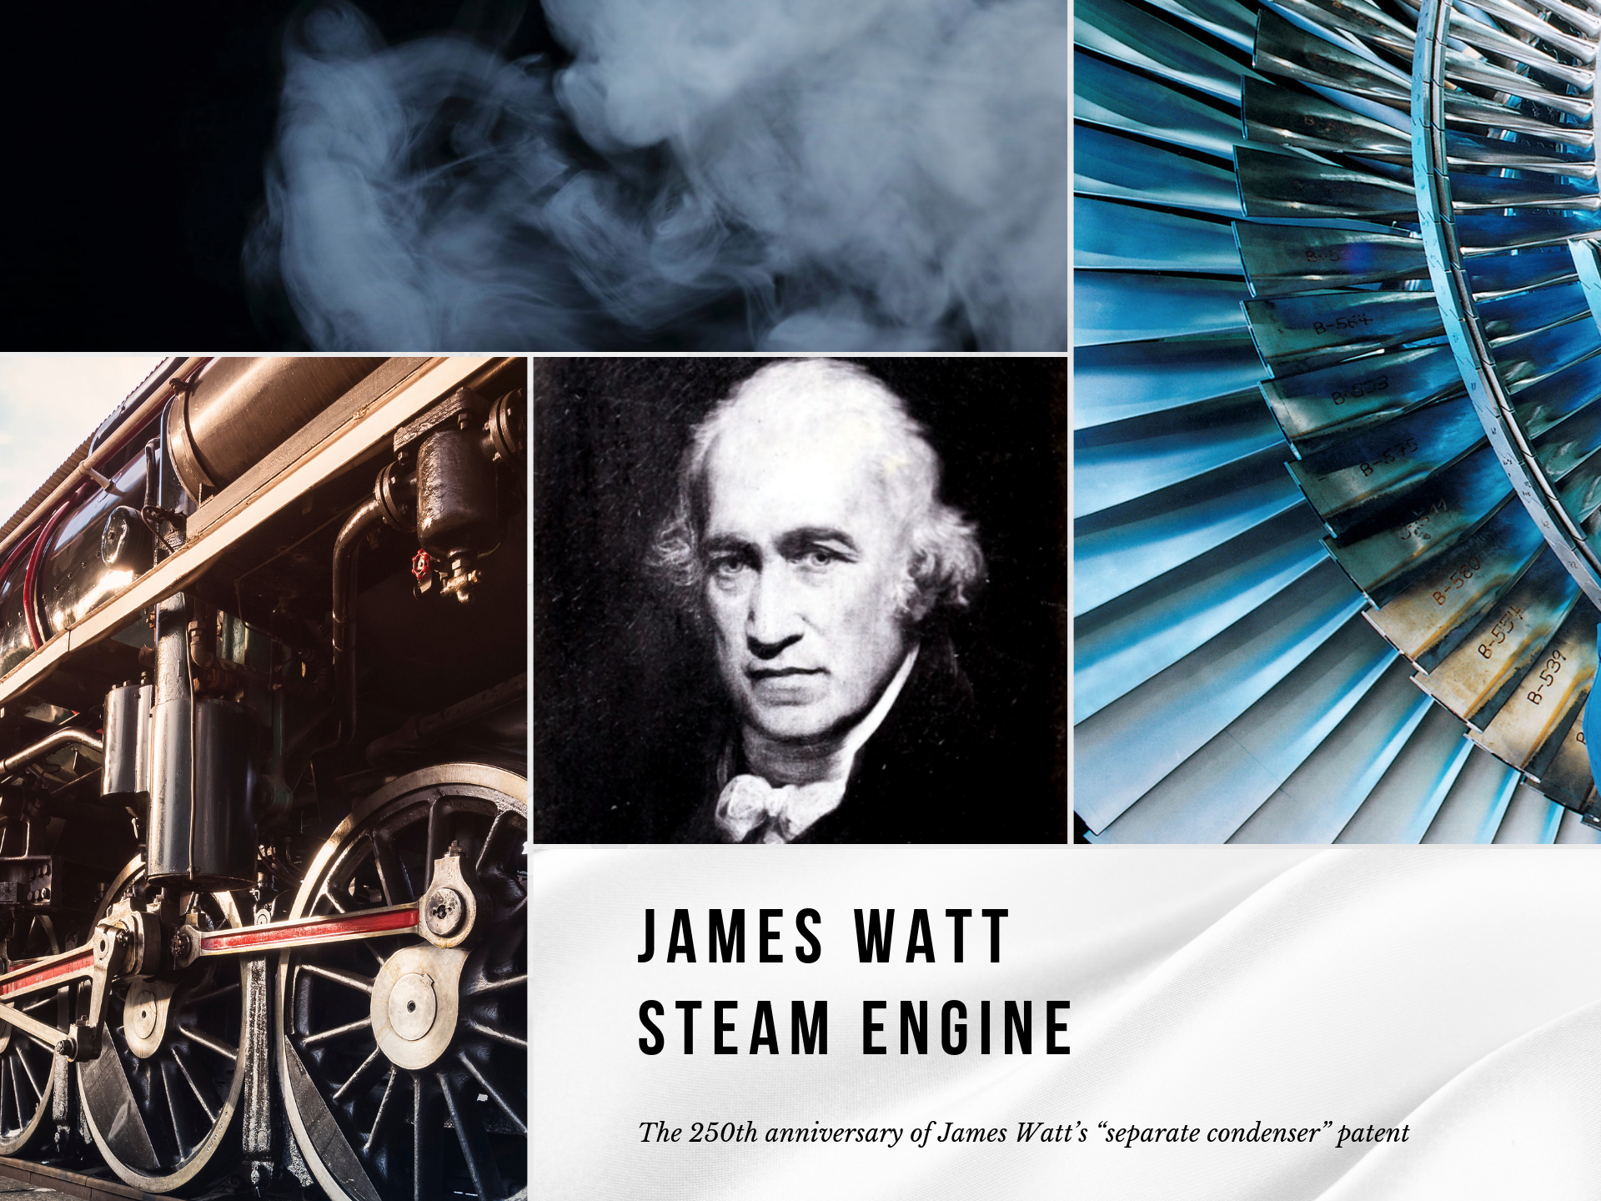

Are steam engines retro?

Exactly 250 years ago the patent of James Watt's “separate condenser” was introduced. The invention improved steam engines and revolutionized the world. 50 years later, the ingenious inventor, James Watt, died. 2019 is therefore a special anniversary year and the right time to pay tribute to one of the greatest inventors of all time.

Did you know how many steps must be completed so we can turn on the light, make a cup of coffee or watch a movie? As most people know, electricity is produced at an electric power plant. But what happens there? A fuel of some kind (coal, oil or natural gas) is being burnt and produces heat. The heat is later employed to boil water and consequently to create steam. The steam spins a turbine which drives a generator. And this is exactly how the steam engine works.

Today, steam engines seem to be associated mostly with the first steam locomotives and ships. However, they are not a thing of the past, as some may assume. Steam engines are still in use today and it doesn't look as if they could be replaced by any other engine.

The principle of the steam engine is still used far and wide in modern power plants to generate electricity. The history of the steam engine goes back to the 1st century (AD), but it was not until the 18th century that James Watt perfected it. As a homage to the British inventor, TradeMachines has created a vivid summary of Watt’s work. Read on and learn more about this fascinating personality.

See image gallery:

https://press.trademachines.com/latest_media

No. 1. Water vapor and its potential

H2O, colloquially known as water, is the only chemical compound on earth that occurs in nature in three states of aggregation: as a liquid, solid and gas. Water reaches its gaseous state through evaporation. Even though it almost invisible to the human eye, the energetic potential of water vapor is enormous. The inventors in the first century (AD) were very much aware of that fact and used the vapor in their prototype steam engines.

No. 2. First steam engines

The first functional steam engine - a machine that converts the energy of steam into motion - was designed by an English inventor Thomas Newcomen. However, the invention needed further development, which was driven by mining. At that time, many lost their lives in flooded mines. Thomas Savery was the first one to realise that a steam engine could be employed to pump water out of the flooded areas.

No. 3. Watt’s steam engine

In 1764 James Watt (1736-1819) was commissioned to repair the model of Thomas Newcomen’s steam engine, and immediately realised that a large part of the heat was lost from the cylinder after each cycle. To minimize energy loss by heating and cooling the cylinder, he introduced the condenser and the steam jacket. By transferring the cooling process from the cylinder to a separate condenser in the Watt steam engine, the coal consumption could be reduced by over 60%. It was not until 1769 when James Watt obtained his first British patent (No. 913).

No. 4. James Watt and Horsepower

To illustrate the enormous power of his steam engine, James Watt invented a new unit of measurement: The horsepower. He measured how much a group of ponies could lift and compared it to the power of his steam engine. One horsepower corresponded to the power of a strong horse that could pull the weight of 550 pounds over a distance of one foot in one second. Strategically, it was a very important and smart move by James Watt, as it enabled him to market his steam engine better. The horsepower is still used today - especially in the automotive industry.

No. 5. Steam locomotives and ships

James Watt's steam engine literally set the world in motion and played a crucial role in industrialization and urbanization. The introduction of steam locomotives and the first steam ships improved living and working conditions for many people. Thanks to the innovative infrastructure, large quantities of goods and raw materials could be transported at a fraction of the cost and in a much shorter time. Transportation was completely revolutionized. People could move easily from place to another. Moreover, the use of steam engines in factories made automation and process optimization possible while ensuring accuracy and efficiency.

No. 6. Modern power plants

The steam engine is still used in the most modern power plants. 80% of the world's electricity is generated by steam power. What has changed, however, is the use of huge steam turbines that have replaced pistons in steam engines. The energy of coal, sunlight, biomass, wind or nuclear energy is used to generate steam to drive a turbine. The turbine, which has been put into motion, generates electricity via a synchronous turbogenerator.

No. 7. Steam turbine

The world's largest steam turbine, Arabelle, was built for a British nuclear power plant - Project Hinkley Point C (HPC). The turbine is longer than an Airbus 380 and larger than a human being. HPC is expected to produce approximately 3.2 GW of power with near-zero carbon emissions. The generated energy should be sufficient to cover six million households.

Contact

Beata Majka
Online Marketing Manager
https://trademachines.com/

Tel. +49 30 61 29 71 16
Email: beata.majka@trademachines.com

Press information:

- TradeMachines is a meta search engine for used machinery. We consolidate offers from traders and auctioneers all over the world, and have every type of machine under one roof. Our platform is a convenient way for potential buyers to search for local and global offers online.
- Reprint free of charge.
- Image source can be found in image gallery.
- In case of usage of our work please credit us by inserting a link to trademachines.com. All pictures used are free of rights.
- For more information about TradeMachines, please contact onlinemarketing@trademachines.com

Sources & Ranking:

No. 1. Water vapor and its potential

https://de.wikipedia.org/wiki/Wasser
https://de.wikipedia.org/wiki/Wasserdampf
https://de.wikipedia.org/wiki/Verdampfungsw%C3%A4rme

Image:
https://www.flickr.com/photos/photopitti/30125059343

No. 2. First steam engines

https://de.wikipedia.org/wiki/Thomas_Newcomen
https://de.wikipedia.org/wiki/Dampfmaschine

Image:
https://www.geograph.org.uk/photo/4947928

No. 3. Watt’s steam engine

https://de.wikipedia.org/wiki/James_Watt
https://de.wikipedia.org/wiki/Dampfmaschine

Image:
https://de.wikipedia.org/wiki/Datei:JamesWattEngine.jpg

No. 4. James Watt and Horsepower

https://de.wikipedia.org/wiki/Pferdest%C3%A4rke

Image:
https://commons.wikimedia.org/wiki/File:Illustratedcatal00anna_orig_0241.png
No. 5. Steam locomotives and ships

https://de.wikipedia.org/wiki/Dampflokomotive

Image:
https://www.flickr.com/photos/bods/5031122914

No. 6. Modern power plants

https://de.wikipedia.org/wiki/Sonnenw%C3%A4rmekraftwerk

Image:
https://www.flickr.com/photos/squeaks2569/6160850722

No. 7. Steam turbine

https://de.wikipedia.org/wiki/Dampfturbine
https://www.power-technology.com/news/ge-power-begins-arabelle-steam-turbine-production-uks-hinkley-point-c/

Image:
https://en.wikipedia.org/wiki/Steam_engine#/media/File:Dampfturbine_Laeufer01.jpg

