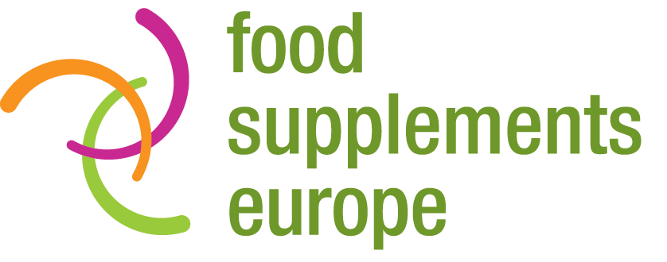

**Under embargo until 11.00am CET Wednesday 22 February 2017**

**NEWS ALERT**

**Cost of dealing with bone fractures could plunge with   
wider use of calcium + vitamin D supplements**

Greater use of calcium + vitamin D supplements could save nearly €4 billion a year in healthcare costs through avoiding bone fractures caused by osteoporosis, according to a new independent analysis commissioned by Food Supplements Europe.

Researchers from Frost & Sullivan examined the economic burden of addressing osteoporosis-attributed bone fractures among the 27.8 million over-55s in the EU with osteoporosis. With 1.24 million related fractures occurring in the EU every year, they forecast that the total cost of dealing with these events will amount to €132 billion between 2016 and 2020 – €26.4 billion a year, or €21,231 per event.

Scientific research shows that daily supplementation with 1,000 mg of calcium and 15 µg (micrograms) of vitamin D results in a 15% reduction in the risk of osteoporosis-attributed fractures among those aged 55 or over with the disease. As such, if all of these at-risk individuals were to consume calcium and vitamin D at this amount and regularity, there could be 186,690 fewer fractures every year with potential savings of €3.96 billion per annum in avoidable healthcare costs.

The study was commissioned and funded by Food Supplements Europe but conducted independently by Frost & Sullivan using existing published literature and official data. The full results appear in a new report: Healthcare Cost Savings of Calcium and Vitamin D Food Supplements in the European Union.

Food Supplements Europe Chair Ingrid Atteryd said: “Over several decades, a significant amount of clinical research has been conducted showing that the daily use of calcium and vitamin D food supplements is highly correlated to a lower risk of experiencing an osteoporosis-attributed fracture. This new analysis, for the first time, demonstrates that more widespread supplementation with these nutrients could also save many billions of euros in avoidable healthcare costs. Educating target consumers to understand the benefits of calcium and vitamin D, through official advice at both EU and national level, and via healthcare professionals in the media, could deliver major benefits in both wellbeing and financial terms.”

There are 157.6 million people aged 55 or over in the EU. In total 17.6% of them have osteoporosis and are therefore considered to be at risk of sustaining a related fracture. European women aged 55 or over account for 80% of cases of osteoporosis.

Frost & Sullivan’s report highlights the differences in the cost of addressing an osteoporosis-attributed bone fracture in the different EU member states. The cost is highest in Germany – at €34,197 per case. It is lowest in Romania, at €3,151 per fracture.

Ms Atteryd added: “The EU’s population is ageing and without taking action the number of bone fractures attributed to osteoporosis will almost certainly rise. As such it has never been more important to leverage the substantiated benefits of calcium and vitamin D to help minimise the financial burden of this disease on healthcare systems across Europe. In addition, quality of life would be improved for millions of people – a benefit that is priceless.”

Osteoporosis is a bone disease in which the density and quality of bone are reduced, leading to a weakness of the skeleton. The condition significantly increases the risk of fracture from a fall, particularly at the hip, spine and wrist.

The Frost & Sullivan study is the second in-depth analysis commissioned by Food Supplements Europe to examine the positive impact of supplementation on EU healthcare costs. In May 2016, a ground-breaking report highlighted that €12.9 billion a year could be cut from spending on cardiovascular disease through more widespread consumption of Omega 3 EPA+DHA supplements by people aged 55 or over.

**ENDS**

**For more information, please contact:**

Richard Clarke, Ingredient Communications

Tel: +44 1293 886291 / +44 7766 256176

Email: [richard@ingredientcommunications.com](mailto:richard@ingredientcommunications.com)

Twitter: [@ingredientcomms](https://twitter.com/ingredientcomms)

**About Food Supplements Europe**  
Based in Brussels, Food Supplements Europe is a not-for-profit trade organisation representing the interests of the European food supplements sector. Its membership includes national associations and companies who are committed to ensuring that future EU legislation and policy reflect the important role that the supplements sector plays in improving the health of consumers. You can find more information about Food Supplements Europe at [www.foodsupplementseurope.org](http://www.foodsupplementseurope.org)