Urgent Action Needed for our Cocoa Suppliers in Colombia

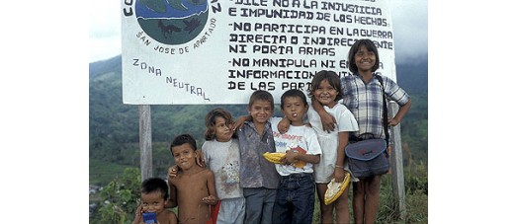
Kids at the Community Border Sign
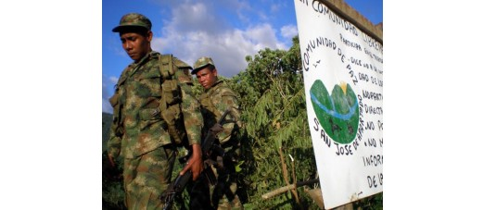
Soldiers at the Community Boundary

The Community Logo
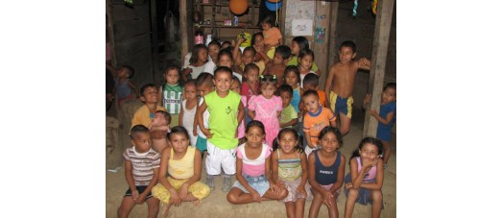
Kids in the School
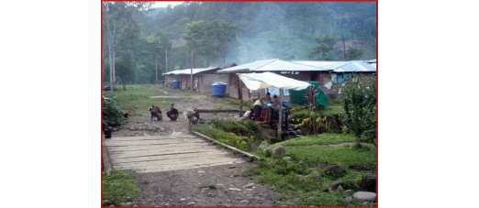
Hamlet of San Josecito
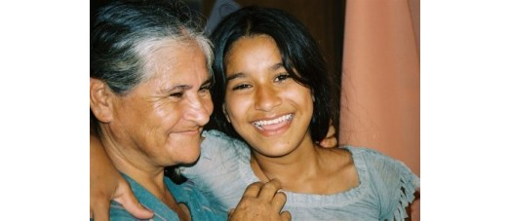
Brìgida and her daughter Eliseña, who was murdered by the army
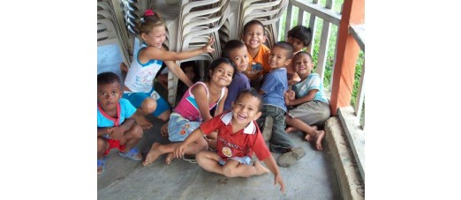
"Chiquitos" or "little ones"
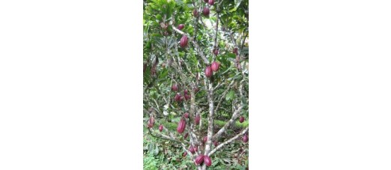
Cocoa pods on the trees
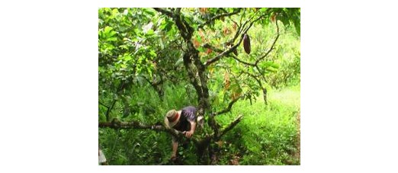
Harvesting cocoa from the forest
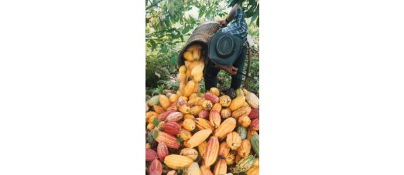
Collecting the cocoa pods for fermentation
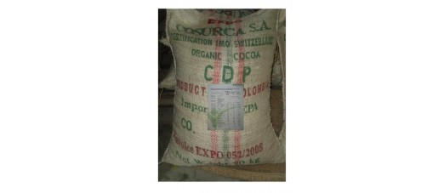
Organic fair trade cocoa from the community
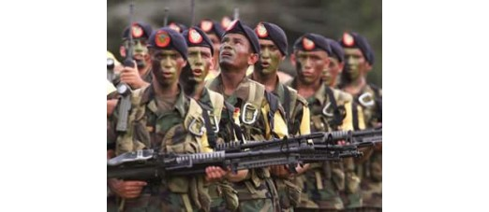
Colombian army "anti-narcotic" troops
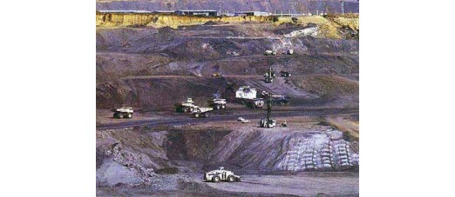
Cerrejòn opencast coalmine, Colombia
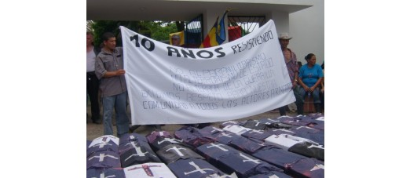
10 YEARS RESISTING: NO TO PARAMILITARISM. NO TO STATE TERRORISM. NO TO GUERILLA TERROR. WE DEMAND RESPECT FOR OUR COMMUNITY FROM ALL ARMED ACTORS
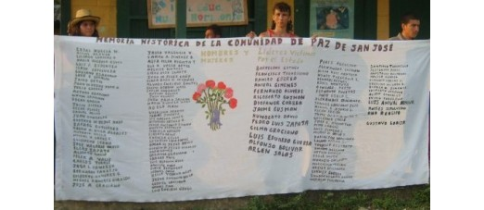
Names of Murdered Community Members
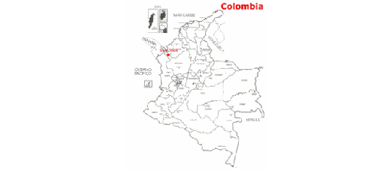
Location in NW Colombia
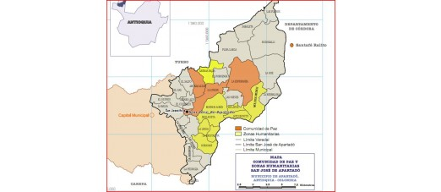
Peace Community area across the Apartado region

Members of peace community are in serious danger
Earlier this year Lush received its first consignment of quality cocoa beans sourced from the amazing Peace Community, San José de Apartadó, nestled in the mountains of North-West Colombia. We decided to use our trade to help support their difficult position in the region. Caught in the crossfire of a brutal 40 year civil war, the community strive to break the cycle of violence and refuse to bear arms or take part in the prolific drugs trade in the area.
Since their formation in 1997 over 200 villagers have been murdered, and many more abused and injured. The land they live from is green and fertile, rich with minerals and therefore eyed greedily by those wanting to plunder it.
When Lush agreed to enter into business with the community it was with the understanding that we extended our support not just financially but in other ways as well. We began by using the butter from their cocoa beans in our Peace massage bar to help raise awareness of their situation.
Now the people of San José de Apartadó need our help more than ever. Right-wing paramilitaries, working in collusion with the government, have entered the villagers family homes fully armed and are threatening anyone who does not work for them with eviction and death. The villagers are under real threat. Soon we hope to have a 1-click way to sign our letter in the pdf below that will send a fax to the Colombian president letting him know that the world is watching. In the meantime, please use the pdf below to print and post, or copy and paste into your email program and send to :
UK Colombian Embassy Email: elondres@cancilleria.gov.co
Colombian Ministry of Defence :
- mailto:siden@mindefensa.gov.co
- infprotocol@mindefensa.gov.co
You can also go to http://faxzero.com to send an email to the fax machine of the Colombian president.
The number is +57 1 596 0631
You can also send a fax to President Santos direct at the end of this article. - Just scroll to the bottom of the page, insert your name and select Send Now.
To learn more, read on below where we have a blow by blow account of recent events. And well try to keep you updated on the current situation :
Letter to president Santos (PDF, 80KB)
---

Account of recent events:
November 14
Around 6:00pm, 30 paramilitaries arrived in the rural district of La Esperanza with long guns and in civilian clothing. They entered people's homes, including homes belonging to families that are part of the Peace Community. Once again they repeated their message: those who do not submit to them and work with them will have to leave or die; from now on they will act more forcefully.
November 18
Around 4pm, paramilitaries entered the rural district of La Esperanza once again, this time in camouflage and carrying long guns. They repeated that they would start acting more forcefully.
November 19 and 20
Paramilitaries set up checkpoints on roads around La Esperanza and two other hamlets close to the Peace Community. They stopped and questioned everyone travelling and stole the food that people were carrying, saying that no one was allowed to bring food to the houses; they had decreed a food blockade and anyone who disobeyed these orders would be killed.
November 22
There were battles between paramilitaries and guerrillas in the rural districts of La Esperanza and Playa Larga, and the civilian population was stuck in the middle. Several families had to flee in the middle of the battle to save their lives. The paramilitaries, who continue to act in close coordination with the Army, try to use the civilian population as a shield, which is a war crime.
November 28
Community members were held captive for several hours when almost 200 paramilitaries came to the hamlet of La Esperanza, which is one of several hamlets and villages forming the Peace Community of San José de Apartadó. Around 50 people were held captive in the health centre for several hours. The paramilitaries took the names of those held captive, saying they would 'investigate' them. The paramilitaries came from a base in Playa Larga, a hamlet close to La Esperanza, where they own land. They have told local residents that they will take control of any land they require, regardless of the owners wishes. Paramilitaries have also made known that they would do the same in other hamlets nearby.
(Source : Emails with peace community members and Amnesty international (PDF, 82KB))
Paramilitaries have consolidated their presence in the areas around the Peace Community. Despite the fact that the area is heavily militarized, the army does nothing to stop the paramilitaries. Paramilitary action against the Peace Community has increased, and people are at risk of being displaced and killed.
The Peace Community says it will stand strong on its land and will not submit under any circumstances to the rule of these criminals who are supported by the State. They have asked for international solidarity and help to put pressure on the central government, demanding an end to paramilitary action.
---

History
The Peace Community of San José de Apartadó consists of individuals living in a number of hamlets and villages in the municipality of Apartadó, in Antioquia Department, north-western Colombia, who defend their right not to be drawn into Colombia's armed conflict and refuse to take sides with any of the parties in the conflict. The Peace Community refuses to bear arms or to provide information or logistical support to either side. In return, they demand that the parties to the conflict do not enter their communities and that they respect their decision not to participate in or to collaborate with the warring parties.
The land is fertile and rich in mineral resources (oil, coal, ore, gold). Due to its geographical position it is strategically important for the communication lines between North and South America (inter- Oceanic canal and Pan-American strait).
Because of its rich natural resources and its geographical position Antioquia has been hard-fought for in a bloody conflict between the army, paramilitary and police groups and the left-wing FARC guerrillas for 40 years. The civilian population have been the victims of this conflict and are attacked from both sides by armed groups who follow a scorched earth policy to try to make the hard-fought for area uninhabitable. The defenceless peasant farmers living in the combat zone have nowhere else to go and are accused of collaboration with the other side from all sides and are thereby declared outlaws by everyone. This often pushes them to join one side or the other: in order to survive they must join in the violence.
Today, numerous peace initiatives exist in Colombia, amongst them 20 peace communities with about 12,000 inhabitants in war zones. They chose to leave the killing spiral thereby becoming targets of the death squads of the different armed groups. They live in combat areas in a permanent state of emergency. Most acutely threatened by elimination is the peace village San José de Apartadó. They give a powerful alternative vision for people in the region, offering a way out of the spiral of violence and murder, and encourage the young people not to take up arms.
---

Peace Community San José Founded : March, 23, 1997

In attendance were representatives of different Columbian NGOs and a representative of the European Parliament. At a ceremony the charter of the peace community was formally adopted by its members.
---
Peace Community Charter
- No cooperation/interaction with armed conflict parties
- No information, no support for neither conflict party
- Peaceful, non-violent resistance
- No gunmen in the peace community
- No drugs (no cultivation, trade, use in the community)
- No alcohol in the peace village
- Mutual support (production, health)
- Transparency in the community
Since the Peace Community's formation on 23 March 1997, nearly 200 of its members have been killed or subjected to enforced disappearance, while others have been threatened or sexually assaulted. In 2004 alone there were 530 reported assaults (murders, rapes, robbery of food, robbery of money, threats and false accusations). Those in the Peace Community are in constant danger. The majority of these killings have been carried out by paramilitaries who continue to operate with the support and acquiescence of members of government armed forces in the area. Guerrilla forces have also been responsible for killings of members of the Peace Community.
Over the last decade many civilians who are not members of the Peace Community, but who are close to them or living in the area, have also been killed. Many of the killings coincide with periods of intense threats against the Peace Community and appear to be part of attempts to intimidate its members.
Amnesty international says that although Colombia's paramilitary groups supposedly demobilized in a government-sponsored process that began in 2003, it is clear from the killing and the threats against human rights defenders in different parts of the country that they are still operating.
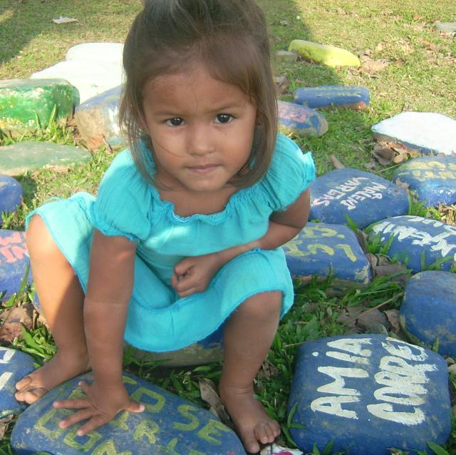
Child at the monument of stones, where the name of each murdered community member is painted on a stone.
---

War on Terrorism
The Colombian government claims that there is no civil war in Colombia, only terrorism. In 2005 President Uribe spoke about the peace community on television saying that their leaders cooperate with the FARC. He therefore would not consider them as a Peace Community or being in a Human Protection Zone which needs special protection according to the Geneva Convention of 1945. They are terrorists. With this assumption, strictly contested by the inhabitants of San José and international observers, Uribe started thinking like the paramilitary. For them the rural population is considered to be the foundation of the guerrilla. This flat suspicion of terrorism is fatal for the villagers as it leads to political isolation and eviction or even elimination of its inhabitants.
Despite the release of propaganda leaflets, falsified evidence and videoed witness testimony extracted by torture that the peace community sides with the guerrillas, international observers of human rights organisations acknowledge again and again that there is no connection between San José and the guerrilla groups.
---

False Positives
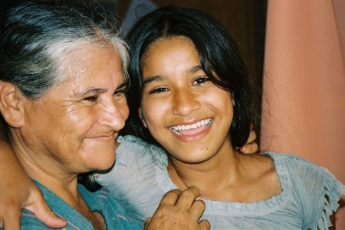
This is Brìgida, a member of the peace community, and her daughter Eliseña. Eliseña went to a birthday party in a nearby village, and the army killed her on the road. They did not deny they killed her they said she was a Guerrilla. She was 15. The army often dresses murdered civilians in combat uniforms and plants weapons on them, presenting the innocent civilian victims as guerrillas killed in combat. Often their bodies are moved to another municipality and any identification is removed, which is a means of impeding any subsequent investigations. Such practices are encouraged by a national law which provides rewards, in the form of money or promotion, for soldiers who kill guerrillas.
This practice is known as False Positives, and supports the further criminalisation of the community and labelling of them as terrorists.
---

No Giving Up
The inhabitants do not give up: to the contrary, they build up a future model for an autonomous and peaceful life. This includes running 8 schools in different areas of the community for over 350 children where they teach the children about a way of life focused on sustainability and peace. This is because since the marginalisation and political isolation that resulted from accusations of siding with the guerrillas, the state will no longer provide schools in the community. They also run a university of resistance for older community members, run on a model of popular education where they teach each other and share skills and knowledge.
They record details of all of the abuses against them and maintain a published ongoing history of the community on their website (in Spanish) : http://cdpsanjose.org. This can never be killed or silenced.
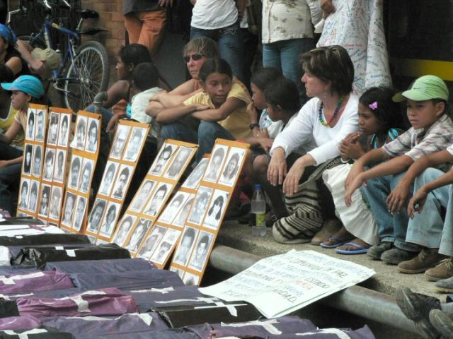
They are in contact with many international human rights and other NGOs and invite solidarity actions from civil society organisations and other groups. There have been visits to their community by international peace volunteers, particularly from Peace Brigades International and the Portuguese ecovillage Tamera, to help them improve infrastructure in their community and to protect them with the presence of internationals they are safer from attack when foreigners are with them. Tamera run a website in English, German and Spanish about the community with more information : http://www.sos-sanjose.org.
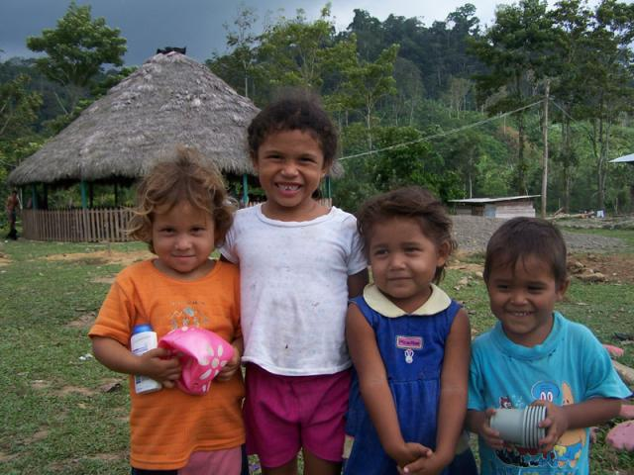

Films in English about the Peace Community San Jose can be seen here :
- http://www.youtube.com/watch?v=VOFSZHBEQyo&feature=player_embedded
- http://vimeo.com/13418712
- http://www.youtube.com/watch?feature=player_embedded&v=-ZdnMsPrrNQ#at=22
- http://www.youtube.com/watch?v=kIIU0UQ6X6E&NR=1
- http://www.youtube.com/watch?v=8vhh5KNnrxA
---

Why is this being done to them? Civil War, Free Trade, Drugs and the Plan Colombia
Not because there is war are there displaced people, there is war because people shall be displaced.
Hector Mondragon, persecuted Columbian economist.
The peace community and human rights observers argue that the Columbian civil war has escalated to a war of the Columbian state against its own population. Any form of political opposition and resistance is attacked. The paramilitary units are the main actors of the war. Their cooperation with the military is an open secret, and they use weapons and equipment given to the Colombian government by the Americans, who have given billions in military aid (paid for by US taxpayers) under the Plan Colombia war on drugs and terrorism.
Goals in the war are :
- Assurances for corporate economic development in one of the most important geo-strategic areas of World Trade and the enforcement of a free trade zone under the notoriously unjust Free Trade of the Americas Agreement (FTAA).
- Access to oil, coal and other mineral resources.
- Control of the cocaine trade with which weapons, uprisings and wars of all kinds are financed globally.
- Concentration of land into the hands of the few.
- Powerful interests wish to open the area up for free exploitation by multinational corporations, and the people who live there are in the way of this. Farmers are evicted or murdered. Many farmers are forced to sell their land while being evicted, maintaining the illusion of legality.
The concentration of real estate grows: in 1984, 32 percent of the registered estate belonged to the Latifundistas (big landowners), in 1988, 36 percent, in 1996, 43 percent and in 1997, 45 percent. (Figures taken from the national land survey office and land registry office).
As well as the obvious human rights concerns, there are major environmental issues just under the surface: if the farmers are moved off their land to make way for access by corporations, then environmental destruction follows as surely as night follows day, with deforestation, industrial agriculture and opencast mining.
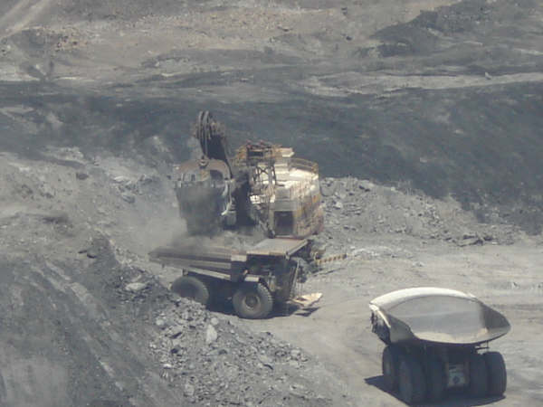
A company also wants to build a large hydroelectric dam in their area that will flood much of the lowland farms and communities.
The peace community are making a stand against human rights abuses, corporate land grabs and social and environmental destruction. They are shining a light in their area for an alternative future for Colombia that is not based on war and drug production, and that has the potential to have an acupuncture-like effect to create positive change on a much bigger scale in the country.
They desperately need the solidarity and help of the international community in order to survive, and the more visible they are in the eyes of the world and the more the Colombian government feels they are being watched, the more protected the members of the community will be.
---

Lush's involvement so far
Lush has supported the community by buying cacao (cocoa beans) from their farms, where they grow cacao with other crops integrated into the mountain rainforest. The beans are certified organic and fair trade and Lush helps the community to pay for the renewal of their organic and fair trade certification so they can continue to try to find other buyers in that market and not just depend upon Lush. In Europe we process the beans into cocoa butter, which we use a lot of in our products, and cocoa powder which we will sell on for making chocolate.
By giving the community a market and a way to generate income from their farm produce, Lush enable them to access vital financial resources to be able to continue building their community, funding their schools and health centres, and campaigning for justice at home and travelling to raise publicity and support abroad.
For further information on this project, please contact Paulo@lush.co.uk
Sources :
- http://www.amnesty.org/en/library/asset/AMR23/009/2011/en/673f9a70-c714-44f5-8432-734c018aaa85/amr230092011en.pdf
- http://www.sos-sanjose.org/
- http://www.amnesty.org/es/library/asset/AMR23/005/2010/es/8abbee9d-726e-4b33-b928-1174a15833f4/amr230052010en.pdf
- http://www.amnesty.org/en/library/asset/AMR23/023/2008/en/65b11bee-a04b-11dd-81c4-792550e655ec/amr230232008eng.pdf
- http://www.pbi-colombia.org/?L=1
- http://www.amnesty.org/en/library/asset/AMR23/002/2009/en/f50d06ea-b9e1-49cb-b188-2fa000e3a4ea/amr230022009en.pdf
- http://en.wikipedia.org/wiki/Colombian_paramilitaries

