Press Release

Celebrating the J-Wave Revolution at CharaExpo 2015

June 25, 2015, Singapore – Over 16,324 fans attended CharaExpo 2015 over the weekend of June 20 and 21 in Singapore, welcoming more than 45 Japanese stars of anime, manga, games, cosplay and pro-wrestling. Veteran illustrators Yoichi Takahashi (Captain Tsubasa), Mel Kishida (Atelier Rorona, Hanasaku Iroha) were present; voice actor Ryo Horikawa (Vegeta from the Dragon Ball series, Kou Uraki from Mobile Suit Gundam 0083: Stardust Memory) and pop stars, Maon Kurosaki, Mashiro Ayano and BACK-ON, among others, treated the audience to exclusive artist showcases as well as mini concerts and talks at the two-day expo.

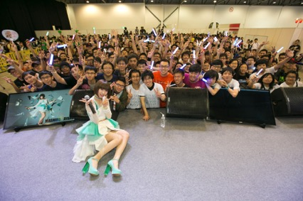
Pop sensation, Maon Kurosaki with her fans from Singapore and around the region

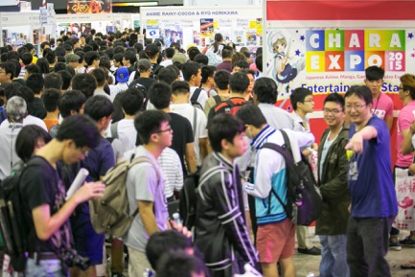
Fans from around the region filled the CharaExpo on both days

Wrestling fans got up close and personal with the stars of New Japan Pro-Wrestling who were in town for their maiden showcase.

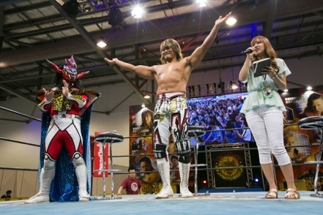
New Japan Pro-Wrestling’s Jushin Thunder Liger (left) and Hiroshi Tanahashi (right)

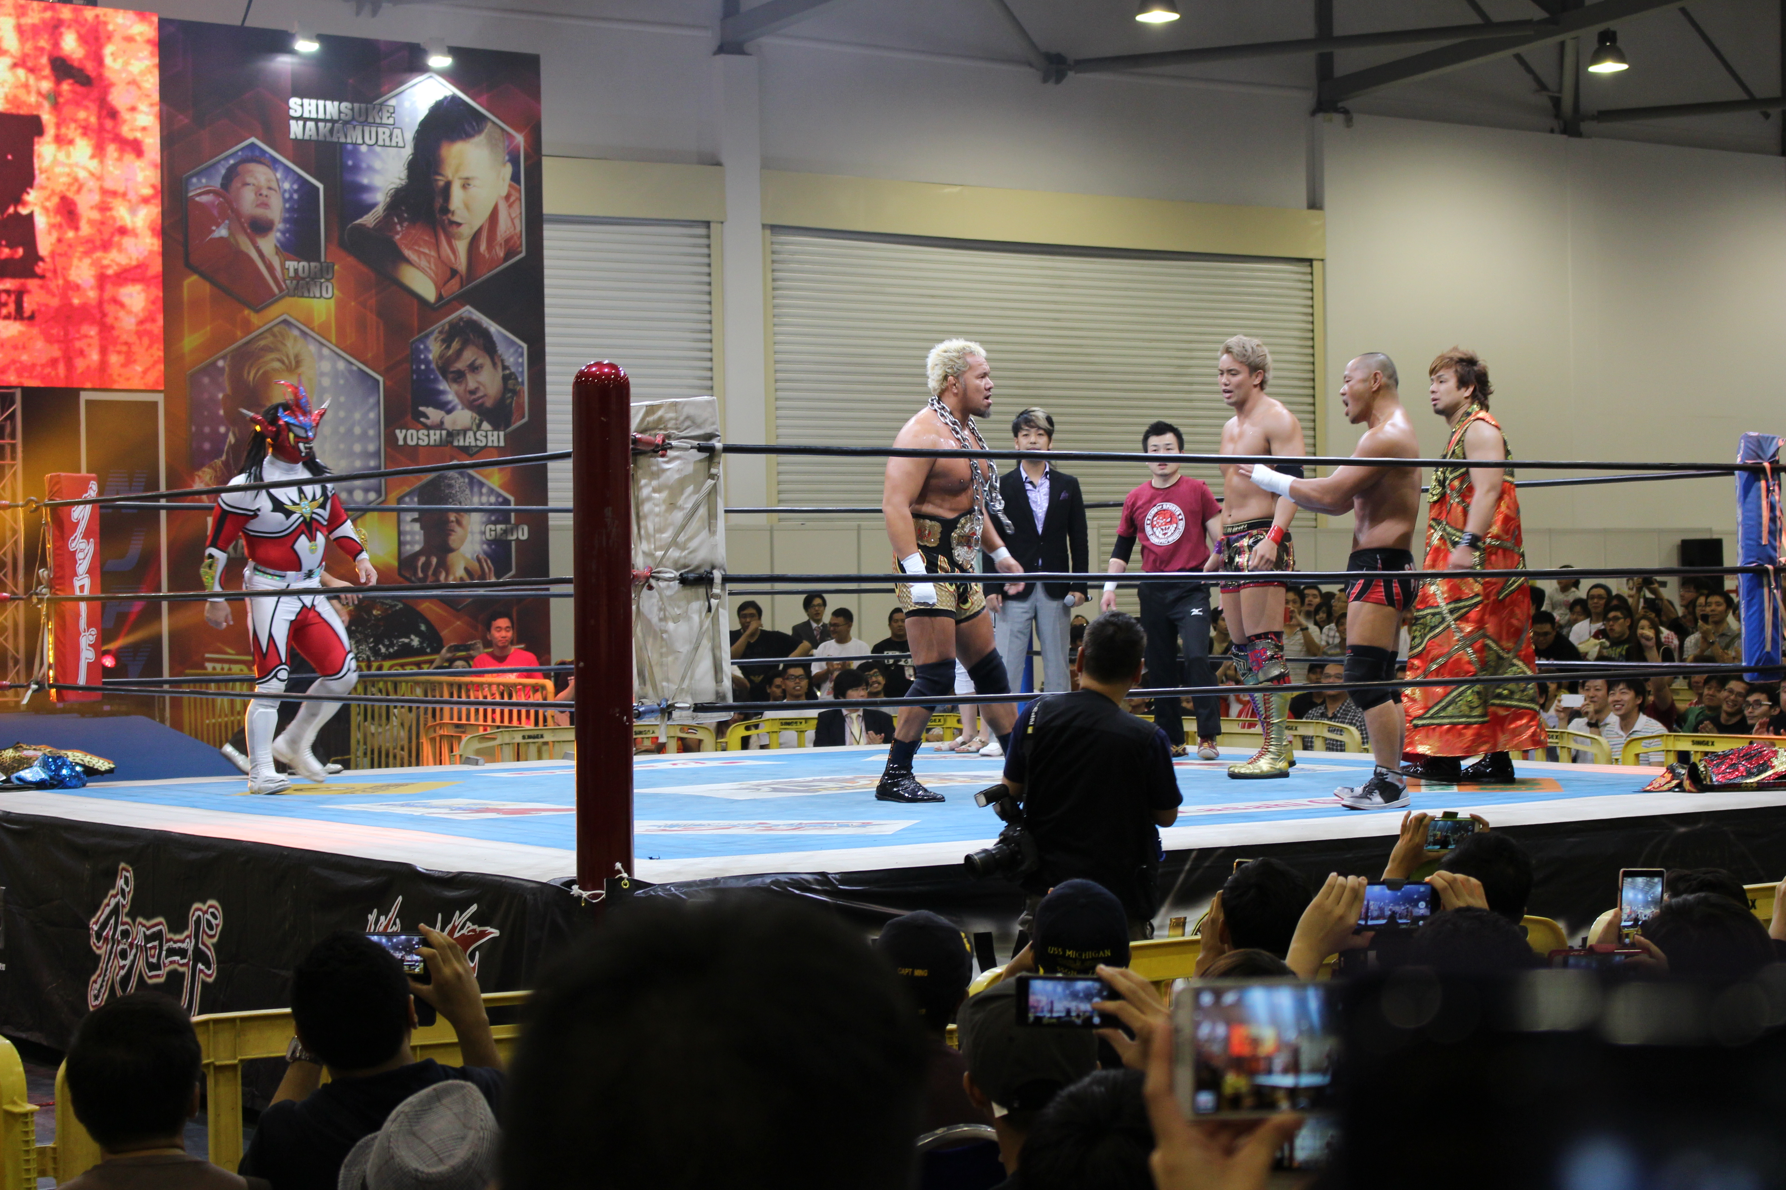
Totally packed NJPW matches were a fan highlight

The Cos☆Stage cosplay competition saw Evie Tan’s entry of Guildmarm from MonHunt, emerge as its winner and Singapore’s representative at this year’s Tokyo Game Show in September. “I really love this nerdy character who is very much like me and loves helping people. It was a really great feeling to be onstage at CharaExpo and seeing all the fans and other competitors. I’m extremely excited about winning and attending the Tokyo Game Show as this would be my very first plane ride!”

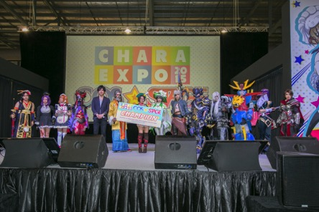
The CharaExpo’s Top 10 cosplayers

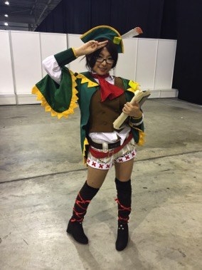
Evie Tan, winner of the Cosplay competition at CharaExpo

Bushiroad’s Spring Fest 2015, had more than 600 participants in their highly competitive trading card game tournament.

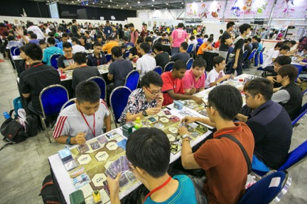
The trading card booth was always filled

President and Chief Executive Officer of Bushiroad Inc., Mr. Takaaki Kidani, elaborated on the popularity of trading cards, “Trading card games remain popular today because they foster personal interaction and community bonding. Players regularly meet for tournaments, to trade cards and also widen their circle of friends. The illustrations have also evolved into collector’s items, with each deck becoming more beautiful and detailed. More and more artists are gaining acclaim for their work on trading card decks.”

First-time exhibitors such as Visual Art’s, Frontwing, bili bili and AniCrush!! treated fans to exclusive merchandise. Good Smile Company’s Representative Mr. Darren Tan, were overwhelmed by keen collectors who are out for exclusive buys. “This is the first time that we’re exhibiting at the CharaExpo and the fan response has been very positive. Fans in Singapore really love our figurines. Our exclusive nendriod figures have been in high demand throughout the expo. We hope that the CharaExpo will grow and that we will grow in together with them over the years.” Exhibitors such as Visual Art’s had merchandises sold out within the first hour of opening.

CharaExpo will return in Singapore in early June 2016 with more artist sessions and cosplay demonstrations. CharaExpo 2016 will also feature discussion panels on how locals can develop their talent in this sector. For more information visit http://chara-expo.com/2015.

-- END--

About CharaExpo
CharaExpo 2015 is a Japanese manga, anime, games and cosplay event that will be held from June 20 to 21, 2015 in Singapore EXPO Hall 7. This is the first major Japanese content-related event to be held in Singapore.

CharaExpo 2015 aims to shine the spotlight on the people and team behind the scenes of these Japanese-related content. The event will feature prominent producers, manga artists, illustrators, cosplayers and more. Fans can look forward to meeting these special guests and learn more about their passion and work. Major Japanese anime, manga and game companies will also be participating in the event to showcase and offer event-exclusive exhibits and merchandise. For more information, visit: http://chara-expo.com/2015/

About Bushiroad
Bushiroad Inc. is an entertainment company known for developing Cardfight!! Vanguard, Future Card Buddyfight, Detective Milky Holmes, Weiss Schwarz and other card games, promotional items, smartphone applications around the world.

Bushiroad Inc. consists of 6 sub-entities: Bushiroad Inc., Bushiroad South East Asia Pte Ltd, Bushiroad USA Inc., Bushiroad Media, Bushiroad Music, and New Japan Pro-Wrestling Co., Ltd. Bushiroad South East Asia Pte Ltd was established in Singapore on November 12, 2011 in order to expand the overseas market for Bushiroad card games such as Cardfight!! Vanguard, Weiβ Schwarz, Chaos TCG and Five Qross.

Media Contact
Selena Sheikh
Director, PINPOINT Public Relations
HP: +65 9746 8519
Email: selena@pinpoint-pr.net

