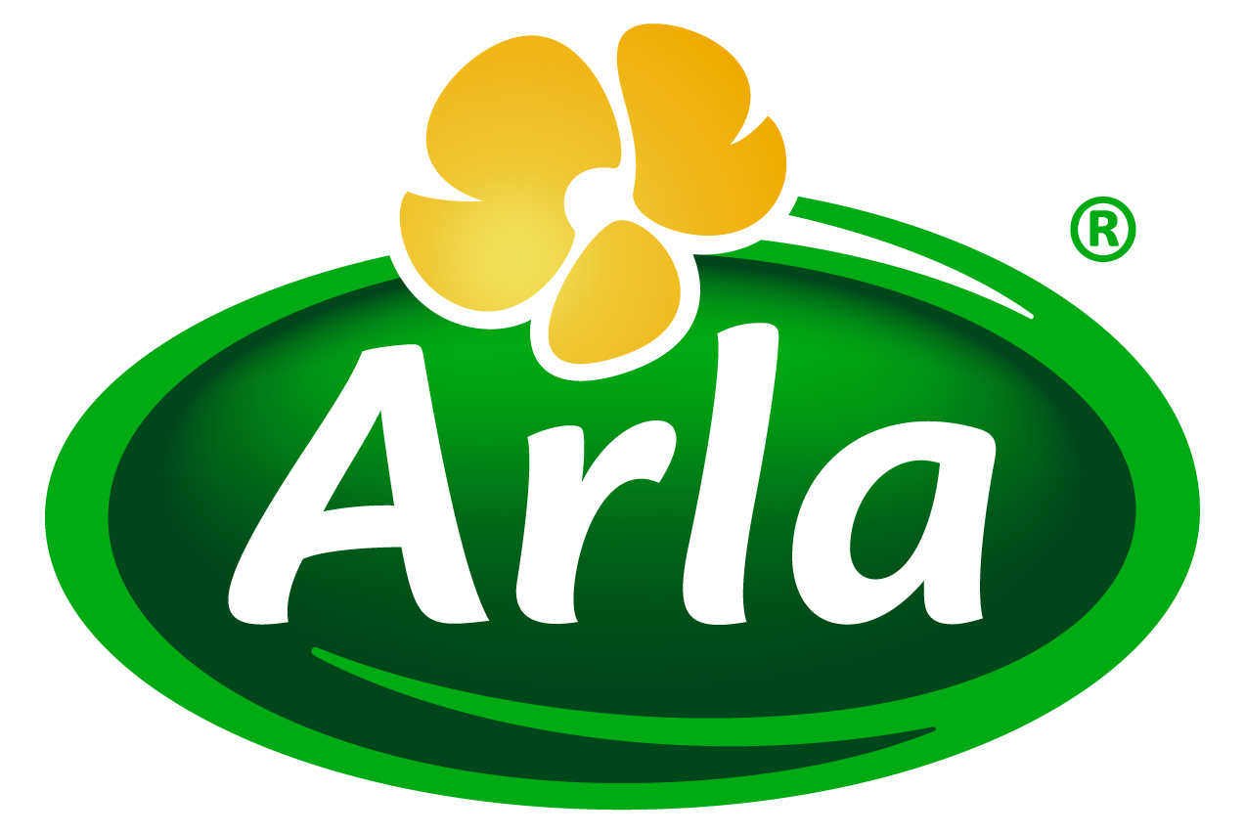
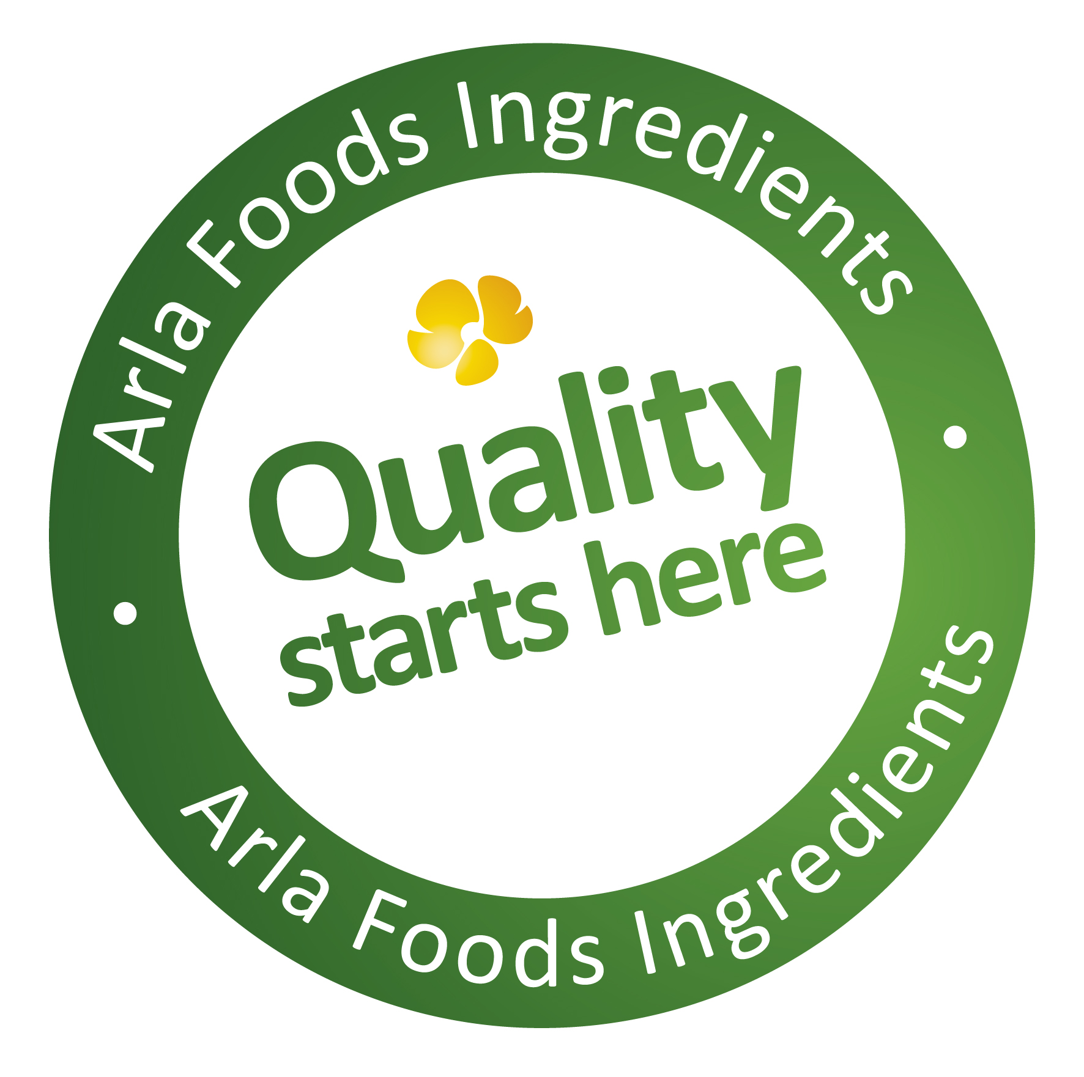

1 April 2015
PRESS RELEASE
Arla Foods Ingredients reveals efforts
to reduce malnutrition in CSR report

Arla Foods Ingredients has published its first independent CSR report, in which it reveals its participation in a new ethical initiative that seeks to make affordable and nutritious food solutions available to low-income families in Ethiopia. The initiative is called the GAIN Nordic Partnership and is driven by the Global Alliance for Improved Nutrition (GAIN), in co-operation with businesses from across the food supply chain.
Although there are more than 54 million cattle in Ethiopia, low milk yield per cow and poor distribution limit the availability of affordable dairy products in stores. In an effort to address this, Arla Foods Ingredients – along with its partners in the GAIN Nordic Partnership – is providing processing expertise and whey ingredients for local production of an inexpensive, multi-nutrient powder supplement for children up to the age of two.
The initiative is explained in detail in the new CSR report, which says: “Joint venture initiatives established through GAIN are not about food aid. The key to their enduring success is that they are economically sustainable for all involved. Our need for the latest knowledge and technologies is insatiable if we are to identify sustainable new ways to feed the growing global population and document the effects of whey nutrients.”
Also in the CSR report, CEO Henrik Andersen hails Arla Foods Ingredients’ role in moving whey protein from being a low-cost by-product of cheese-making to become a high value ingredient. “The rise of whey must be one of the dairy industry’s all time greatest sustainability stories,” he writes. “Today, the former waste product is a sought-after raw material.”

The report goes on to explain how, in the past couple of years, Arla Foods Ingredients has worked specifically to make good use of the lactose found in the by-product of protein concentration – whey permeate. In November 2014, for example, the company inaugurated a new facility for dry-blend lactose, which represented an important step forward in terms of increasing the amount of whey permeate that is redirected into infant formula. In addition, Arla Foods Ingredients is contributing to a move to establish a global codex standard for whey permeate powder by 2017.

Henrik Andersen commented: “Many of the initiatives we outline in our new CSR report have their roots in our ‘Quality starts here’ platform – a fundamental driver of our corporate strategy. Our commitment is to use this programme to unfold the full potential of whey and create a successful and sustainable business model for the long-term. As a business, our primary mission will always be to meet the needs of our customers, but we also recognise the impact we have on the wider world and the communities where we operate. Our first independent CSR report embodies this commitment and outlines the steps we have taken – and will be taking in the future – to fulfill it.”
Arla Foods Ingredients’ new CSR report is available to download free of charge at http://www.arlafoodsingredients.com/csr
ENDS
For more information, please contact:
Kine Bjoralt, Ingredient Communications
Tel: +44 141 280 4141
Email: kine@ingredientcommunications.com
@ingredientcomms

About Arla Foods Ingredients
Quality starts here: Arla Foods Ingredients is a global leader in natural whey ingredients for products in a range of categories – from sports nutrition, beverages, bakery, dairy and ice cream to clinical and infant nutrition. The cornerstones of our business are innovative ingredients, world-class facilities and a staff of dedicated experts. Drawing on our portfolio of functional and nutritional whey proteins, milk minerals, lactose and permeate, our expert team delivers solutions that bring new food products quickly and efficiently to market. Our application centres run hundreds of customer product trials every week. All ingredients are produced using state-of-the-art processing technology at our plant in Denmark, or by one of our joint ventures in Argentina, Germany and the UK. Arla Foods Ingredients Group P/S is a 100% owned subsidiary of Arla Foods, a global dairy company and cooperative owned by dairy farmers in Denmark, Sweden, the UK, Germany, the Netherlands, Belgium and Luxemburg.

RSS Feed
Visit our website at http://www.mynewsdesk.com/arla-foods-ingredients and sign up to our News RSS feed for all the latest developments – updated regularly.

Twitter
Follow us on twitter for all the latest updates @ArlaIngredients

LinkedIn
http://www.linkedin.com/company/arla-foods-ingredients

