**Bäckman's selected for the Sweden National Team for the fourth year in a row**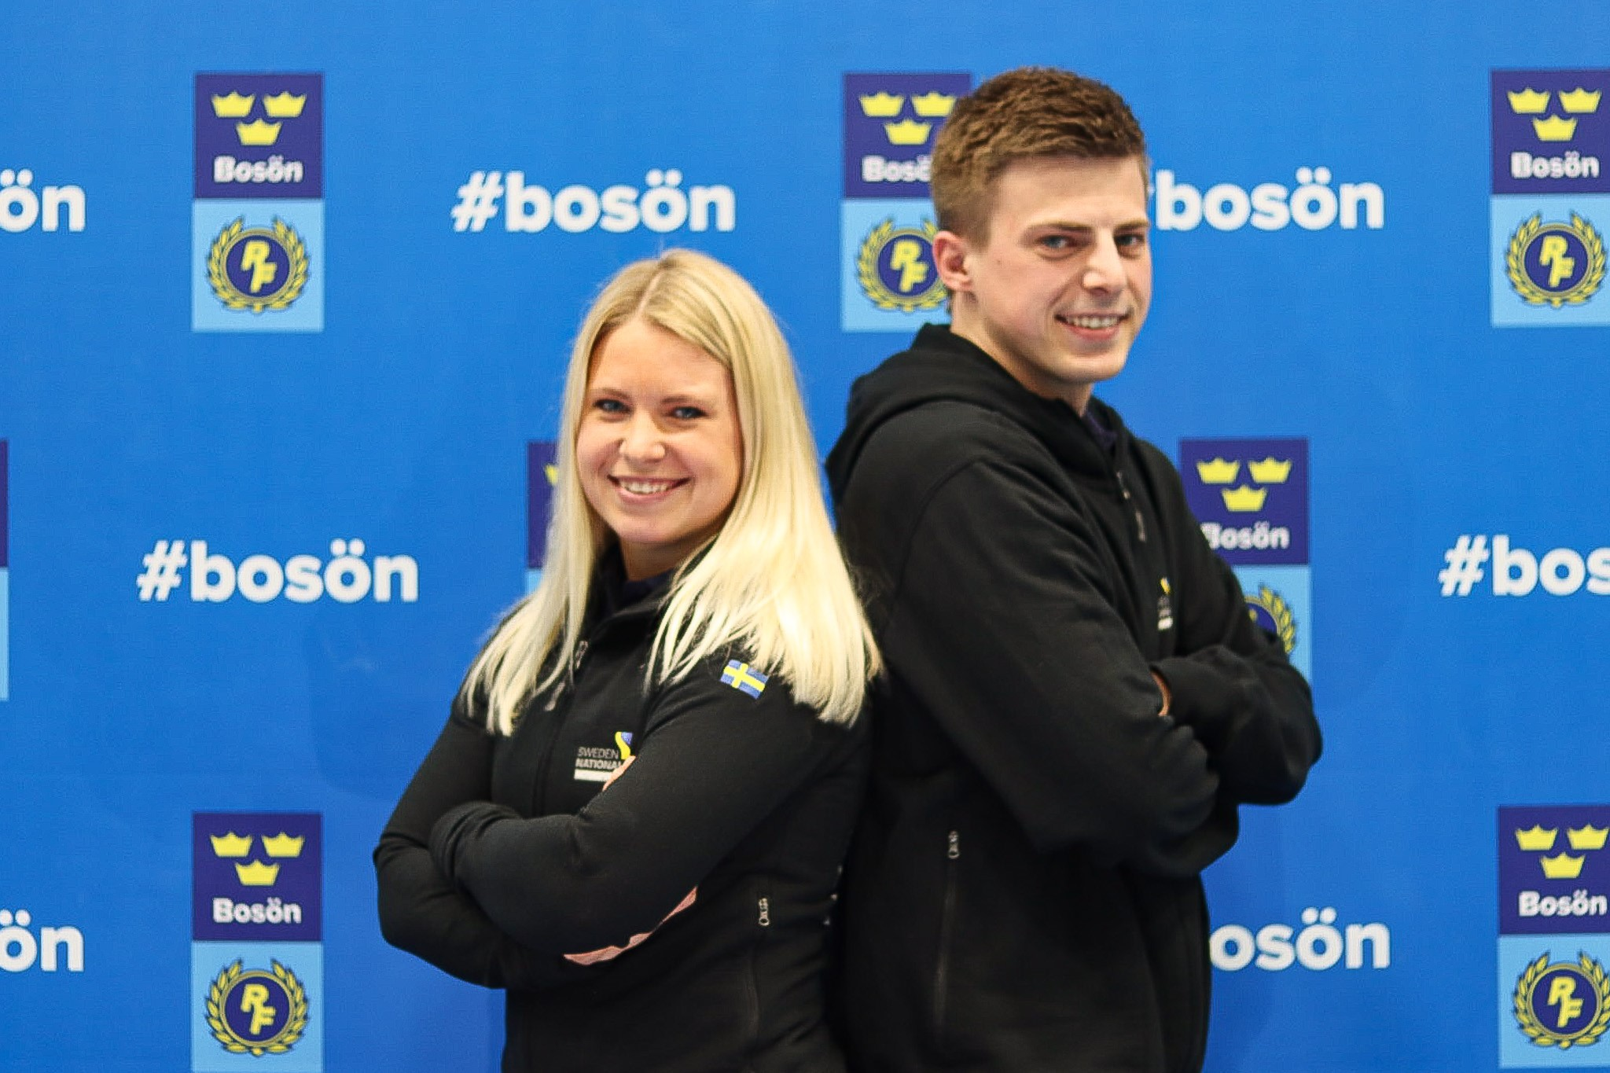Jessica and Andreas Bäckman selected for the Swedish National Team for Motorsports in 2023.  
Photo: Ellinor Aspeqvist (Free rights to use the image)

**Today it was announced that the Bäckman siblings Andreas and Jessica Bäckman from Sweden has been selected for the Sweden National Team for car racing for the fourth consecutive year.  
- This is a great opportunity for us to continue our development as racing drivers and we are extremely proud to once again be part of the Sweden National Team this season, Andreas Bäckman says.**

Today, the Swedish Automobile Sports Federation announced its National Team drivers for 2023. Among all the talented drivers from Sweden, the siblings Andreas and Jessica Bäckman from the North of Sweden were among the names of the selected drivers. Both siblings will once again be part of the Senior National Team “Sweden National Team”.

- Very happy and grateful that the Swedish National Team wants to continue to invest in us. It is an important piece of the puzzle for us to be able to continue our path forward in our careers. Being part of the National Team will also help us to develop as a driver and everything that comes with being an elite racing driver, **Jessica Bäckman** says.

The main purpose of the National Team is to develop the drivers and give them as many tools as possible to reach the top in car racing.

- This is a great opportunity for us to continue our development as racing drivers and we are extremely proud to once again be part of the Sweden National Team this season, **Andreas Bäckman** says.

**The National Team's elite investment in car racing talents**The Sweden National Team Manager Pier Steffansson is looking forward to continuing to work with Andreas and Jessica:

- I have been able to follow the development that Jessica and Andreas have made in recent years in TCR cars. And now take the step into GT4, from front-wheel drive to rear-wheel drive, I think is an exciting step and will be very fun to follow during this season. The fact that it is then a pair of siblings who do it is very unique, **Pier Steffansson**, Sweden National Team Manager says.

Andreas and Jessica are looking forward to developing more at all levels in 2022 and are hoping to become more complete as racing drivers with the help of this initiative:

- In 2020, it came as a positive surprise when we found out that we have been selected for the National Team and that we now being allowed to be part of the National Team for the fourth year in a row feels amazing. As an athlete in car racing, there is so much behind the few opportunities in the racing season when you must perform on the track, and there the National Team is an important part of our efforts, **Andreas Bäckman** says.

***Free rights to use the images.***

***Download press-photos here:***[***http://bit.ly/jabaeckman-photos***](http://bit.ly/jabaeckman-photos)[***https://www.mynewsdesk.com/se/ja-backman/images***](https://www.mynewsdesk.com/se/ja-backman/images)

