Bäckman enters the legendary Circuit de Spa-Francorchamps
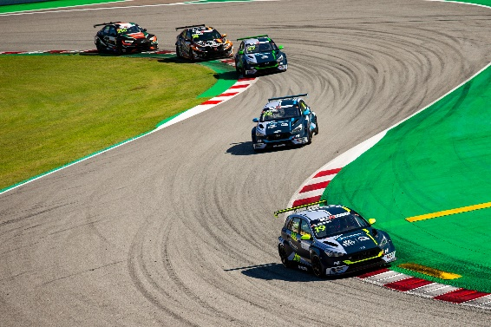
Andreas and Jessica Bäckman are ready for Belgium.
Photo: TCR Europe (Free rights to use image)
This weekend, October 22nd-24th, the fifth round of TCR Europe is held at the legendary Circuit de Spa-Francorchamps in Belgium. The Bäckman siblings enters the longest circuit on the calendar and the iconic corner Eau Rouge.
- Looking forward to face this challenging track, says Jessica Bäckman.
It is now about two weeks since the siblings Andreas and Jessica Bäckman last competed in TCR Europe. The fourth event was held at the Formula 1 track Circuit de Barcelona-Catalunya, where Andreas claimed his first win of the season. Now the championship will enter the legendary Circuit de Spa-Francorchamps, just over 50 kilometres South East of Liège in eastern Belgium. The fifth event of the championship will take place at this 7,004 km long circuit, which includes the iconic Eau Rouge corner. The track is often top-ranked when racing drivers name their favourite tracks. Circuit de Spa-Francorchamps has been part of the Formula 1 calendar for many years.
7,004 km - and the iconic Eau Rouge corner
The weekend begins with one Free Practice session on Thursday, followed by another Free Practice session, Qualifying and Race 1 on Friday. The second and final race is held on Saturday and the siblings are excited.
– I'm looking forward to get back and compete again and it will be exciting to drive at the famous track at Spa, to be challenged in the Eau Rouge corner. Last race in Barcelona was perfect for me, so now I will try follow the positive trend this weekend in Spa, says Andreas Bäckman.
His sister Jessica agrees.
– Last race weekend in Barcelona was positive for me, I showed really good speed in every session, just bad luck that I couldn't fulfil the podium finish. Now this weekend in Spa I will try to fulfil a good result and show good speed again. Looking forward to face this challenging track, says Jessica Bäckman.

Timetable for this weekend’s race (TCR Europe round 5):
All times is in local time (Belgium time)
Thursday October 22nd:
16:55 Free Practice 1
Friday October 23rd:
09:00 Free Practice 2
12:10 Qualifying (Q1 and Q2)
16:45 Race 1 (LIVE at JA Bäckman's Facebook-page)
Saturday October 24th:
11:45 Race 2 (LIVE at JA Bäckman's Facebook-page)
Live-streaming
Both races are live-streamed at JA Bäckman's Facebook page, as well as on TCR TV on YouTube.
Live-timing
All practice sessions, qualifying and races can be followed via live-timing HERE.
About the track:
Circuit de Spa-Francorchamps
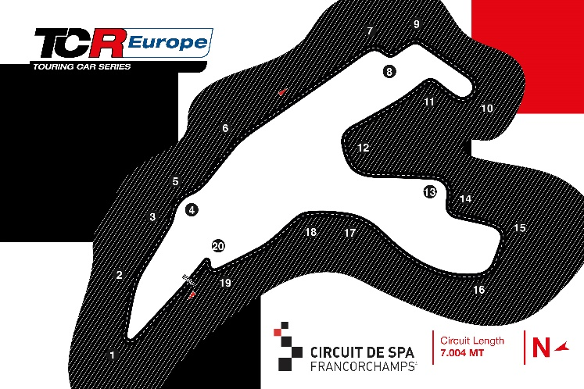
Located in: Francorchamps, Belgium
Length: 7,004 km
Corners: 20
Race duration: 8 laps (55 km)
Lap record (TCR): 2min 28.735s
Free rights to use the images.

